Product Technical Specification (Moving Head Light Series)
Product Image |  | Product Dimension Drawing
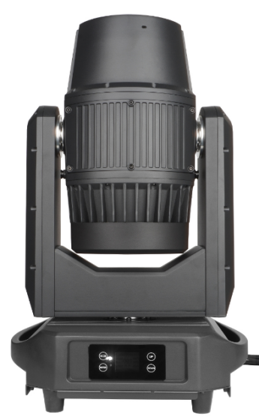 |  | 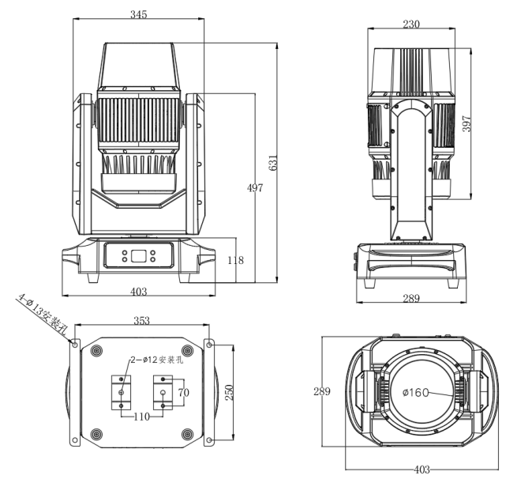
Lighting Specifications |  |  |  |  | Parameters
Product Name | Outdoor Waterproof Moving Head Beam Light | Product Model | 380 BEAM IP |  | Input Voltage: AC100V-240V 50/60HZ  Power Consumption: 550W  Light Source: USHIO NSLU6C  Light source lifespan: 1500 hours  Diameter of Frontal Lens: 160mm  Beam angle: 1.7°  Operating Temperature: -10-40℃  Control Mode: DMX512, Master-Slave, Auto Run, RDM  Channel: 16 Channels  1 Color Wheel: 14 colors + plus open, Features half-color and linear adjustment, enabling bi-directional rainbow effects  1 Static Gobos: 13 gobos + plus open, Variable Speed Jitter and Bidirectional Rotation  Prism: 2 Prisms, Independent Rotation, Can be Overlapped  Frost Filter: 1 Frost Filter  Dimming: 0–100% linear dimming  Strobe: 1-20 Times/Second, Adjustable Speed  IP Rating: IP66, Waterproof  Pan scan: 540 Degrees 16 bit  Tilt scan: 270 Degrees 16 bit  Display: LCD Display with 4 Touch Buttons  Cooling Fan: Mute Fan, Variable Speed  Shell: Die-cast Aluminum  Data In/Out: DMX 3-pin Input/Output + 5-pin Input/Output  Power In/Out: Waterproof power connector in/out  Product Dimensions: 631*403*289mm  Packing Dimensions: 755*445*460mm  Net Weight: 25kg  Gross Weight: 28kg  With folding clamp and arm handle
Product Name | Outdoor Waterproof Moving Head Beam Light | Light Color | Black
Net Weight | 25kg | Gross Weight | 28kg
Product Dimensions | 631*403*289mm | Packing Dimensions | 755*445*460mm
Protection Rating | IP66 | Lighting Material | All die-cast aluminum body
Optical System |  | Effect System
Light Source Information | USHIO NSLU6C | Rotating Gobos | None
Light Source Life | 1500 hours | Static Gobos | 1 Static Gobo Wheel with 13 Gobos, Variable Speed Jitter and Bidirectional Rotation
Beam Angle | 1.7° | Color | 1 color wheel with 14 colors plus open white, Features half-color and linear adjustment, enabling bi-directional rainbow effects
Color Temperature | / | Prism | 2 Prisms（8-facet prism, 24-facet prism）, Bidirectional Variable Speed Rotation, Achievable Overlay Effect
Dimming | 0–100% mechanical linear dimming | Fogging | 1 Independent Frost Effect, Soft and Natural Light Spot
Focus | 0~100% electronic linear high-definition Focus | Strobe | 1-20Hz Fast Strobe per Second, with Pulse Strobe, Synchronous and Asynchronous Strobe Effects
Electrical Connection |  | Control System
Input Voltage | 100V-240V AC，50/60HZ | Mechanical Movement | Horizontal Scanning Angle 540°, Vertical Scanning Angle 270°, Automatic Return Correction and 16bit Precision Fine-Tuning Function
Total Lamp Power | 550W | Communication Design | DMX Wired/Wireless Transmission, Convenient and Fast Software Upgrade via DMX Data Cable
Signal Connection | Waterproof signal cable | Heat Dissipation System | Fan Heat Dissipation Structure and Temperature Intelligent Monitoring Technology, Automatically Adjusts Heat Dissipation System to Effectively Control Lamp Temperature
Power Connection | Waterproof power input & output | Control Protocol | Auto Run, Master-Slave Mode, DMX512
Display Screen | Fixture and lamp usage time can be queried for easy maintenance | Channel Mode | 16CH
Others
Photometric Diagram |  |  |  | 1 Color Wheel: 14colors+plus open
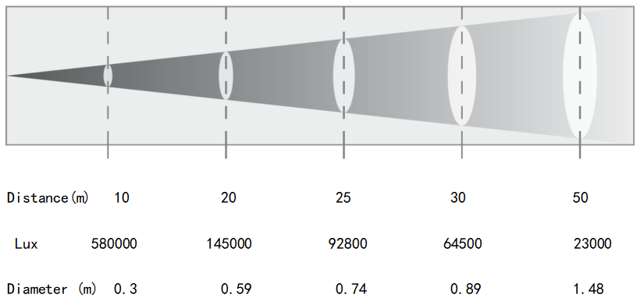 |  |  |  | 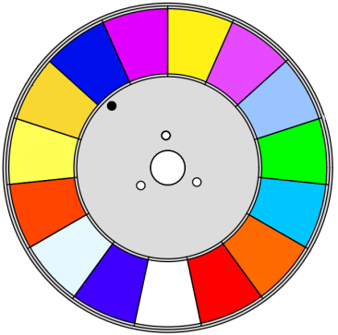
Gobo+Prisms/Frost Filters |  |  |  | Effect
1 Static Gobos：13 gobos + plus open  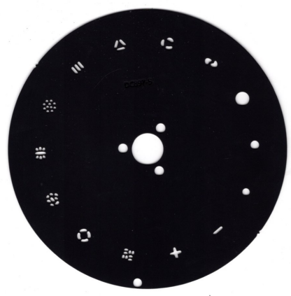   |  |  |  | 