Product Technical Specification (Moving Head Light Series)
Product Image |  | Product Dimension Drawing
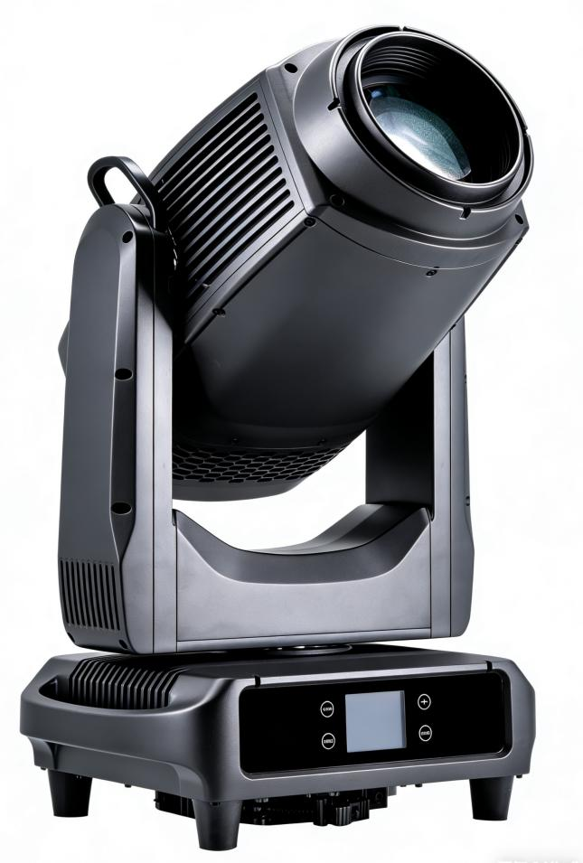 |  | 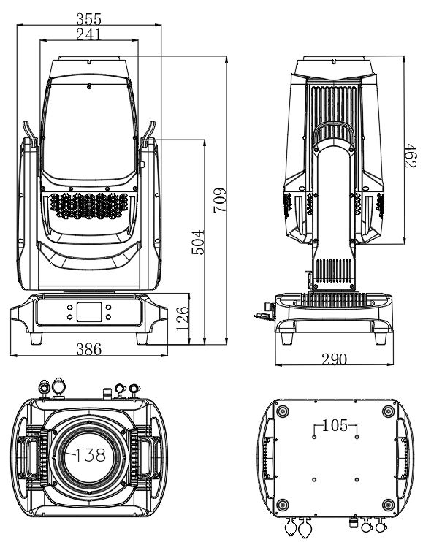
Lighting Specifications |  |  |  |  | Parameters
Product Name | Outdoor Waterproof Moving Head 3-in-1 | Product Model | 450 BSW IP |  | Input Voltage: AC100V-240V 50/60HZ  Power Consumption: 600W  Light Source: USHIO NSLU7  Light source lifespan: 1500 hours  Diameter of Frontal Lens: 140mm  Beam angle: 2°-31°  CCT：7900K  CRI：＞70  Operating Temperature: -10-40℃  Control Mode: DMX512, Master-Slave, Auto Run, RDM  Channel: 28CH/20CH  Color: Linear CMY color mixing& Linear CMY color mixing Linear CTO Color Correction3200K-6700K  1 Color Wheel: 6 Colors  2 Color Wheel: 6 Colors  1 Static Gobo Wheel：16 gobos  1 Rotating Gobo Whee: 9 interchangeable gobos  Prism: 2 Prisms, Independent Rotation, Can be Overlapped  Frost Filter: 1 Frost Filter  Homogenizer：1 homogenizer lens  Dimming: 0-100% Smooth Dimming  Strobe: 1-20 Times/Second, Adjustable Speed  IP Rating: IP66, Waterproof  Pan scan: 540 Degrees 16 bit  Tilt scan: 270 Degrees 16 bit  Display: LCD Display with 4 Touch Buttons  Cooling Fan: Mute Fan, Variable Speed  Shell: Magnesium Alloy  Data In/Out: DMX 3-pin Input/Output + 5-pin Input/Output  Power In/Out: Waterproof power connector in/out  Product Dimensions: 709*386*290mm  Packing Dimensions:790*405*485mm  Net Weight: 27kg  Gross Weight: 30kg
Product Name | Outdoor Waterproof Moving Head 3-in-1 | Light Color | Black
Net Weight | 27kg | Gross Weight | 30kg
Product Dimensions | 709*386*290mm | Packing Dimensions | 790*405*485mm
Protection Rating | IP66 | Lighting Material | All-magnesium alloy body
Optical System |  | Effect System
Light Source Information | USHIO NSLU7 | Rotating Gobos | 1 rotating gobo wheel with 9 interchangeable gobos
Light Source Life | 1500 hours | Static Gobos | 1 Static Gobo Wheel with 16 Gobos, Variable Speed Jitter and Bidirectional Rotation
Beam Angle | 2°-31° | Color | 1、Linear CMY color mixing system and linear CTO color temperature adjustment  2、2 Color Wheels with 12 Colors
Color Temperature | 7900K | Prism | 2 Prisms（6-facet prism , 6 facet linear prism）, Bidirectional Variable Speed Rotation, Achievable Overlay Effect
Dimming | 0-100% Smooth Dimming | Fogging | 1 Independent Frost Effect, Soft and Natural Light Spot
Focus | 0~100% Electronic High-Definition Focus | Strobe | 1-20Hz Fast Strobe per Second, with Pulse Strobe, Synchronous and Asynchronous Strobe Effects
Homogenizer | 1 homogenizer lens
Electrical Connection |  | Control System
Input Voltage | AC 100V-240V，50/60HZ | Mechanical Movement | Horizontal Scanning Angle 540°, Vertical Scanning Angle 270°, Automatic Return Correction and 16bit Precision Fine-Tuning Function
Total Lamp Power | 600W | Communication Design | DMX Wired/Wireless Transmission, Convenient and Fast Software Upgrade via DMX Data Cable
Signal Connection | 3-pin/5-pin Waterproof Signal Cable & Xishang Waterproof 3-pin XLR Socket | Heat Dissipation System | Fan Heat Dissipation Structure and Temperature Intelligent Monitoring Technology, Automatically Adjusts Heat Dissipation System to Effectively Control Lamp Temperature
Power Connection | Waterproof Power Cable Input/Output & Xishang Waterproof Power Socket | Control Protocol | Auto Run, Master-Slave Mode, DMX512
Display Screen | 2.8-inch Display Screen with Automatic Flip Function | Channel Mode | 28CH/20CH
Others
Photometric Diagram |  |  |  | Color: Linear CMY Mixing System, Linear CTO Color Temperature Adjustment, 2 Color Wheels with 12 Colors
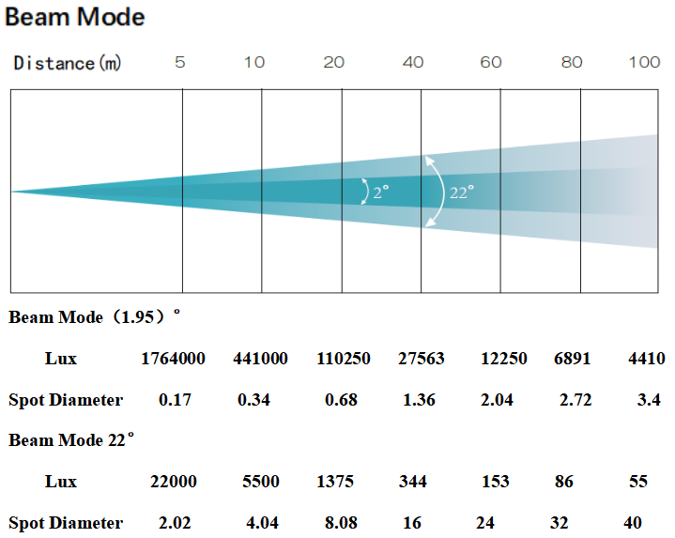  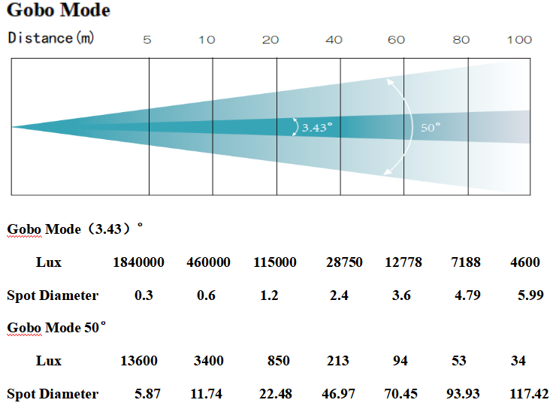 |  |  |  | 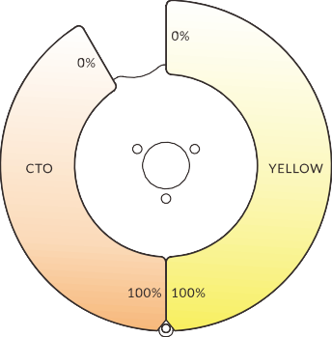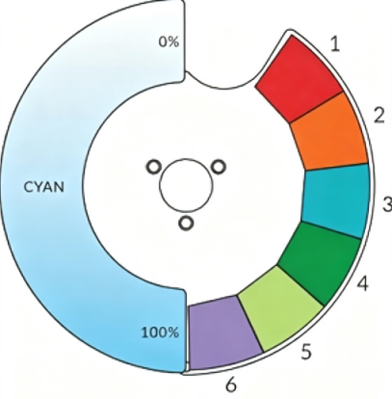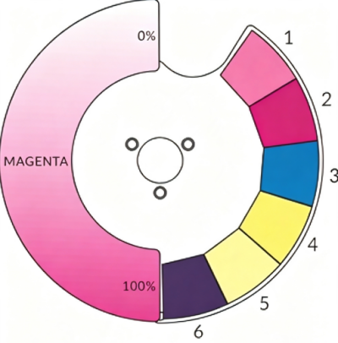
Gobo Wheel |  |  |  | Effect
