All-round Protection 420W Waterproof Prism King

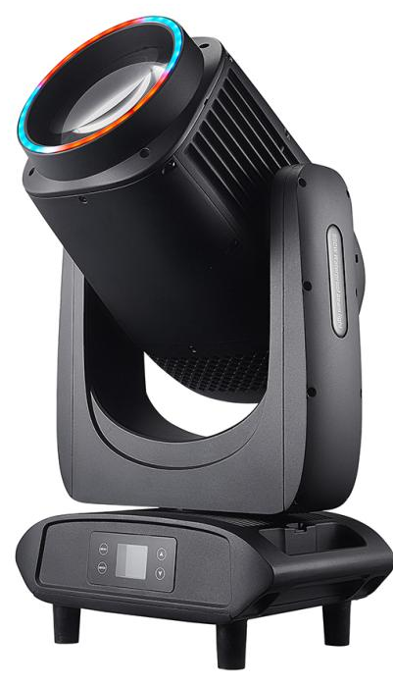

Manual - Instruction

Read the instructions carefully before use
Catalogue
1. Precautions and installation
1
1.1 Declaration
1
1.2 Maintenance
1
1.3 Product precautions
1
1.4 Product Introduction
1
1.5 Connecting Signal Cables
2
1.6 Lighting Installation
2
2. Control panel
4
2.1 Key Instructions
4
2.2 Main Menu
5
2.2.1 Settings
5
2.2.2 Manual
5
2.2.3 Information
6
2.2.4 Factory
7
3. Channel function
8
3.1
Channel Table
8
4. Common Faults
11

1. Precautions and installation Precautions and installation
  - Declaration
Thank you for choosing our products! 8, This product is in good condition and the package is complete when it leaves the factory. For your safe and effective use of this product, before you use this product, please read this manual carefully and completely. This manual contains important information for installation and use. Please install and operate according to the requirements of the manual. At the same time, please keep this manual properly for use at any time. Our company does not assume all responsibility for damage to lamps or other performance due to individuals not operating in accordance with the instructions during installation, use and maintenance.
This manual is subject to technical changes without prior notice.

  - Maintenance
- Disconnect the power supply before performing maintenance.
- This lamp should be kept dry and avoid working in wet environment.
- Intermittent use will effectively extend the life of the luminaire.
- In order to obtain good ventilation and lighting effects, pay attention to cleaning the fan and fan net as well as the lens often.
- Do not rub the luminaires housing with organic solvents such as alcohol to avoid damage.

  - Product precautions
- This light fixture is for professional use only.
- Ensure that the power supply voltage matches the required power supply voltage of the equipment before operation.
- Do not place this product in a place that is easy to loose or shake.
- During use, if the lamp is abnormal, stop using the lamp in time.
- In order to ensure the service life of the product, this product should not be placed in a humid or leaking place, and should not work in an environment where the temperature exceeds 60 degrees.
- When the lamp is used, the power supply voltage change should not exceed ±10%, the voltage is too high, will shorten the life of the lamp, the voltage is too low, it will affect the light color of the lamp.
- After the power off, it takes 20 minutes to use the lamp to cool down fully before it can be used again.
- The rotating parts of the lamp and the attaching accessories must be checked regularly, and the loosening and shaking should be reinforced in time to prevent accidents.
- In order to ensure the normal use of this product, please read this instruction carefully.

  - Product Description
Features & Technical Parameters
Features
• Fixture Material: Adopts high-end national standard die-cast aluminum shell—no plastic parts at all. Suitable for use in harsh outdoor environments such as heavy rainfall, high altitude, strong sandstorms, seaside, extreme cold and extreme heat.
• Waterproof Grade: Withstands 360° all-round huge wave impact, truly achieving IP65 waterproof rating.
• The waterproof beam light meets high industry standards in optics, structure, appearance and other performances. It adopts advanced technology, high-brightness light source, optical technology and rigorous industrial design to ensure the perfect presentation of lighting effects.
Technical Parameters
• Latest Mainboard Program: Supports RDM function; programmable built-in programs include multiple effect programs, enabling single white beam slow left-right swing, single color-changing beam slow left-right swing and multi-color-changing beams slow left-right swing.
• Voltage: Wide voltage 110V-240V, 50-60Hz
• Bulb Brand: Osram 371+ long-life light source
• Output Power: 480W
• Color Wheel: 15 colors + 7-color rainbow effect + atomization function
• Gobo Wheel: 14 fixed gobos
• Zoom: Electronic linear high-definition dynamic zoom, equipped with high-density glass optical lens
• Linear Dimming Curve: 0%-100% linear dimming
• Beam Angle: 1.8°
• Channels: 24 international standard DMX512 channels
• XY Motors: Three-phase electric drive, powerful, faster, more stable and quieter
• Control Modes: DMX 512, RDM, Auto-run, Master-Slave Auto-run
• Prisms: 8-prism / 8+16 prisms superimposed, rotatable with macro functions
• Display Screen: LCD screen adaptable to different installation positions
• Horizontal/Vertical Scanning: Capable of 540° horizontal or 270° vertical scanning with fast and stable speed
• Intelligent Photoelectric Reset Correction System: Automatically returns to the original position in case of accidental misoperation; equipped with horizontal and vertical locking knobs for easier maintenance and transportation
• Fixture Dimensions: 329228603mm
• Net Weight: 19.8KG
• Package Dimensions: 645490420mm
• Gross Weight: 24KG

  - Signal cable connection
Light fixtures feature standard DMX input and output 3-core or 5-core XLR sockets. Use a twisted-pair signal cable shielded specifically for DMX 512; The signal line is generally connected at a distance of 150 meters, and the DMX512 signal amplifier must be added for long distance signal transmission.
Use a shielded twisted-pair signal line from the DMX outlet of the controller to the DMX input of the first device, and from the DMX outlet of the first device to the DMX input of the second device, and so on, until all the lamps are connected. Then install a terminal plug on the last 3-pin connector of the connecting luminaire output on each line. (Weld a 4/1W, 120Ω resistor between the 2 and 3 pins of the 3-pin pin cannon plug).

Important: The wires should not touch each other or the metal housing.

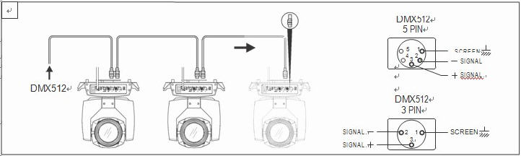
Figure 1 Schematic diagram of DMX signal wire connection
- The calculation method of the starting address code of the lamp:
The initial address code of the current luminaire is equal to (the initial address code of the previous luminaire)+(the number of channels of the luminaire)
1: The initial address code value of the first luminaire A001.
2: The basic channel number of the controller should be greater than or equal to the total number of channels used by the luminaire.
3: Note: when using any controller, each luminaire should have its own starting address code, if the first luminaire's starting address code is set A001, the number of luminaire channels is 16CH; Then the starting address code of the second lamp is set to A017; The starting address code of the third lamp is set to A033; And so on,(this setting also needs to be determined according to different consoles)

  - Luminaire installation
Luminaires can be placed horizontally, hung diagonally, and hung upside down. Be sure to pay attention to the installation method when hanging diagonally and upside down.
As shown in Figure 2, before positioning the luminaire, it is necessary to ensure the stability of the installation site. During the reverse hanging installation, it is necessary to ensure that the luminaire does not fall down on the support frame. It is necessary to use the safety rope to pass through the support frame and the luminaire handle for auxiliary hanging to ensure safety. Prevent the luminaire from falling and sliding.
During the installation and commissioning of the lamp, pedestrians are prohibited from passing under the lamp, and the safety rope is regularly checked for wear and whether the hook screws are loose.
If the hanging installation is not stable, resulting in the fall of the lamp and all the consequences, our company does not assume any responsibility.
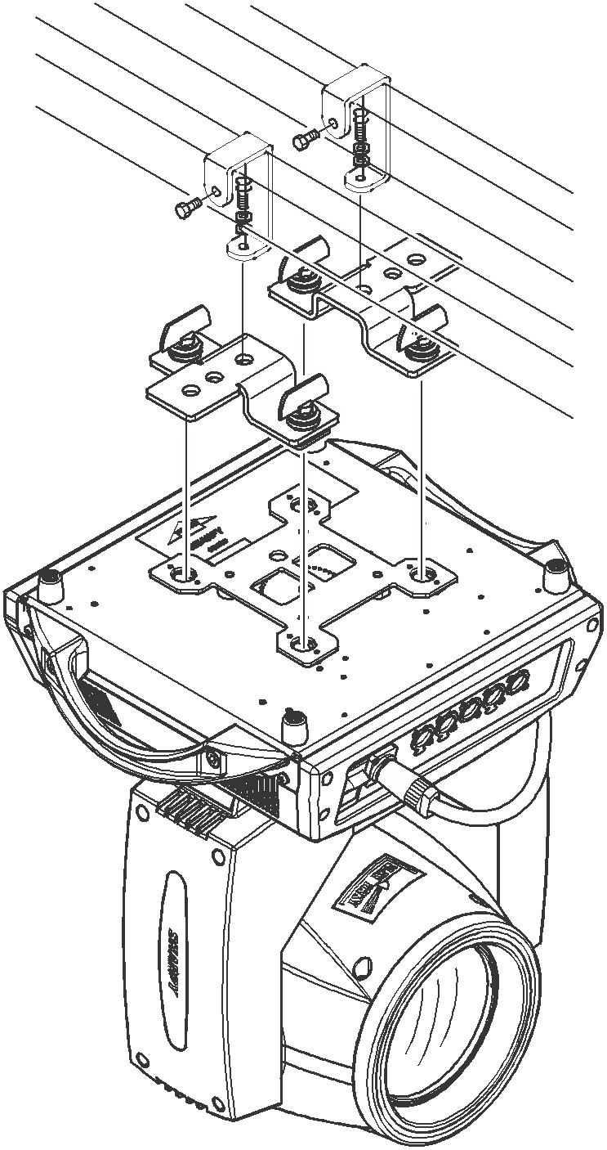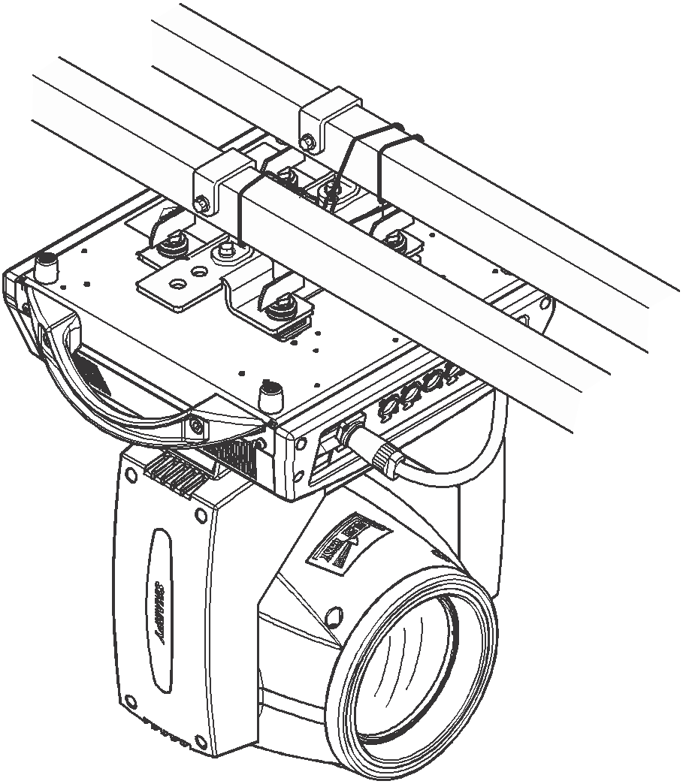
Figure 2 Schematic diagram of the lamp hanging upside down

Control panel

2.1 Key Instructions
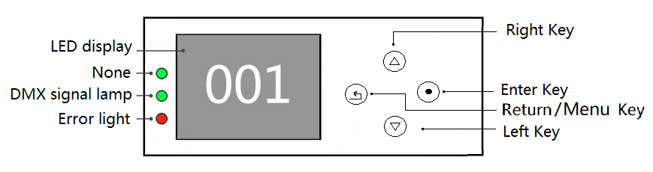

Figure 3 Schematic diagram of key description on the panel
The following takes "Modify DMX address code" as an example to describe the use of keys:
1, if the current is not the main interface, press the "left" key (one or more times) to return to the main interface
2, in the home screen, press the "up" key or "down" key to select the "Settings" button
3. Press the "OK" key to enter the "Settings" interface
4, in the "Settings" interface, press the "up" key or "down" key to select "DMX address"
5, press the "OK" key to enter the editing state
6, press the "up" key or "down" key to modify the DMX address code
7, press the "OK" key to exit the editing state

2 Menu Description
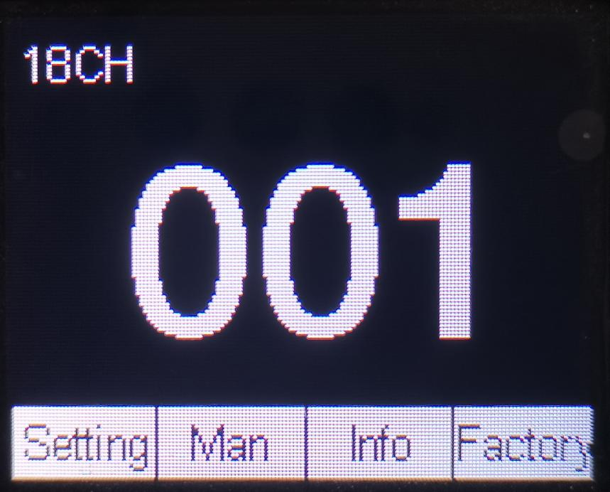

Figure 4 Schematic diagram of main menu
2.2.1 Settings
Options | Instructions
Run | DMX | Slave state: Receives DMX signals from the console or host
Run | Bootstrap | Host status: Self-drive and send DMX signal to slave
Run | Voice Control | Host status: Self-drive and send DMX signal to slave
Scene setting
DMX address | 1-512 | Press "OK" to enter the editing state. At this time, the hundreds digit is selected, and press the "up" and "down" keys to change the address code. Press the "OK" key again to select the tens edit. Press "OK" again to select the ones edit. Press again to exit the editing state
Bulb | Off | Off Bubble
Bulb | On | Bright Bubble
Motor reset | Off
Motor reset | On | Light fixture reset
Channel | Standard 16CH | Standard 16 channel mode
Channel | Extended 24CH | Expand 24 channel mode
Language | English | Set to English interface
Language | Chinese | Set to the Chinese interface
Screen flip | Off | Front display
Screen flip | On | Screen inverted display
X Inversion | Off
X Inversion | On | X Motor direction rotation 540 degrees
Y reversal | Off
Y reversal | On | Y Turn the motor 270 degrees in the direction
XY switching | Off
XY switching | On | Channel for switching XY axes (including fine tuning)
XY encoder | On | Use an encoder (optocoupler) to judge out of step and automatically correct the position
XY encoder | Off | Correct position without using an encoder (optocoupler)
DMX signal | Hold | Continue running in its original state
DMX signal | Reset | Turn the motor back and stop running
Turn on bright bubble | Off
Turn on bright bubble | On | Bright bubble after turning on
Linear color | On | The color wheel changes linearly
Linear color | Off | Color wheel nonlinear change, half-color change
Clear scene data |  | Press the "OK" key to clear scene data
Restore default | On
Restore default | Off | Press "OK" to see the confirmation dialog box, press "OK" again to restore the default Settings

- Scene Setup Instructions
Options | Instructions
Scene selection | 01-20 | Select Scenario 1- Scenario 20 for programming
Scene time | 0-255. | Set the running time of the current scene, up to 255 seconds
Scene Run | On | The default is on, which will be executed during auto run, and if it is set to interrupt, it will skip the current scene and run the next scene
Scene Run | Off
Step 1: Color | 0-255. | Set console values 0-255
2 Cut light/strobe | 0-255. | Set console values 0-255
3 Dimmer | 0-255. | Set console values 0-255
4 Pattern plates | 0-255. | Set console values 0-255
5... | 0-255. | Set console values 0-255
6... | 0-255. | Set console values 0-255

2.2.2 Manual control
This interface is used to control the current luminaire (does not receive DMX signals), corresponding to the channel. Refer to the channel table for details
Options | Instructions
1CH. | 0 ~ 255 | Press "OK" to enter the editing state. At this time, the hundreds digit is selected, and press the "up" and "down" keys to change the channel value. Press the "OK" key again to select the tens edit. Press "OK" again to select the ones edit. Press again to exit the editing state
... | 0 ~ 255
15CH. | 0 ~ 255
... | 0 ~ 255

2.2.3 Information

Options | Instructions
Ver |  | Show software version
DIS |  | Display board software version
MT |  | Motor board software version
Time information | Time information Steps 1 Total brightening bubbles  2. Total use | Record the cumulative bright-bubble time  Record the lighting time
System error |  | If the red ERR indicator is bright, it indicates that the lamp is running incorrectly. You can go to the subinterface to view the details. After viewing, you can press the "Clear" button to clear the error record
Blower speed |  | Displays the current blower speed
Hall Status | 0000 | 0 when magnetic is detected, 1 otherwise
The X-axis encodes the disk step value | 0000 | The number of steps should increase for forward travel and decrease for reverse travel. The number should be normal every time you reach the same point
The Y-axis encodes the disk step value | 0000 | The number of steps should increase for forward travel and decrease for reverse travel. The number should be normal every time you reach the same point
Permission Duration |  | 9999 No encryption; Other values can be used with encryption

A. Error message description

Common Error Messages | Instructions
MT board connection failed | Motor board not responding. There is a problem with the serial communication line connecting the display board to the motor board, or there is a problem with the motor board.
X-axis reset failed | There is a problem with the X-axis photoelectric switch, or the X-axis motor or motor board
Y-axis reset failed | Y-axis photoelectric switch, or Y-axis motor or motor board problem
X-axis Hall error | X-axis Hall, or a problem with the motor board
Y-axis Hall error | Y-axis Hall, or a problem with the motor board
Color disk reset failed | Color disk Hall, or there is a problem with the color disk motor
The pattern plate failed to reset | Pattern plate Hall, or pattern plate motor has a problem
The focus reset failed | Focusing Hall, or a problem with the focusing motor
Bulb control failure | Failure to light or extinguish bubbles, lamplighter or bulb problem

2.2.4 Factory
Calibrate | Fan adjustment (test) | Fan regulation
Calibrate | Fan adjustment (test) | Blower speed
Calibrate | Fan adjustment (test) | Wind speed low off Bubble on/off
Calibrate | Data download | After changing the display board, download the calibration data of the original display board from the motor board
Calibrate | X | After entering the sub-interface, the reset position of the motor such as X axis and Y axis can be adjusted to make up for the error on the hardware installation. The adjustment range is -128~+127, and +0 indicates no adjustment.
Calibrate | Y
Calibrate | Colors
Calibrate | Gobo
Calibrate | Focus
Calibrate | Dimming
Calibrate | Prism 1 Zero
Calibrate | Prism 1 Stroke
Calibrate | Prism 2 Zero
Calibrate | Prism 2 Stroke
Calibrate | Frost white light
Calibrate | Frost stroke
Calibrate | Colorful mirror stroke
Calibrate | Zeroing | close
Calibrate | Zeroing | On, the data is restored to default values
Calibrate | X Hall | Off, X Hall report wrong off
Calibrate | X Hall | On, X Hall reports the wrong off
Calibrate | Y Hall | Off, Y Hall reports wrong off
Calibrate | Y Hall | On, Y Hall reports an error
Calibrate | Half power | Off, no half power function
Calibrate | Half power | On, with half power function

Channel function

3.1
Channel Table
Channels | 24 channel mode
1 | Color Wheel
2 | Shutter
3 | Dimming
4 | Gobo
5 | Prism 1
6 | Prism 1 Rotation
7 | Prism 2
8 | Prism 2 Rotation
9 | Focus
10 | X
11 | X Fine
12 | Y
13 | Y Fine
14 | XY Speed
15 | Frost /Colorful
16 | Lamp& Reset
17 | LED_Dimming
18 | LED_Shutter
19 | LED_Red
20 | LED_Green
21 | LED_Blue
22 | LED_Color macro
23 | LED_Scene
24 | LED_Scene Speed

Channel parameter values (full version) :
channel 1 | definition | figure | describe
[ CH1 ] | x-axis | 0-255 | 0-540 degrees
[ CH2 ] | X-axis fine-tuning | 0-255 | 0-2degrees
[ CH3 ] | Y-axis | 0-255 | 0-270degrees
[ CH4 ] | Y-axis fine-tuning | 0-255 | 0-1 degrees
[ CH5 ] | XY velocity | 0-255 | From fast to slow
[ CH6 ] | aiming | 0-255 | 0-100%dimming
[ CH7 ] | stroboflash
 |  | 0-3 | Deinking
 |  | 4-103 | Pulse stroboscopic effect from slow to fast
 |  | 104-107 | switch
 |  | 108-207 | Gradual flicker transition from slow to fast
 |  | 208-212 | switch
 |  | 213-251 | Random strobe from slow to fast
 |  | 252-255 | switch
[ CH8 ] | atomization
 |  | 0-127 | not have
 |  | 128-255 | atomization
[ CH9 ] | colour disk
 |  | 0-4 | white light
 |  | 5-9 | White light color 1
 |  | 10-14 | Color 1
 |  | 15-19 | Color 1+Color 2
 |  | 20-24 | Color 2
 |  | 25-29 | Color 2+ Color 3
 |  | 30-34 | Color 3
 |  | 35-39 | Color 3+ Color 4
 |  | 40-44 | Color 4
 |  | 45-49 | Color 4+Color 5
 |  | 50-54 | Color 5
 |  | 55-59 | Color 5+Color 6
 |  | 60-64 | Color 6
 |  | 65-69 | Color 6+Color 7
 |  | 70-74 | Color 7
 |  | 75-79 | Color 7+Color 8
 |  | 80-84 | Color 8
 |  | 85-89 | Color 8+Color 9
 |  | 90-94 | Color 9
 |  | 95-99 | Color 9+Color 10
 |  | 100-104 | Color 10
 |  | 105-109 | Color 10+Color 11
 |  | 110-114 | Color 11
 |  | 115-119 | Color 11+Color 12
 |  | 120-124 | Color 12
 |  | 125-129 | Color 12+Color 13
 |  | 130-134 | Color 13
 |  | 135-139 | Color 13+Color 14
 |  | 140-197 | From fast to slow, in a continuous flow
 |  | 198-255 | Reverse flow from slow to fast
[ CH10 ] | Map Plate
 |  | 0-4 | white light
 |  | 5-9 | Pattern 1
 |  | 10-14 | Pattern 2
 |  | 15-19 | Pattern 3
 |  | 20-24 | Pattern 4
 |  | 25-29 | Pattern 5
 |  | 30-34 | Pattern 6
 |  | 35-39 | Pattern 7
 |  | 40-44 | Pattern 8
 |  | 45-49 | Pattern 9
 |  | 50-54 | Pattern 10
 |  | 55-59 | Pattern 11
 |  | 60-64 | Pattern 12
 |  | 65-69 | Pattern 13
 |  | 70-125 | Reverse flow from fast to slow
 |  | 126-130 | cease
 |  | 131-190 | From slow to fast, like a flowing stream
 |  | 191-195 | Jitter pattern from slow to fast 1
 |  | 196-200 | Jitter pattern from slow to fast 2
 |  | 201-205 | Jitter pattern from slow to fast 3
 |  | 206-210 | Jitter pattern from slow to fast 4
 |  | 211-215 | Jitter pattern from slow to fast 5
 |  | 216-220 | Jitter pattern from slow to fast 6
 |  | 221-225 | Jitter pattern from slow to fast 7
 |  | 226-230 | Jitter pattern from slow to fast 8
 |  | 231-235 | Jitter pattern from slow to fast 9
 |  | 236-240 | Jitter pattern from slow to fast 10
 |  | 241-245 | Jitter pattern from slow to fast 11
 |  | 246-250 | Jitter pattern from slow to fast 12
 |  | 251-255 | Jitter pattern from slow to fast 13
[ CH11 ] | Rainbow Mirror
 |  | 0-127 | not have
 |  | 128-255 | colorful
[ CH12 ] | Prism 1
 |  | 0-63 | not have
 |  | 64-127 | Insert Prism 1-1
 |  | 128-191 | Insert Prism 1-2
 |  | 192-255 | Insert Prism 1-3
[ CH13 ] | Prism Rotation
 |  | 0-127 | 0-360 degrees
 |  | 128-187 | From fast to slow, in a continuous flow
 |  | 188-195 | cease
 |  | 196-255 | Reverse flow from slow to fast
[ CH14 ] | Prism 2
 |  | 0-63 | not have
 |  | 64-127 | Insert Prism 2-1
 |  | 128-191 | Insert Prism 2-2
 |  | 192-255 | Insert Prism 2-3
[ CH15 ] | Prism 2 Rotation
 |  | 0-127 | 0-360 degrees
 |  | 128-187 | From fast to slow, in a continuous flow
 |  | 188-195 | cease
 |  | 196-255 | Reverse flow from slow to fast
[ CH16 ] | focus | 0-255 | From far to near
[ CH17 ] | lamp bulb
 |  | 0-99 | No feature available
 |  | 100-105 | Turn off the light bulb in 6 seconds
 |  | 106-199 | No feature available
 |  | 200-205 | Turn on the light bulb in 6 seconds
 |  | 206-255 | No feature available
[ CH18 ] | Reduction/Function
 |  | 0-209 | No feature available
 |  | 210-215 | Reset the XY motor in 6 seconds
 |  | 216-219 | No feature available
 |  | 220-235 | 6-second reset effect motor
 |  | 236-239 | No feature available
 |  | 240-255 | Reset the entire light in 6 seconds
[ CH19 ] | Effect Dimming | 0-255
[ CH20 ] | Stroboscopic Flash
 |  | 0-3 | opening the light
 |  | 4-255 | Shake from slow to fast
[ CH21 ] | effect
 |  | 0-14 | not have
 |  | 15-255 | Apply a different effect for every five values
[ CH22 ] | Effect Speed
 |  | 0-127 | From fast to slow, in a continuous flow
 |  | 128-255 | Reverse flow from slow to fast

Common fault
According to some common faults, the corresponding solutions are put forward. Any problems that cannot be solved should be dealt with by professionals. Disconnect the light fixture from the power supply before maintaining it.

The light bulb is not working
- Check that the voltage that matches the light fixture is installed;
- Check whether the lamp power supply connection or control switch is in poor contact;
- Check whether the power supply is insufficient;
- Check that the DMX512 controller is sending instructions.

The light fixture does not accept control from the console after normal reset
- Check luminaire digital start address value and function options are correct;
- Check whether the connection of the communication control line is correct, the communication line is too long or has been interrupted;
- Check whether the control equipment is invalid, check whether the signal amplifier connected to the series is invalid;
- Check whether the communication line is too long or other devices interfere with each other;
- Optimize wiring, shorten the length of the control signal line, high-voltage and low-voltage lines separate wiring;
- Add signal amplifiers;
- Signal line using high quality shielded twisted pair wire;
- Connect the signal terminal resistor (120 ohms) at the end of the lamp.

Luminaire does not start
- Check that the power supply parameters are consistent with the luminaire;
- Check the lamps in the long distance transportation process due to extrusion deformation, internal parts vibration, moisture and other reasons, resulting in poor contact
Or fall off.
- Please check whether the internal wire integration connector of the lamp has fallen off and is loose.
- Check whether the electronic components of the lamp (such as electronic transformer, PCB board, motor control board, etc.) are loose, short circuit and burned out.

When working, the action of the X axis or Y axis of the luminaire is abnormal
- Check them one by one by following the previous step;
- Check whether the transmission belt corresponding to the X and Y axis direction in the lamp falls off and breaks;
- Check whether the data feedback receiver (optocoupler) corresponding to the X and Y directions in the lamp is damaged;
- Restart and reset once.

