500W LED Cutting Light
Instruction manual

Please read the instructions carefully before use.

Catalogue
1. Precautions and installation1
1.1Statement1
1.2 Maintenance 1
1.3 Precautions 1
1.4 Product Introduction 1
1.5 Connecting Signal Cables 2
1.6 Installing the Lamp 2
2. Control Panel 4
2.1 Key Description 4
2.2 Main Menu 5
2.2.1 Settings 5
2.2.2 Manual 5
2.2.3 Information6
2.2.4 Factory 7
3. Channel Function 8
3.1 Channel Table 8
4. Common faults 12

Precautions and Installation Precautions and Installation
  - statement
Thank you for choosing our products! This product has good performance and complete packaging when it leaves the factory. For your safe and effective use of this product, please read this instruction manual carefully and completely before you use this product. This manual contains important information about installation and use. Please install and operate according to the requirements of the manual. At the same time, please keep this manual properly for use at any time. Our company is not responsible for any damage to lamps or other performance due to personal failure to follow the instructions during installation, use and maintenance.
This manual is subject to technical changes without prior notice.

  - maintaining
- Please disconnect the power supply before carrying out maintenance.
- This lamp should be kept dry to avoid working in wet environment.
- Intermittent use will effectively prolong the life of this lamp.
- In order to obtain good ventilation effect and lighting effect, attention should be paid to cleaning fans, fan nets and lenses frequently.
- Please don't use alcohol and other organic solvents to wipe the lamp shell to avoid damage.

  - Precautions for products
- This lamp is for professional use only.
- Before operation, ensure that the power supply voltage is consistent with the power supply voltage required by the equipment.
- Do not place this product in a place that is easy to loosen or vibrate.
- During use, if the lamps are abnormal, stop using them in time.
- In order to ensure the service life of the product, this product should not be placed in a damp or leaking place, and it should not work in an environment where the temperature exceeds 60 degrees.
- When the light bulb is used, the change of power supply voltage should not exceed 10%. If the voltage is too high, the life of the light bulb will be shortened, and if the voltage is too low, the light color of the light bulb will be affected.
- After the power is cut off, it takes 20 minutes to fully cool the lamps before they can be powered on again.
- The rotating parts and pasted fittings of lamps and lanterns must be inspected regularly, and they should be reinforced in time to prevent accidents.
- To ensure the normal use of this product, please read this instruction carefully.

  - Product introduction
- Light source power: 500 w;
- Voltage: AC 200V~240V/50~60Hz;
- Color wheel: each color wheel consists of a color plate and white light;
- Pattern disk: a pattern effect;
- 540 translation, 270 tilt.
- Overheating protection;
- Control mode: DMX512/ master-slave/automatic;
- IP20 protection level

  - Signal wire connection
Lamps and lanterns are equipped with standard DMX input and output 3-core or 5-core XLR sockets. Please use twisted-pair signal wire specially shielded for DMX 512; Generally, the connection distance of signal lines is 150 meters. When transmitting long-distance signals, DMX512 signal amplifier must be added.
Use a shielded twisted-pair signal line to connect from the DMX output port of the controller to the DMX input port of the first device, and from the DMX output port of the first device to the DMX input port of the second device, and so on until all the lamps are connected, and then install a terminal plug on the last 3-core jack connected to the lamp output of each connection. (Weld a 4/1W, 120Ω resistor between pins 2 and 3 of the 3-core Canon plug with needle).

Important: The wires must not touch each other or the metal shell.

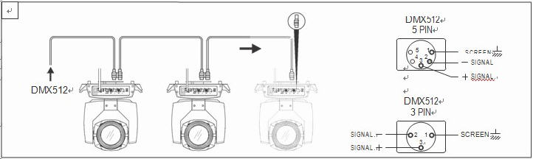
Fig. 1 schematic diagram of DMX signal line connection
- Calculation method of initial address code of lamps and lanterns:
The starting address code of the current lamp is equal to (the starting address code of the previous lamp)+(the number of channels of the lamp).
1: The initial address code value A001 of the first lamp.
2. The number of basic channels of the controller should be greater than or equal to the total number of channels used by lamps.
3. Note: When using any controller, each lamp must have its own starting address code. If the starting address code of the first lamp is set to A001, the number of lamps is 16CH; Then the starting address code of the second lamp is set to A017; The starting address code of the third lamp is set to A033; And so on, (this setting mode also needs to be determined according to different consoles)

  - Lighting installation
Lamps and lanterns can be placed horizontally, hung obliquely and upside down. Pay attention to the installation method when hanging obliquely and upside down.
such asfigure 1As shown in the figure, before positioning the lamps, it is necessary to ensure the stability of the installation site. During the reverse hanging installation, it is necessary to ensure that the lamps do not fall off the support frame, and it is necessary to use a safety rope to pass through the support frame and the lamp handle for auxiliary hanging to ensure safety and prevent the lamps from falling and sliding.
When installing and debugging lamps, pedestrians are forbidden to pass below, and regularly check whether the safety rope is worn and the hook screw is loose.
If the hanging installation is unstable and the lamps fall, our company will not bear any responsibility.
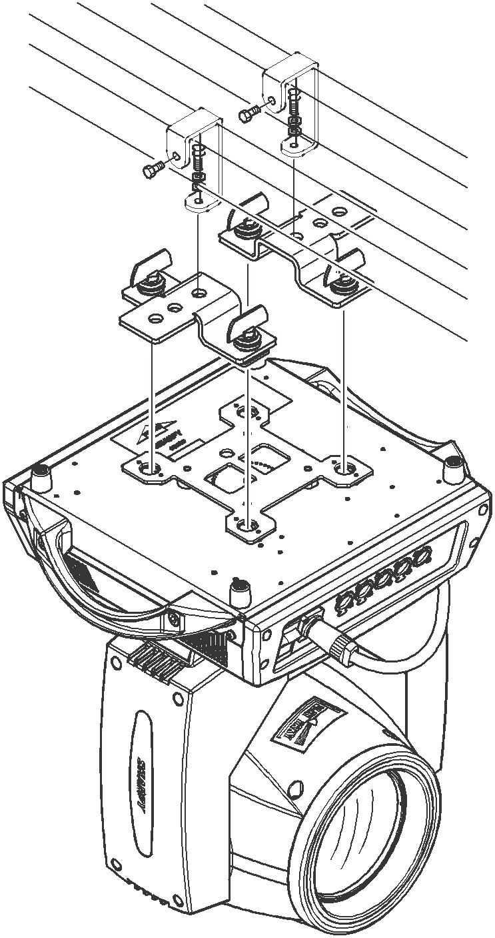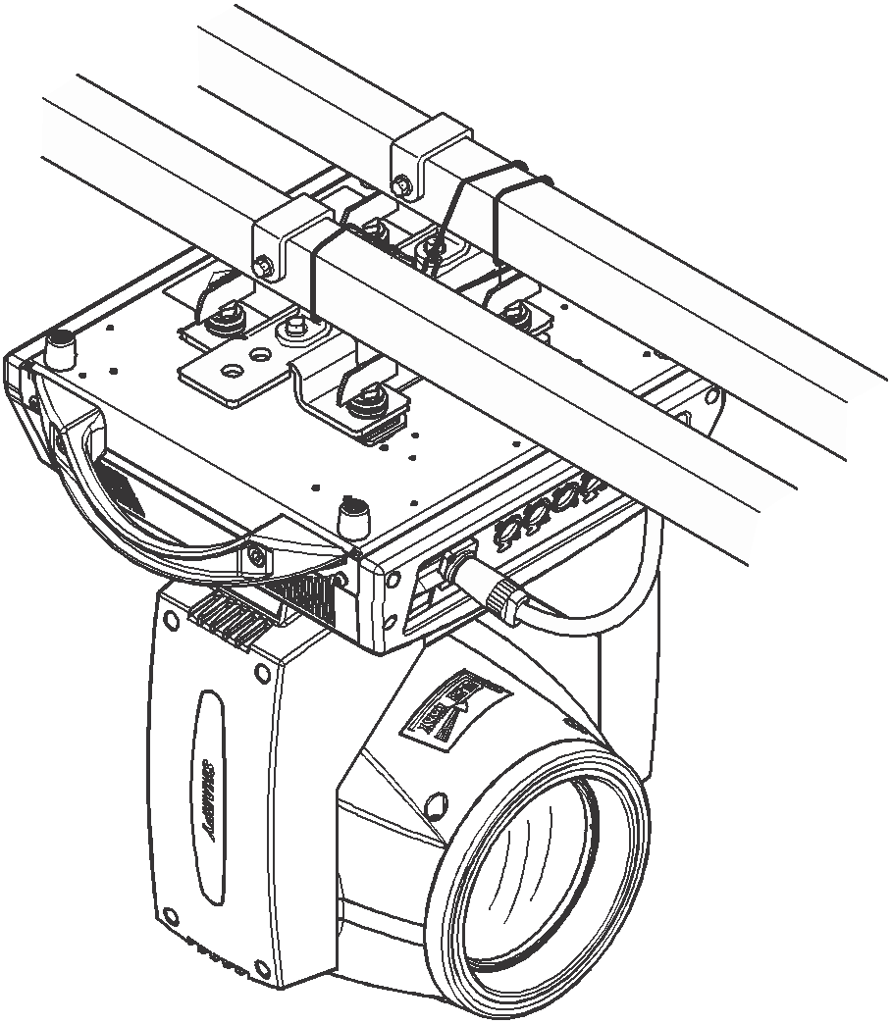
pictureoneSchematic diagram of upside-down lamps

control panel

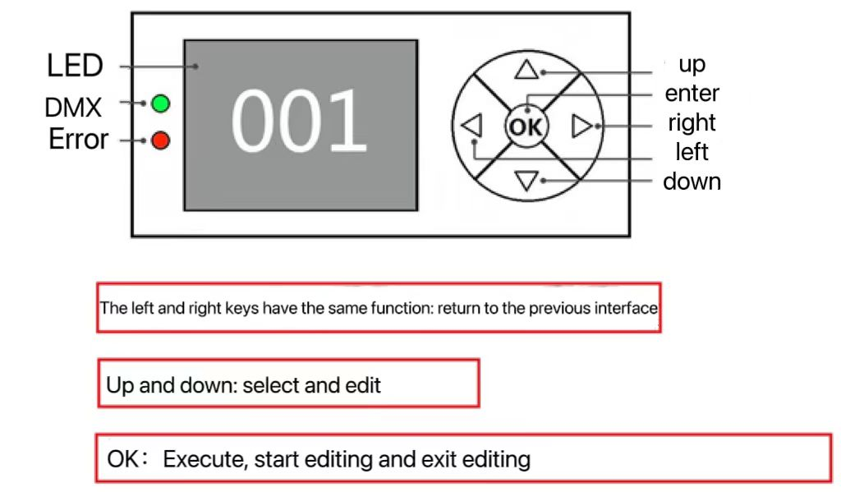
2.1 key description

Fig. 3 schematic diagram of panel key explanation
The following describes the use of keys:
1. If it is not the main interface at present, press the "Left" key (one or more times) to return to the main interface.
2. In the main interface, press the "Up" key or the "Down" key to select the "Settings" button.
3. Press the "OK" key to enter the "Settings" interface.
4. In the "Settings" interface, press the "Up" key or "Down" key to select "Menu".
5. Press the "OK" key to enter the editing state.
6. Press "Up" key or "Down" key to modify the menu.
7. Press "OK" to exit the editing status.

2.2 menu description
2.1.1 Main interface
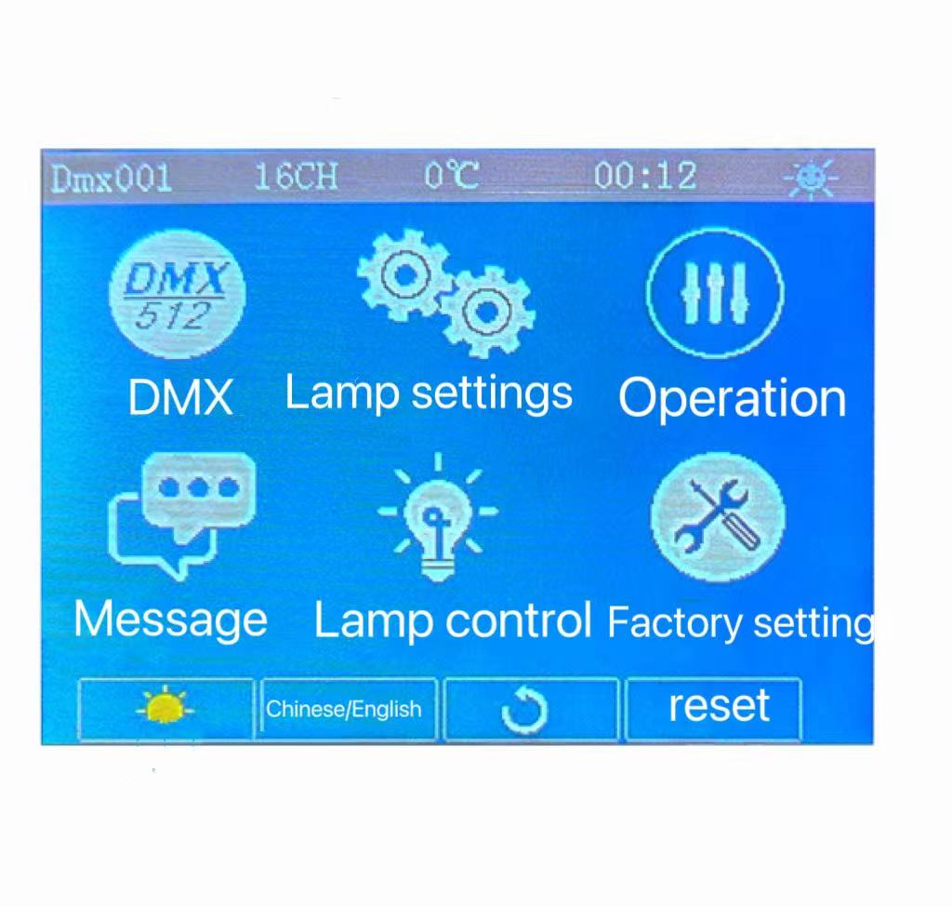
Schematic diagram of main menu

2.2.2 Setting of lamps and lanterns
option | explain
DMX channel | 23CH  27CH | Channel mode switching
RMD function | Off/on | Turn off/on RDM function
language | Chinese | Set to Chinese interface
language | English | Set to English interface
Screen flip | close | Front display
Screen flip | open | Screen inversion display
DMX signal | keep | Continue to run as it is.
DMX signal | clear | The motor returns to its original position and stops running.
screen saver | On/off | After opening, do not operate the interface for 30 seconds and then turn off the screen.
X inversion | On/off | X axis 0-255 inversion
Y inversion | On/off | Y axis 0-255 inversion
XY exchange | On/off | Swap channels of XY axis (including fine adjustment)
XY encoder | open | Use encoder (optical coupler) to judge out-of-step and automatically correct position.
Color linearity | open | Linear change of color wheel
Color linearity | close | Non-linear change of color wheel
Restore default |  | Press the "OK" key and you will see the confirmation dialog box. Press the "OK" key again to restore the default settings.
2.2.3 Operation mode
Description: DMX mode, self-propelled mode and voice control mode can be selected.
option | explain
Self-propelled mode | DMX | Slave status: receiving DMX signals from the master station or the host.
Self-propelled mode | sound-controlled | Master status: self-propelled and sends DMX signal to slave.
Self-propelled mode | Go by yourself | Master status: self-propelled and sends DMX signal to slave.
Manual control |  | Enter the manual control interface
Lamp reset |  | After confirmation, all motors begin to reset.
XY reset |  | After confirmation, the XY motor starts to reset.
MT reset |  | After confirmation, the small motor starts to reset.

2.2.2 Manual control
This interface is used to control the current lamps (not receiving DMX signals) and corresponding channels. Refer to the channel table for details.
option | explain
1CH. | 0~255 | Press "OK" key to enter the editing state. At this time, select 100 digits, and press the "Up" and "Down" keys to change the channel value. Press OK again to select ten editors. Press the "OK" key again to select one bit for editing. Press again to exit the editing state.
…… | 0~255
15CH. | 0~255
…… | 0~255

2.2.4 system information
option | explain
System version |  | Display board and software version of each board
Temperature information |  | Display bulb temperature
System time | Total bright bubble | Cumulative light bubble time (accurate to minutes)
System time | This bright bubble | Time of this light bubble (accurate to the minute)
System time | Total usage | Cumulative usage time (accurate to the minute)
System time | This use | Usage time since this boot (accurate to minutes)
System time | Permission duration | 9999 stands for no encryption and can be used for a long time;  Other values indicate the remaining use time, with encryption;
Sensor monitoring | X hall  Y hall  Color 1 Hall  Color 2 Hall  Amplified hall  Focusing hall  X-coded state  Y-coded state | Optocoupler Hall state view;  0 when magnetism is detected, otherwise 1;
Sensor monitoring | X-coded step value  Y-coded step value | XY coded step value: when walking in the positive direction, the step value should increase, and when walking in the reverse direction, the step value should decrease. Every time you go to the same point, the value is normal;
SYSTEMERROR |  | View error records; After viewing, you can press the "Clear" key to clear the error record.
DMX monitoring |  | Corresponding channel, real-time view DMX value.

A. error message description

Common error message | explain
MT board connection failed. | The motor board is not responding. There is something wrong with the serial communication line connecting the display board and the motor board, or there is something wrong with the motor board.
X-axis reset failed | X-axis photoelectric switch, or X-axis motor or motor board has a problem.
Y-axis reset failed | Y-axis photoelectric switch, or Y-axis motor or motor board has a problem.
X axis Hall error | X-axis Hall, or there is something wrong with the motor board
Y axis Hall error | Y axis Hall, or there is something wrong with the motor board.
Color wheel reset failed. | There is something wrong with the color wheel Hall or the color wheel motor.
Pattern disk reset failed. | There is something wrong with the pattern disc Hall or the pattern disc motor.
Focus reset failed. | There is something wrong with focusing Hall or focusing motor.
Bulb control failure | Blister lighting or bubble extinguishing failed, and there was something wrong with the lamp or bulb.

2.2.5 bulb control
option | explain
Dimming curve | SCurve (sine) | The dimming curve is straight by default, refer to the dimming curve.
Dimming curve | InSquare (logarithm)
Dimming curve | Square (index)
Dimming curve | Linear (linear)

Dimming curve:

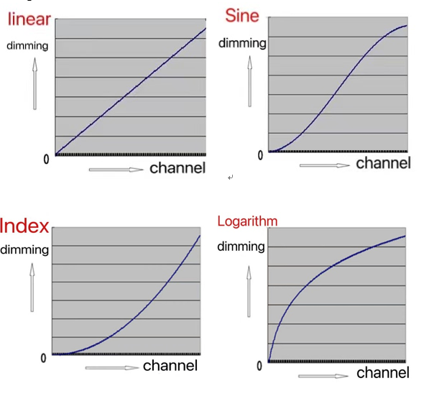

2.2.6 Factory Settings
Motor calibration | X axis | After entering the sub-interface, the reset positions of motors such as X axis and Y axis can be adjusted to make up for the errors in hardware installation. The adjustment range is -128~+127, and +0 means no adjustment.
Motor calibration | Y axis
Motor calibration | Color 1
Motor calibration | Color 2
Motor calibration | Gif
Motor calibration | Moving picture rotation
Motor calibration | focus
Motor calibration | amplify
Motor calibration | Cutting 1
Motor calibration | Cutting 2
Motor calibration | Cutting 3
Motor calibration | Cutting 4
Motor calibration | Cutting 5
Motor calibration | Cutting 6
Motor calibration | Cutting 7
Motor calibration | Cutting 8
Fan regulation | Fan regulation | Adjust the voltage or speed of the blower, and do not save it when the power is off, for temperature measurement.  Current blower speed
Fan regulation | Blower speed
XY speed adjustment | X axis velocity | 0~255 from slow to fast
XY speed adjustment | Y axis velocity | 0~255 from slow to fast
X hall | On/off
Y hall | On/off
LED power

·

Channel function

3.1 channel table
passage | 23-channel mode | 27 channel
one | X | X
2 | X fine tuning | X fine tuning
three | Y | Y
four | Y fine tuning | Y fine tuning
five | XY speed | XY speed
six | Cut light/strobe | Cut light/strobe
seven | aiming | aiming
eight | Color wheel 1 | Dimming and fine tuning
nine | Color wheel 2 | Color wheel 1
10 | CTO | Color wheel 2
11 | Pattern disk | CTO
12 | Pattern disk rotation | Pattern disk
13 | amplify | Pattern disk rotation
14 | focus | Pattern disk rotation fine adjustment
15 | Cutting 1 | amplify
16 | Cutting 2 | Amplification and fine tuning
17 | Cutting 3 | focus
18 | Cutting 4 | Focusing fine adjustment
19 | Cutting 5 | Cutting 1
20 | Cutting 6 | Cutting 2
21 | Cutting 7 | Cutting 3
22 | Cutting 8 | Cutting 4
23 | reset | Cutting 5
24 |  | Cutting 6
25 |  | Cutting 7
26 |  | Cutting 8
27 |  | reset

passage | passage | function | Channel value | effect
one | one | X | 000-255 | Horizontal 540-degree scanning
2 | 2 | X fine tuning | 000-255 | Horizontal 1.2-degree fine adjustment
three | three | Y | 000-255 | Vertical 270-degree scanning
four | four | Y fine tuning | 000-255 | Vertical 1.2-degree fine adjustment
five | five | XY speed | 000-255 | Speed from fast to slow
six | six | Cut light/strobe | 000-003  004-103  104-107  108-207  208-212  213-251  252-255 | Shutter closed  Strobe from slow to fast  Shutter open → (controlled by dimming channel)  Pulse stroboscopic from slow to fast  Shutter open → (controlled by dimming channel)  Random strobe from slow to fast  Shutter open → (controlled by dimming channel)
seven | seven | aiming | 000-255 | From dark to bright
 | eight | Dimming and fine tuning | 000-255 | Dimming and fine tuning
eight | nine | Color wheel 1 | 000-127  128-191  192-255 | linear  Forward flow (from fast to slow)  Reverse flow (from slow to fast)
nine | 10 | Color wheel 2 | 000-255 | linear
10 | 11 | CTO | 000-255 | linear
11 | 12 | Pattern disk | 000-009  010-019  020-029  030-039  040-049  050-059  060-069  070-079  080-089  090-099  100-109  110-119  120-129  130-139  140-149  150-200  201-255 | Pattern 1  Pattern 2  Pattern 3  Pattern 4  Pattern 5  Pattern 6  Pattern 7  Pattern 8  Pattern 2 jitter (from slow to fast)  Pattern 3 jitter (from slow to fast)  Pattern 4 jitter (from slow to fast)  Pattern 5 jitter (from slow to fast)  Pattern 6 jitter (from slow to fast)  Pattern 7 jitter (from slow to fast)  Pattern 8 jitter (from slow to fast)  Forward flow (from fast to slow)  Reverse flow (from slow to fast)
12 | 13 | Pattern disk rotation | 000-127  128-190  191-192  193-255 | Angle adjustment  Forward fast rotation to slow rotation  stop  Reverse slow rotation to fast rotation
 | 14 | Pattern disk rotation fine adjustment | 000-255 | Pattern disk rotation fine adjustment
13 | 15 | amplify | 000-255 | Patterns from small to large
 | 16 | Amplification and fine tuning | 000-255 | Amplification and fine tuning
14 | 17 | focus | 000-255 | Pattern clarity from far to near
 | 18 | Focusing fine adjustment | 000-255 | Focusing fine adjustment
15 | 19 | Cutting 1 | 000-255
16 | 20 | Cutting 2 | 000-255
17 | 21 | Cutting 3 | 000-255
18 | 22 | Cutting 4 | 000-255
19 | 23 | Cutting 5 | 000-255
20 | 24 | Cutting 6 | 000-255
21 | 25 | Cutting 7 | 000-255
22 | 26 | Cutting 8 | 000-255
23 | 27 | reset | 000-025  026-050  061-085  251-255 | Invalid area  Small motor reset  XY reset  Complete machine reset
Common faults
Aiming at some common faults, the corresponding solutions are put forward. Any problem that cannot be solved should be handled by professionals. Please disconnect the power supply before maintaining the lamps.

The light bulb doesn't work
- Check whether the voltage matched with the lamp is installed;
- Check whether the power supply connection or control switch of lamps and lanterns is in poor contact;
- Check whether the power supply is insufficient;
- Check whether the DMX512 controller has sent instructions.

Lamps and lanterns do not accept the control of the console after normal reset.
- Check whether the digital starting address value and function options of lamps and lanterns are correct;
- Check whether the connection of the communication control line is correct, the communication line is too long or has been interrupted;
- Check whether the control equipment fails, and check whether the signal amplifier connected in series fails;
- Check whether the communication line is too long or other equipment interferes with each other;
- Optimize wiring, shorten the length of control signal line, and separate wiring for high voltage and low voltage lines;
- Add a signal amplifier;
- The signal line adopts high-quality shielded twisted pair;
- Connect the signal termination resistor (120 ohms) at the end of the lamp.

Lamps can't start.
- Check whether the parameters of power supply are consistent with the lamps;
- Check the lamps for poor contact due to extrusion deformation, vibration and humidity of internal parts during long-distance transportation.
Or fall off.
- Please check whether the wiring connector inside the lamp falls off or is loose.
- Check whether the electronic components of lamps (such as electronic transformer, PCB board, motor control board, etc.) are loose, short-circuited and burned out.

When working, the X-axis or Y-axis of the lamp is not normal.
- Check one by one according to the previous step;
- Check whether the drive belt corresponding to the X and Y axis directions in the lamp falls off and breaks;
- Check whether the data feedback receiver (optical coupler) corresponding to the X and Y directions in the lamp is damaged;
- Reboot and reset once.

