350W Beam lamp shaking head lamp

Make use of the saying book

Read the instructions carefully before use

Catalogue
1. Precautions and installation 1
1.1 Statement 1
1.2 Maintenance 1
1.3 Product Precautions 1
1.4 Product Introduction 1
1.5 Signal Cable connection 2
1.6 Lamp Installation 2
2 Control Panel 4
2.1 Keystroke Instructions 4
2.2 Main Menu 5
2.2.1 Settings 5
2.2.2 Manual 5
2.2.3 Information 6
2.2.4 Factory 7
3 Channel functions 8
3.1 Channel table 8
4 Common faults 11

Precautions and installation Precautions and installation
  - Statement
Thank you for choosing our products!734 This product is in good condition and the package is complete when it leaves the factory.For your safe and effective use of this product, please read this instruction carefully and completely before you use this product.This instruction manual contains important information for installation and use. Please install and operate in accordance with the instructions. At the same time, please keep this instruction manual properly for use at any time.Our company does not assume all responsibility for damage to luminaires or other performance due to individuals not following the instructions during installation, use or maintenance.
This manual is subject to technical changes without prior notice.

  - Maintenance
- Disconnect the power supply before performing maintenance.
- The lamp should be kept dry and avoid working in wet environment.
- Intermittent use will effectively extend the life of the luminaire.
- For good ventilation and lighting, take care to clean the fan and fan net as well as the lens frequently.
- Do not rub the light fixture housing with organic solvents such as alcohol to avoid damage.

  - Product Precautions
- This light fixture is for professional use only.
- Ensure that the power supply voltage is consistent with the equipment requirements before running.
- Do not place this product in a place that is easy to loosen or shake.
- In the process of use, if the lamp appears abnormal, it should stop using the lamp in time.
- In order to ensure the service life of the product, the product should not be placed in damp or leaking places, but also should not work in the environment where the temperature exceeds 60 degrees.
- When the bulb is used, the voltage change of the power supply should not exceed ±10%. If the voltage is too high, the life of the bulb will be shortened. If the voltage is too low, the light color of the bulb will be affected.
- After the power off, it takes 20 minutes to use the lamp to cool down fully before it can be used again.
- The rotating parts of the lamps and pasting accessories must be checked regularly. If they are loose and shake, they should be reinforced in time to prevent accidents.
- In order to ensure the normal use of this product, please read the instructions carefully.

  - Product Introduction
- Power of light source: W;
- Voltage: AC 200V~240V/50~60Hz;
- Color disk: Each color disk consists of a color plate + white light;
- Pattern plate: a pattern effect;
- 540° translation, 270° tilt.
- Overheat protection;
- Control mode: DMX512/ master-slave/Automatic;
- IP20 protection level

  - Signal cable connection
Light fixtures feature standard DMX input and output 3-core or 5-core XLR sockets.Use a shielded twisted-pair signal cable designed for DMX 512;The signal line is generally connected at 150 meters, and the DMX512 signal amplifier must be added for long distance signal transmission.
Connect a shielded twisted-pair signal line from the DMX outlet of the controller to the DMX input of the first device, and from the DMX outlet of the first device to the DMX input of the second device, and so on, until all lights have been connected. Then install a terminal plug on the last connected light outlet 3-core jack on each circuit.(Weld a 4/1W, 120Ω resistor between the 2 and 3 pins of the 3-core pin cannon plug).

Important: The wires should not touch each other or the metal housing.

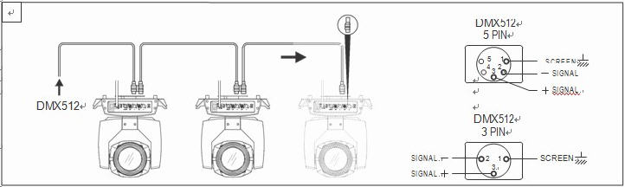
Figure 1 Schematic diagram of DMX signal cable connection
- Calculation method of starting address code of luminaire:
The initial address code of the current luminaire is equal to (the initial address code of the previous luminaire)+(the number of channels of the luminaire)
1: Start address code value A001 of the first luminaire.
2: The basic channel number of the controller, should be greater than or equal to the total number of channels used by the lamp.
3: Note: when using any controller, each lamp should have its own initial address code, if the initial address code of the first lamp is set A001, the number of lamp channel pass is 16CH;Then the start of the second lamp address code is set to A017;The initial address code of the third lamp is set to A033;And so on,(this setting also needs to be determined according to different control platforms)

  - Luminaire installation
Light fixtures can be placed horizontally, slanted, and hung upside down.Be sure to pay attention to the installation method when hanging diagonally and upside down.
As shown in Figure 2, before positioning the lamp, it is necessary to ensure the stability of the installation site. When installing the reverse hanging, it is necessary to ensure that the lamp does not fall down on the support frame. It is necessary to use the safety rope through the support frame and the lamp handle for auxiliary hanging to ensure safety. Prevent the luminaire from falling and sliding.
When installing and debugging the lamps, it is forbidden for pedestrians to pass under them. Regularly check whether the safety rope is worn and whether the hook screws are loose.
Our company does not assume any responsibility for all consequences caused by the fall of the lamp due to the unstable installation of the hanging.
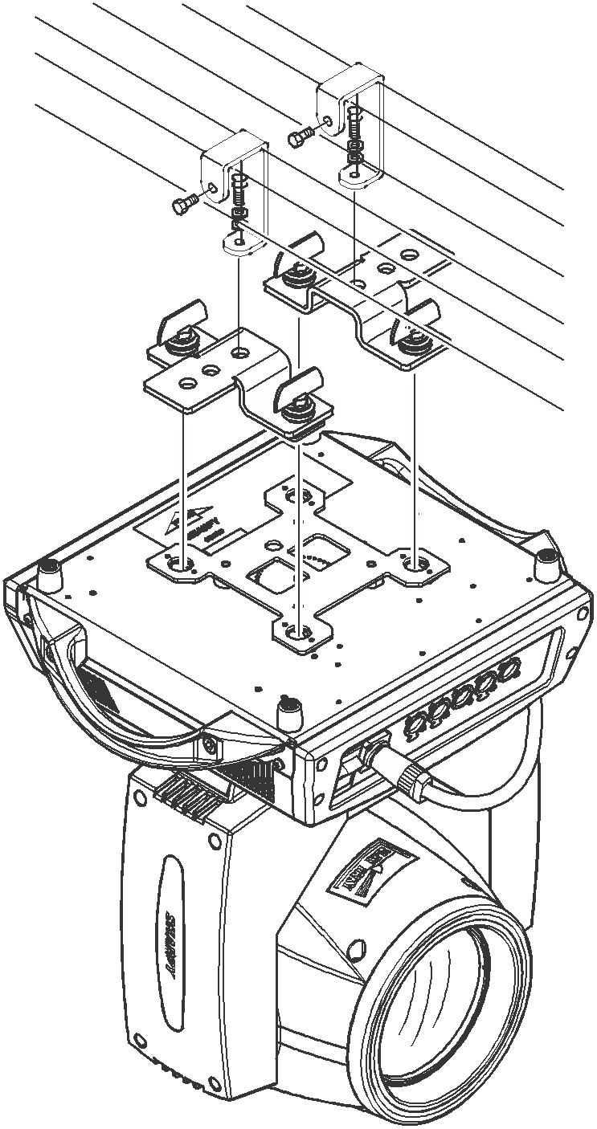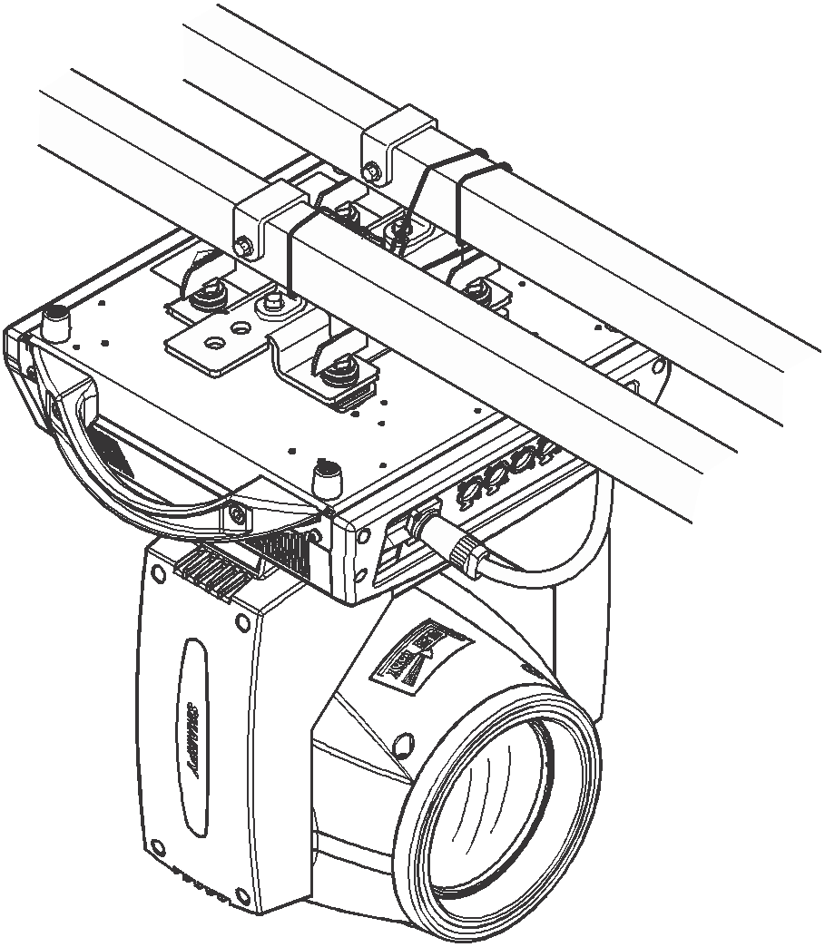
Figure 2. Schematic diagram of the lamp hanging upside down

Control panel

2.1 Key Instructions
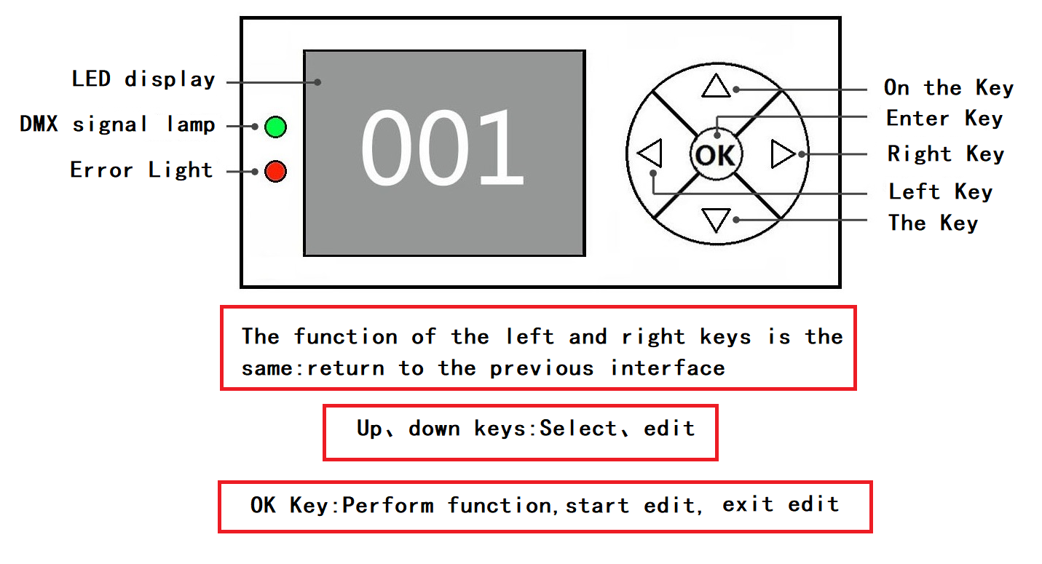

Figure 3 Schematic diagram of key description on the panel
The following takes "Modify DMX address code" as an example to describe the use of keys:
1, if the current is not the main interface, press the "left" key (one or more times) to return to the main interface
2, in the home screen, press the "up" key or "down" key to select the "Settings" button
3. Press the "OK" key to enter the "Settings" interface
4, in the "Settings" interface, press the "up" key or "down" key to select "DMX address"
5, press the "OK" key to enter the editing state
6, press the "up" key or "down" key to modify the DMX address code
7, press the "OK" key to exit the editing state

2.2.1 Settings
Options | Instructions
Running mode | DMX | Slave state: Receives DMX signals from the console or mainframe
Running mode | Bootstrapping | Host state: Self-actuated and sends DMX signal to slave
Running mode | Voice control | Host state: Self-actuated and sends DMX signal to slave
DMX address | 1-512 | Press "OK" to enter editing mode.At this point, the hundreds digit is selected, and press the "up" and "down" keys to change the address code.Press the "OK" key again to select the tens edit.Press "OK" once more to select the ones edit.Press again to exit the editing state
Light Bulb | Off | Closing bubble
Light Bulb | On | Brightening bubble
Turn on brightening Bubble | Off
Turn on brightening Bubble | On | Light bubbles when you power it on
Motor reset | Off
Motor reset | On | Light fixture reset
Channel mode | Standard 19CH  Extended 24CH | Standard 19 channel mode  Extend the 24 channel mode
Language | Chinese | Set to the Chinese interface
Language | English | Set to the English interface
Screen flip | Off | Front display
Screen flip | On | Screen reverse display
X Inversion | Off
X Inversion | On
Y-reverse | Off
Y-reverse | On
XY swap | Off
XY swap | On | Channel for switching XY axes (including trims)
XY encoder | On | Use an encoder (optocoupler) to judge out of step and automatically correct the position
XY encoder | Off | Correct the position without using an encoder (optocoupler)
DMX signal | Hold | Continue running in its original state
DMX signal | Clear zero | Turn the motor back and stop running
Turn on bright bubble | Off | Direct reset after power on, no light bulb (need to manually light bubbles with menu or console)
Turn on bright bubble | On | Automatically light up bubbles after power on, and to wait until the bulb successfully lit up before reset
The color wheel changes linearly | On | The color wheel changes linearly
The color wheel changes linearly | Off | Color wheel nonlinear change, half color change
Restore default Settings |  | When you see the confirmation dialog after pressing "OK", press "OK" again to restore the default Settings

2.2.2 Manual control
This interface is used to control the current light fixture (which does not receive DMX signals), corresponding to the channel.Refer to the channel table for details
Options | Instructions
1CH. | 0 ~ 255 | Press "OK" to enter editing.At this point, the hundreds digit is selected, and press the "up" and "down" keys to change the channel value.Press the "OK" key again to select the tens edit.Press "OK" once more to select the ones edit.Press again to exit the editing state
... | 0 ~ 255
15CH. | 0 ~ 255
... | 0 ~ 255

2.2.3 Information

Options | Instructions
DIS |  | Display board software version
MT |  | Motor board software version
Manual | Manual interface | Corresponding channel manual control
Time information | Steps 1 Total brightening bubbles  2. Use in total | Keep track of cumulative brightening bubble times  Record the lighting time
System error |  | If the red ERR indicator lights up, it indicates that the lamp is running incorrectly. You can enter the sub-interface to check the details.After viewing, you can press the "Clear" button to clear the error record
Blower speed |  | Displays the current blower speed
Hall XY12 | 0000 | 0 when magnetic is detected, 1 otherwise
Hall 3-10 | 11100010 | 0 when magnetic is detected, 1 otherwise
X-axis codes the disk step value | 0000 | The number of steps should increase when walking in the forward direction and decrease when walking in the opposite direction.The number should be normal every time you reach the same point
The Y-axis codes the disk step value | 0000 | The number of steps should increase when walking in the forward direction and decrease when walking in the opposite direction.The number should be normal every time you reach the same point
Permission duration |  | 9999 No encryption;Other values can be used with encryption

A. Error message description

Common error messages | Instructions
MT board connection failed | The motor board is not responding.There is a problem with the serial communication line connecting the display board to the motor board, or there is a problem with the motor board.
X-axis reset failed | There is a problem with the X-axis photoelectric switch, or with the X-axis motor or motor board
Y-axis reset failed | Y-axis photoelectric switch, or Y-axis motor or motor board has a problem
X axis Hall error | X-axis Hall, or there is a problem with the motor board
Y-axis Hall error | Y-axis Hall, or a problem with the motor board
Color plate reset failed | Color disk Hall, or there is a problem with the color disk motor
Pattern disk reset failed | Pattern plate Hall, or pattern plate motor has a problem
The focus reset failed | Focus Hall, or there is a problem with the focusing motor
Bulb control failure | Failure to light or extinguish bubbles, faulty laminator or bulb

2.2.4 Factory
Calibration | X-axis | After entering the sub-interface, you can adjust the reset position of the motor such as X axis and Y axis to make up for the error on the hardware installation. The adjustment range is -128~+127, and +0 indicates no adjustment.
Calibration | Y-axis
Calibration | Color
Calibration | Gobo
Calibration | Gobo 2
Calibration | Gobo 2 Rotation
Calibration | Focus
Calibration | Zoom
Calibration | Dimming
Calibration | Prism 1 zero
Calibration | Prism 1 stroke
Calibration | Prism 2 zeros
Calibration | Prism 2 stroke
Calibration | Frost zero
Calibration | Frost stroke
Calibration | Prism 1 Rotation
Calibration | Prism 2 Rotate
Calibration | Zeroing

Channel function

3.1 Channel table
Channels | Channel pattern
Channels | 19 | 24
1 | X | X
2 | Y | Y
3 | XY speed | X Fine
4 | Dimming | Y Fine
5 | Shutter | XY speed
6 | Color | Lamp & Reset
7 | Gobo | Color
8 | Gobo 2 | Color Fine
9 | Gobo 2 Rotation | Gobo
10 | Prism 1 | Gobo 2
11 | Prism 1 Rotate | Gobo 2 Rotation
12 | Prism 2 | Gobo 2 Rotation Fine
13 | Prism 2 Rotate | Prism 1
14 | Frost | Prism 1 Rotate
15 | Zoom | Prism 2
16 | Focus | Prism 2 Rotate
17 | Lamp & Reset | Frost
18 | X Fine | Zoom
19 | Y Fine | Zoom Fine
20 |  | Focus
21 |  | Focusing Fine
22 |  | Shutter
23 |  | Dimming
24 |  | Dimming Fine

Channel parameter values (full version) :
19 Channel mode:
Channel | Features | Channel value | Effects
1 | X | 000-255. | Horizontal 540 degree scan
2 | Y | 000-255. | Vertical 270 degree scan
3 | XY speed | 000-255. | Speed from fast to slow
4 | Dimming | 000-255. | Dark to light
5 | Shutter | 000-003.  004-250.  251-255. | Light brake closed  Stroboscopic from slow to fast  Light brake on → (controlled by dimmer channel)
6 | Color | 000-004.  005-009  010-014  015-019  020-024  025-029  030-034  035-039  040-044  045-049  050-054  055-059  060-064  065-069  070-074  075-079  080-084  085-089  090-094  095-099  100-104  105-109  110-114  115-119  120-124  125-129  130-134  135-139  140-200  201-255 | White light  White light + Color 1  Color 1  Color 1+ Color 2  Color 2  Color 2+ Color 3  Color 3  Color 3+ Color 4  Color 4  Color 4+ Color 5  Color 5  Color 5+ Color 6  Color 6  Color 6+ Color 7  Color 7  Color 7+ Color 8  Color 8  Color 8+ Color 9  Color 9  Color 9+ Color 10  Color 10  Color 10+ Color 11  Color 11  Color 11+ Color 12  Color 12  Color 12+ Color 13  Color 13  Color 13+ white light  Positive flowing water (from fast to slow)  Reverse flow (slow to fast)
7 | Gobo | 000-004  005-009  010-014  015-019  020-024  025-029  030-034  035-039  040-044  045-049  050-054  055-059  060-064  065-069  070-074  075-079  080-084  085-089  090-094  095-099  100-104  105-109  110-114  115-119  120-124  125-129  130-134  135-139  140-200  201-255 | Gobo 1  Gobo 2  Gobo 3  Gobo 4  Gobo 6  Gobo 7  Gobo 8  Gobo 9  Gobo 10  Gobo 11  Gobo 12  Gobo 13  Gobo 14  Gobo 15  Gobo 1 Shake(from slow to fast)  Gobo 2 Shake(from slow to fast)  Gobo 3 Shake(from slow to fast)  Gobo 4 Shake(from slow to fast)  Gobo 6 Shake(from slow to fast)  Gobo 7 Shake(from slow to fast)  Gobo 8 Shake(from slow to fast)  Gobo 9 Shake(from slow to fast)  Gobo 10 Shake(from slow to fast)  Gobo 11 Shake(from slow to fast)  Gobo 12 Shake(from slow to fast)  Gobo 13 Shake(from slow to fast)  Gobo 14 Shake(from slow to fast)  Gobo 15 Shake(from slow to fast)  Reverse flowing water (from fast to slow)  Forward flow (slow to fast)
8 | Gobo 2 | 000-009  010-019  020-029  030-039  040-049  050-059  060-069  070-079  080-089  090-099  100-104  105-109  110-114  115-119  120-124  125-129  130-134  135-139  140-144  145-200  201-255 | Gobo 1  Gobo 2  Gobo 3  Gobo 4  Gobo 5  Gobo 6  Gobo 7  Gobo 8  Gobo 9  Gobo 10  Gobo 2 Shake (from slow to fast)  Gobo 3 Shake (from slow to fast)  Gobo 4 Shake (from slow to fast)  Gobo 5 Shake (from slow to fast)  Gobo 6 Shake (from slow to fast)  Gobo 7 Shake (from slow to fast)  Gobo 8 Shake (from slow to fast)  Gobo 9 Shake (from slow to fast)  Gobo 10 Shake (from slow to fast)  Reverse flowing water (from fast to slow)  Forward flow (slow to fast)
9 | Gobo2 Rotation | 000-127.  128-191.  192-255. | Angle adjustment  Reverse fast rotation to slow rotation  Forward slow spin to fast spin
10 | Prism 1 | 000-127.  128-255. | None  Prism 1 Cut in
11 | Prism 1 Rotate | 000-127.  128-191.  192-255. | Prism Angle adjustment  Reverse rotation (from fast to slow)  Forward rotation (from slow to fast)
12 | Prism 2 | 000-127.  128-255. | None  Prism 2 Cut in
13 | Prism 2 Rotate | 000-127.  128-191.  192-255. | Prism Angle adjustment  Reverse rotation (from fast to slow)  Forward rotation (from slow to fast)
14 | Frost | 000-127.  128-255. | Frost  Frost Cut in
15 | Zoom | 000-255. | Gobo clarity from far to near
16 | Focus | 000-255. | Gobo clarity from far to near
17 | Lamp & Reset | 000-099.  100-105.  106-199.  200-205.  206-250.  251-255. | None  Lamp Off  None  Lamp On  None  Reset All
18 | X Fine | 000-255. | Horizontal 1.2 degree fine tuning
19 | Y Fine | 000-255. | Vertical 1.2 degree fine tuning

24 channel mode:
Channels | Features | Channel value | Effects
1 | X | 000-255. | Horizontal 540 degree scan
2 | Y | 000-255. | Vertical 270 degree scan
3 | X Fine | 000-255. | Horizontal 1.2 degree fine tuning
4 | Y Fine | 000-255. | Vertical 1.2 degree fine tuning
5 | XY speed | 000-255. | Speed from fast to slow
6 | Lamp & Reset | 000-099.  100-105.  106-199.  200-205.  206-250.  251-255. | None  Lamp Off  None  Lamp On  None  Reset All
7 | Color | 000-004.  005-009  010-014  015-019  020-024  025-029  030-034  035-039  040-044  045-049  050-054  055-059  060-064  065-069  070-074  075-079  080-084  085-089  090-094  095-099  100-104  105-109  110-114  115-119  120-124  125-129  130-134  135-139  140-200  201-255 | White light  White light + Color 1  Color 1  Color 1+ Color 2  Color 2  Color 2+ Color 3  Color 3  Color 3+ Color 4  Color 4  Color 4+ Color 5  Color 5  Color 5+ Color 6  Color 6  Color 6+ Color 7  Color 7  Color 7+ Color 8  Color 8  Color 8+ Color 9  Color 9  Color 9+ Color 10  Color 10  Color 10+ Color 11  Color 11  Color 11+ Color 12  Color 12  Color 12+ Color 13  Color 13  Color 13+ white light  Positive flowing water (from fast to slow)  Reverse flow (slow to fast)
8 | Color Fine | 000-255.
9 | Gobo | 000-004  005-009  010-014  015-019  020-024  025-029  030-034  035-039  040-044  045-049  050-054  055-059  060-064  065-069  070-074  075-079  080-084  085-089  090-094  095-099  100-104  105-109  110-114  115-119  120-124  125-129  130-134  135-139  140-200  201-255 | Gobo 1  Gobo 2  Gobo 3  Gobo 4  Gobo 6  Gobo 7  Gobo 8  Gobo 9  Gobo 10  Gobo 11  Gobo 12  Gobo 13  Gobo 14  Gobo 15  Gobo 1 Shake(from slow to fast)  Gobo 2 Shake(from slow to fast)  Gobo 3 Shake(from slow to fast)  Gobo 4 Shake(from slow to fast)  Gobo 6 Shake(from slow to fast)  Gobo 7 Shake(from slow to fast)  Gobo 8 Shake(from slow to fast)  Gobo 9 Shake(from slow to fast)  Gobo 10 Shake(from slow to fast)  Gobo 11 Shake(from slow to fast)  Gobo 12 Shake(from slow to fast)  Gobo 13 Shake(from slow to fast)  Gobo 14 Shake(from slow to fast)  Gobo 15 Shake(from slow to fast)  Reverse flowing water (from fast to slow)  Forward flow (slow to fast)
10 | Gobo 2 | 000-009  010-019  020-029  030-039  040-049  050-059  060-069  070-079  080-089  090-099  100-104  105-109  110-114  115-119  120-124  125-129  130-134  135-139  140-144  145-200  201-255 | Gobo 1  Gobo 2  Gobo 3  Gobo 4  Gobo 5  Gobo 6  Gobo 7  Gobo 8  Gobo 9  Gobo 10  Gobo 2 Shake (from slow to fast)  Gobo 3 Shake (from slow to fast)  Gobo 4 Shake (from slow to fast)  Gobo 5 Shake (from slow to fast)  Gobo 6 Shake (from slow to fast)  Gobo 7 Shake (from slow to fast)  Gobo 8 Shake (from slow to fast)  Gobo 9 Shake (from slow to fast)  Gobo 10 Shake (from slow to fast)  Reverse flowing water (from fast to slow)  Forward flow (slow to fast)
11 | Gobo2 Rotation | 000-127.  128-191.  192-255. | Angle adjustment  Reverse fast rotation to slow rotation  Forward slow spin to fast spin
12 | Gobo2 Rotation Fine | 000-255.
13 | Prism 1 | 000-127.  128-255. | None  Prism 1 Cut in
14 | Prism 1 Rotate | 000-127.  128-191.  192-255. | Prism Angle adjustment  Reverse rotation (from fast to slow)  Forward rotation (from slow to fast)
15 | Prism 2 | 000-127.  128-255. | None  Prism 2 Cut in
16 | Prism 2 Rotate | 000-127.  128-191.  192-255. | Prism Angle adjustment  Reverse rotation (from fast to slow)  Forward rotation (from slow to fast)
17 | Frost | 000-127.  128-255. | None  Frost Cut in
18 | Zoom | 000-255. | Gobo clarity from far to near
19 | Zoom Fine | 000-255.
20 | Focus | 000-255. | Gobo clarity from far to near
21 | Focus Fine | 000-255.
22 | Shutter | 000-003.  004-250.  251-255. | Light brake closed  Stroboscopic from slow to fast  Light brake on → (controlled by dimmer channel)
23 | Dimming | 000-255. | Dark to light
24 | Dimming Fine | 000-255.

Common faults
According to some common faults, the corresponding solutions are put forward.Any unsolvable problems should be dealt with by professionals.Disconnect the light fixture before maintaining it.

Light bulb is not on
- Check that the voltage that matches the light fixture is installed;
- Check whether the lamp supply power connection or control switch is in bad contact;
- Check if the power supply is insufficient;
- Check that the DMX512 controller is sending instructions.

The light fixture does not accept control from the console after normal reset
- Check luminaire digital start address value and function options are correct;
- Check whether the connection of communication control line is correct, the communication line is too long or has been interrupted;
- Check whether the control equipment is invalid, check whether the serial access signal amplifier is invalid;
- Check whether the communication line is too long or other equipment interferes with each other;
- Optimize wiring, shorten the length of control signal lines, high voltage and low voltage lines separate wiring;
- Add signal amplifiers;
- Signal line using high-quality shielded twisted pair wire;
- Connect the signal terminal resistor (120 ohm) at the end of the lamp.

Luminaire does not start
- Check that the power supply parameters are consistent with the lamp;
- Check the poor contact caused by extrusion deformation, vibration and moisture of internal parts in the long distance transportation process
Or fall off.
- Please check whether the internal wire integration connector of the lamp has fallen off or loosened.
- Check whether the electronic components of the lamp (such as electronic transformer, PCB board, motor control board, etc.) are loose, short circuit and burned out.

When working, the action of the X or Y axis of the lamp is not normal
- Follow the previous step to check them one by one;
- Check whether the transmission belt corresponding to the X and Y axis directions in the lamp falls off and breaks;
- Check whether the data feedback receiver (optocoupler) corresponding to the X and Y directions in the lamp is damaged;
- Restart the machine and reset it once.

