Please read the manual carefully before installing and using the product
User Manual
810+479+534+A561+A555+P09-5-headed wind tornado

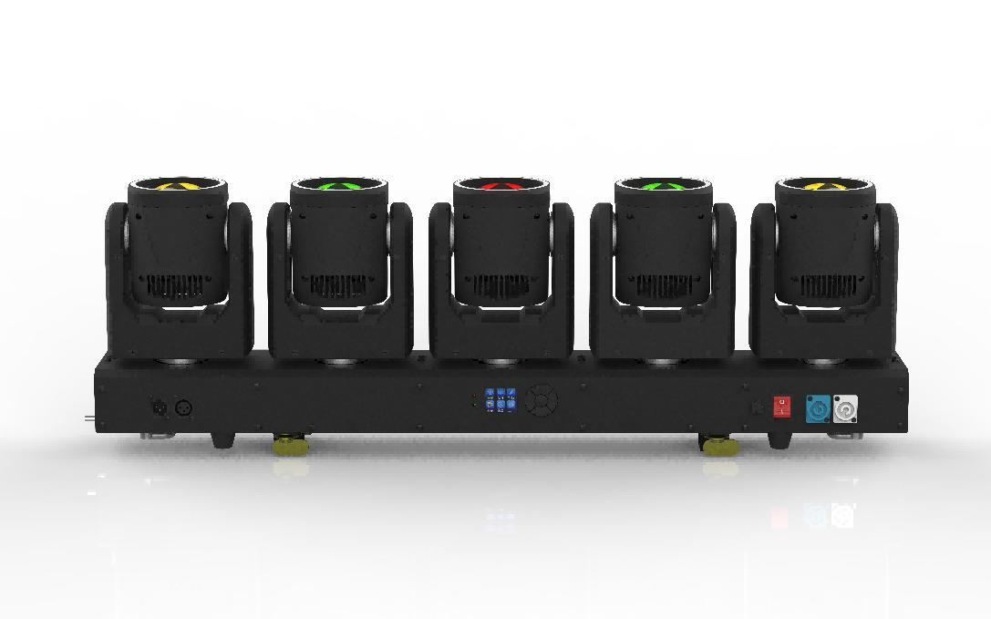
directory

1. Precautions and installation precautions and installation 3
1.1 Statement 3
1.2 Maintenance 3
1.3 Product precautions 3
1.4 Product introduction 4
2. Display panel and key definitions 4
2.1 Control panel 4
2.2 Menu function 5
3. Master-slave control 7
4. DMX512 control 7
4.1 Address Code 7
4.2 CH26 Channel Table 8
4.3 CH75 Channel Table 9
5. Common faults 12

1. Precautions and installation precautions and installation

1.1 Statement
Thank you for choosing our products! This product leaves the factory with good performance and complete packaging. In order for you to use this product safely and effectively, please read this instruction manual carefully and completely before using this product. This manual contains important information for installation and use, please follow the requirements of the manual for installation and operation, and at the same time, please keep this manual properly for use at any time.
This manual is subject to technical changes without notice.

1.2 Maintenance
- This fixture is intended for professional use only.
- If the external flexible cable or wire of this luminaire is damaged, it should be replaced with a special wire or wire provided by the manufacturer or its service agent.
- The light source contained in this luminaire may only be replaced by the manufacturer or its service agent or similar qualified personnel.
- Always connect the product to a protected circuit (circuit breaker or fuse). Ensure that the product has proper electrical grounding to avoid the risk of electric shock or fire.
- To avoid unnecessary wear and extend its life, when not in use, the power supply should be completely cut off by circuit breaker or unplugged.
- The housing may heat up while the product is running. This product should be installed in a well-ventilated location.
- When the product is transferred from an extreme temperature environment (e.g., from a cold truck to a warm and humid environment), the internal electronics of the product can condense. To avoid malfunctions, allow the product to adapt to its surroundings before turning on the power.
- Flash is known to trigger seizures. Users must comply with local notification laws regarding flash use.

1.3 Product precautions
- Disconnect the power supply before cleaning the product or replacing the fuse.
- When not in use, replace and secure all power, data, USB, or other port shields to IP protection.
- Use a safety rope when attaching this product above your head.
- Connect this product to a grounded and protected circuit.
- When the product is on, look at the light source.
- Do not place any flammable materials within 20 cm of this product when operating or turning on the power supply.
- Do not operate this product if the housing, lenses, or cables are damaged.
- This product can only be handled using handles or hoisting/mounting brackets.
- To avoid unnecessary wear and extend its life, when not in use, the power supply should be completely cut off by circuit breaker or unplugged.
- In case of serious operating problems, it should be stopped immediately

1.4 Product introduction
- Voltage: DC 24+12V
- Power: 324W
- Lamp beads: 5pcs 6065 4-in-1 RGBW + 18pcs 5050 colorful 3-in-1 RGB light strip*5
- Control mode: DMX512, self-propelled, voice controlled, with RDM function
- Channels: CH26, CH75
- Dimming: 32bit 0~100% linear dimming
- Features: Electrodeless + auxiliary light + beam
- Working temperature: -30°C~50°C
- Strobe frequency: 1~30HZ
- Appearance: Metallic, black
- Connection: DMX512 input/output / power input/output.
- IP Rating: IP20
- Size:
- Weight:

2. Display panel and key definitions

2.1 Control panel

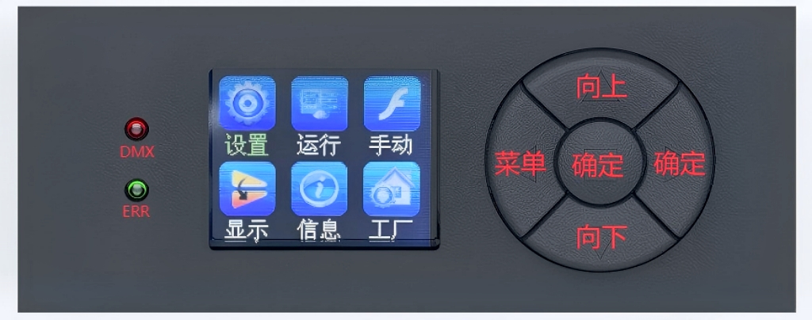

Menu key: enter/return to the main menu
Up key: The menu function selects up/adds parameters
Down key: Menu function selects down/decrements parameters
Confirm key: Select the menu function, and confirm and save it when the menu function parameters are modified.

2.2 Menu function
After powering on and resetting the whole machine, press the menu button to enter the main menu (the main menu interface exits after 30 seconds of no operation), see the main menu menu (a total of 5 main menu options) for details; Select the main menu with the up or down button, click the confirmation button to modify the function parameters of each menu, and then press the confirmation button to save the current function parameters (with power loss memory after saving).

Main menu | Submenu | Menu function description
1. System settings | 1. DMX address | Modify the DMX address code up or down (the address code can be selected in the range 001-512), and confirm that the key is saved, default 001.
1. System settings | 2. X reversal | Modify X up/down to turn on/off, confirm key to save, and turn off by default.
1. System settings | 3. Y reversal | Modify Y upwards or downwards to turn on/off, confirm the key to save, and turn off by default.
1. System settings | 4. No signal | Modify the signal clear/hold up or down, confirm the key to save, and clear the default.
1. System settings | 5. Voice control sensitivity | Modify up or down (range 000-099), make sure the key is saved, default 009.
1. System settings | 6. Temperature-fan | Modify Auto/Standard/Quiet up or down, make sure key save, default auto.
1. System settings | 7. Dimming curve | Modify the linear curve, square rate curve, inverse square rate curve, and S curve up or down, and confirm that the key is saved, and the default linear curve is the default.
1. System settings | 8. Dimming curve | Modify up or down fast/smooth, confirm key save, fast by default.
1. System settings | 9. ID number | Modify up or up to close /Y1-Y5, confirm the key to save, and close by default.
1. System settings | 10. Reset | Modify yes/no up or up, confirm key save, default no.
1. System settings | 11. Restore factory settings | Modify yes/no up or up, confirm key save, default no.
1. System settings | 12. Advanced settings
2. Operation mode | 1. Operation mode | Select the running mode up or down, DMX/Voice Control/Auto, confirm the key to save, default DMX.
2. Operation mode | 2. Channel selection | Select channel CH26, CH75 up or down, confirm key to save, default CH26.
3. Manual control | 1. X-axis | Modify up or down (adjustable range 000-255), confirm the key to save, default 000.
3. Manual control | 2. X-axis fine-tuning | Modify up or down (adjustable range 000-255), confirm the key to save, default 000.
3. Manual control | 3. X-axis speed | Modify up or down (adjustable range 000-255), confirm the key to save, default 000.
3. Manual control | 4. X-axis macro function | Modify up or down (adjustable range 000-255), confirm the key to save, default 000.
3. Manual control | 5. Y-axis | Modify up or down (adjustable range 000-255), confirm the key to save, default 000.
3. Manual control | 6. Fine-tuning the Y-axis | Modify up or down (adjustable range 000-255), confirm the key to save, default 000.
3. Manual control | 7. Y-axis speed | Modify up or down (adjustable range 000-255), confirm the key to save, default 000.
3. Manual control | 8. Y-axis macro function | Modify up or down (adjustable range 000-255), confirm the key to save, default 000.
3. Manual control | 9. The X-axis is infinite | Modify up or down (adjustable range 000-255), confirm the key to save, default 000.
3. Manual control | 10. Dimming | Modify up or down (adjustable range 000-255), confirm the key to save, default 255.
3. Manual control | 11. The main light is flashing | Modify up or down (adjustable range 000-255), confirm the key to save, default 000.
3. Manual control | 12. Halo strobe | Modify up or down (adjustable range 000-255), confirm the key to save, default 000.
3. Manual control | 13. Red | Modify up or down (adjustable range 000-255), confirm the key to save, default 000.
3. Manual control | 14. Green | Modify up or down (adjustable range 000-255), confirm the key to save, default 000.
3. Manual control | 15. Blue | Modify up or down (adjustable range 000-255), confirm the key to save, default 000.
3. Manual control | 16. White | Modify up or down (adjustable range 000-255), confirm the key to save, default 000.
3. Manual control | 17. Color temperature | Modify up or down (adjustable range 000-255), confirm the key to save, default 000.
3. Manual control | 18. Color macro | Modify up or down (adjustable range 000-255), confirm the key to save, default 000.
3. Manual control | 19. Halo red | Modify up or down (adjustable range 000-255), confirm the key to save, default 000.
3. Manual control | 20. Halo green | Modify up or down (adjustable range 000-255), confirm the key to save, default 000.
3. Manual control | 21. Halo blue | Modify up or down (adjustable range 000-255), confirm the key to save, default 000.
3. Manual control | 22. Main light mode | Modify up or down (adjustable range 000-255), confirm the key to save, default 000.
3. Manual control | 23. Main light mode speed | Modify up or down (adjustable range 000-255), confirm the key to save, default 000.
3. Manual control | 24. Halo mode | Modify up or down (adjustable range 000-255), confirm the key to save, default 000.
3. Manual control | 25. Halo mode speed | Modify up or down (adjustable range 000-255), confirm the key to save, default 000.
3. Manual control | 26. Function | Modify up or down (adjustable range 000-255), confirm the key to save, default 000.
4. Display settings | 1. Language selection | Select Chinese/EN (English) up or down, confirm the key to save, default Chinese.
4. Display settings | 2. Inverted settings | Select Turn off/on the display setting up or down, confirm that the key is saved, and turn off by default.
4. Display settings | 3. Screensaver settings | Select Turn off/on backlight settings up or down, confirm the key to save, and turn on by default.
4. Display settings | 4. Software version | M5RF
5. Information settings | sensor | Used to view Hall status and temperature communication status
5. Information settings | error message | Used to display error messages
5. Information settings | Channel information | Used to display DMX channel data
5. Information settings | Time information | Light on time  Luminaire time
6. Factory setting | Show Please enter your password! Modify it up or down to 138, and then press the confirm button to enter the factory settings. | 1. X1 axis calibration | Modify up or down (range 000-255), confirm key save, default 128.
6. Factory setting |  | 2. Y1 axis calibration | Modify up or down (range 000-255), confirm key save, default 128.
6. Factory setting |  | 3. F1 axis calibration | Modify up or down (range 000-255), confirm key save, default 128.
6. Factory setting |  | 4. X2 axis calibration | Modify up or down (range 000-255), confirm key save, default 128.
6. Factory setting |  | 5. Y2 axis calibration | Modify up or down (range 000-255), confirm key save, default 128.
6. Factory setting |  | 6. F2 axis calibration | Modify up or down (range 000-255), confirm key save, default 128.
6. Factory setting |  | 7. X3 axis calibration | Modify up or down (range 000-255), confirm key save, default 128.
6. Factory setting |  | 8. Y3 axis calibration | Modify up or down (range 000-255), confirm key save, default 128.
6. Factory setting |  | 9. F3 axis calibration | Modify up or down (range 000-255), confirm key save, default 128.
6. Factory setting |  | 10. X4 axis calibration | Modify up or down (range 000-255), confirm key save, default 128.
6. Factory setting |  | 11. Y4 axis calibration | Modify up or down (range 000-255), confirm key save, default 128.
6. Factory setting |  | 12. F4 axis calibration | Modify up or down (range 000-255), confirm key save, default 128.
6. Factory setting |  | 13. X5 axis calibration | Modify up or down (range 000-255), confirm key save, default 128.
6. Factory setting |  | 14. Y5 axis calibration | Modify up or down (range 000-255), confirm key save, default 128.
6. Factory setting |  | 15. F5 axis calibration | Modify up or down (range 000-255), confirm key save, default 128.
6. Factory setting |  | 16. X itinerary | Modify up or down (range 000-255), confirm key save, default 128.
6. Factory setting |  | 17. Y itinerary | Modify up or down (range 000-255), confirm key save, default 128.
6. Factory setting |  | 18. Open value | Modify up or down (range 000-255), confirm the key saves, default 180.
6. Factory setting |  | 19. Red | Modify up or down (range 032-255), confirm key save, default 255.
6. Factory setting |  | 20. Green | Modify up or down (range 032-255), confirm key save, default 255.
6. Factory setting |  | 21. Blue | Modify up or down (range 032-255), confirm key save, default 255.
6. Factory setting |  | 22. White | Modify up or down (range 032-255), confirm key save, default 255.
6. Factory setting |  | 23. Red 1 | Modify up or down (range 032-255), confirm the key to save, default 252.
6. Factory setting |  | 24. Green 1 | Modify up or down (range 032-255), confirm the key to save, default 252.
6. Factory setting |  | 25. Blue 1 | Modify up or down (range 032-255), confirm the key to save, default 252.
6. Factory setting |  | 26. White 1 | Modify up or down (range 032-255), confirm the key to save, default 252.
6. Factory setting |  | 27. Red 2 | Modify up or down (range 032-255), confirm the key to save, default 252.
6. Factory setting |  | 28. Green 2 | Modify up or down (range 032-255), confirm the key to save, default 252.
6. Factory setting |  | 29. Blue 2 | Modify up or down (range 032-255), confirm the key to save, default 252.
6. Factory setting |  | 30. White 2 | Modify up or down (range 032-255), confirm the key to save, default 252.
6. Factory setting |  | 31. Red 3 | Modify up or down (range 032-255), confirm the key to save, default 252.
6. Factory setting |  | 32. Green 3 | Modify up or down (range 032-255), confirm the key to save, default 252.
6. Factory setting |  | 33. Blue 3 | Modify up or down (range 032-255), confirm the key to save, default 252.
6. Factory setting |  | 34. White 3 | Modify up or down (range 032-255), confirm the key to save, default 252.
6. Factory setting |  | 35. Red 4 | Modify up or down (range 032-255), confirm the key to save, default 252.
6. Factory setting |  | 36. Green 4 | Modify up or down (range 032-255), confirm the key to save, default 252.
6. Factory setting |  | 37. Blue 4 | Modify up or down (range 032-255), confirm the key to save, default 252.
6. Factory setting |  | 38. White 4 | Modify up or down (range 032-255), confirm the key to save, default 252.
6. Factory setting |  | 39. Red 5 | Modify up or down (range 032-255), confirm the key to save, default 252.
6. Factory setting |  | 40. Green 5 | Modify up or down (range 032-255), confirm the key to save, default 252.
6. Factory setting |  | 41. Blue 5 | Modify up or down (range 032-255), confirm the key to save, default 252.
6. Factory setting |  | 42. White 5 | Modify up or down (range 032-255), confirm the key to save, default 252.
6. Factory setting |  | 43. Current | Modify up or down (range 032-255), confirm the key to save, default 240.
6. Factory setting |  | 44. Temperature | Modify the temperature parameter (range 40-65) up or down, confirm the key to save, default 060.
6. Factory setting |  | 45、LED | Modify LEDA/LEDB up or down, make sure the key is saved, and the default LEDA is the default.
6. Factory setting |  | 46. LEDXYF direction | Modify up or down (range 000-255), confirm the key saves, default 000.
6. Factory setting |  | 47、Logo | Select 000/001 up or down, confirm the key to save, default 000.
6. Factory setting |  | 48. Synchronous update | Select On/Off up or down, confirm to save, and turn off by default.
6. Factory setting |  | 49. Time is cleared | Select Yes/No up or down, confirm the key saves, no by default.

3. Master-slave control
There are 2 or more identical lamps connected with DMX three-core signal cables, all lamps are modified to 001~512 arbitrary address code, any one is set as the host, other lamps are slaves, and all slave displays do not flicker; When the main unit is used to adjust the gradient, pulse change, jump, voice control, and self-propelled effects, all slave synchronized gradients, pulse changes, jumps, voice-controlled, and auto-propelled effects.
Special attention: 1. A group of lamps can only set one host, if there are multiple hosts, all the lamps will flash randomly and not synchronized.
- All luminaires must be active when the DMX512 console is turned off.

4. DMX512 control

4.1 Address Code
All the lamps are set with the address code, connect all the lamps to the DMX512 console in parallel with DMX three-core signal cables, the address code stops flashing, indicating that the DMX512 console signal has been sent to the lamp, and use the DMX512 console to control the relevant functions according to the channel instructions.

4.2 CH26 Channel Table
passage | Channel value | Basic features:
1 | 000-255 | X-axis
2 | 000-255 | X-axis fine-tuning
3 | 000-255 | X-axis speed
4 | 000-255 | X-axis macro function
5 | 000-255 | Y-axis
6 | 000-255 | Y-axis fine-tuning
7 | 000-255 | Y-axis velocity
8 | 000-255 | Y-axis macro function
9 | 000-255 | The X-axis is infinite
10 | 000-255 | Dimming
11 | 000-255 | The main light is flashing
12 | 000-255 | Halo strobe
13 | 000-255 | red
14 | 000-255 | green
15 | 000-255 | blue
16 | 000-255 | white
17 | 000-255 | Temperature
18 | 000-255 | Color macro
19 | 000-255 | The halo is red
20 | 000-255 | Halo green
21 | 000-255 | Halo blue
22 | 000-255 | Main light mode
23 | 000-255 | Main light mode speed
24 | 000-255 | Halo mode
25 | 000-255 | Halo mode speed
26 | 000-255 | Function

4.3 CH75 Channel Table
passage | Channel value | Basic features:
1 | 000-255 | Total dimming
2 | 000-255 | The main light is flashing
3 | 000-255 | Halo strobe
4 | 000-255 | X-axis 1
5 | 000-255 | X-axis 1 fine-tuning
6 | 000-255 | X-axis 1 infinite
7 | 000-255 | Y-axis 1
8 | 000-255 | Y-axis 1 fine-tuning
9 | 000-255 | Red 1
10 | 000-255 | Green 1
11 | 000-255 | Blue 1
12 | 000-255 | White 1
13 | 000-255 | Halo 1 red
14 | 000-255 | Halo 1 green
15 | 000-255 | Aura 1 blue
16 | 000-255 | Halo 1 mode
17 | 000-255 | Halo 1 mode speed
18 | 000-255 | X-axis 2
19 | 000-255 | X-axis 2 fine-tuning
20 | 000-255 | X-axis 2 infinite
21 | 000-255 | Y-axis 2
22 | 000-255 | Y-axis 2 fine-tuning
23 | 000-255 | Red 2
24 | 000-255 | Green 2
25 | 000-255 | Blue 2
26 | 000-255 | White 2
27 | 000-255 | Halo 2 red
28 | 000-255 | Halo 2 green
29 | 000-255 | Halo 2 blue
30 | 000-255 | Halo 2 mode
31 | 000-255 | Halo 2 mode speed
32 | 000-255 | X-axis 3
33 | 000-255 | X-axis 3 fine-tuning
34 | 000-255 | X-axis 3 infinite
35 | 000-255 | Y-axis 3
36 | 000-255 | Y-axis 3 fine-tuning
37 | 000-255 | Red 3
38 | 000-255 | Green 3
39 | 000-255 | Blue 3
40 | 000-255 | White 3
41 | 000-255 | Halo 3 red
42 | 000-255 | Halo 3 green
43 | 000-255 | Halo 3 blue
44 | 000-255 | Halo 3 mode
45 | 000-255 | Halo 3 mode speed
46 | 000-255 | X-axis 4
47 | 000-255 | X-axis 4 fine-tuning
48 | 000-255 | X-axis 4 infinite
49 | 000-255 | Y-axis 4
50 | 000-255 | Y-axis 4 fine-tuning
51 | 000-255 | Red 4
52 | 000-255 | Green 4
53 | 000-255 | Blue 4
54 | 000-255 | White 4
55 | 000-255 | Halo 4 red
56 | 000-255 | Halo 4 green
57 | 000-255 | Halo 4 blue
58 | 000-255 | Halo 4 mode
59 | 000-255 | Halo 4 mode speed
60 | 000-255 | X-axis 5
61 | 000-255 | X-axis 5 fine-tuning
62 | 000-255 | X-axis 5 infinite
63 | 000-255 | Y-axis 5
64 | 000-255 | Y-axis 5 fine-tuning
65 | 000-255 | Red 5
66 | 000-255 | Green 5
67 | 000-255 | Blue 5
68 | 000-255 | White 5
69 | 000-255 | Halo 5 red
70 | 000-255 | Halo 5 green
71 | 000-255 | Halo 5 blue
72 | 000-255 | Halo 5 mode
73 | 000-255 | Halo 5 mode speed
74 | 000-255 | XY axis speed
75 | 000-255 | Function

Function
Channel value | Function description:
000--005 | No function
006--007 | No function
008--009 | No function
010--029 | No function
030--039 | Dimming curve: linear
040--049 | Dimming curve: square rate
050--059 | Dimming curve: antisquare rate
060--069 | Dimming curve: S-curve
070--079 | Temperature-Fan Mode: Automatic
080--089 | Temperature-Fan Mode: Standard
090--099 | Temperature-Fan Mode: Quiet
100--109 | No function
110--119 | No function
120--122 | No function
123 | No function
124 | No function
125 | No function
126 | No function
127 | No function
128 | No function
129 | No function
130 | No function
131 | No function
132 | No function
133 | No function
134 | No function
135 | No function
136 | No function
137 | No function
138--139 | No function
140--149 | X-axis reset
150--159 | Head reset
160--169 | Head reversed: Yes
170--179 | Head reverse: No
180--199 | No function
200--209 | All reset
210--219 | Dimming speed: fast
220--229 | Dimming speed: smooth
230--255 | No function

5. Common faults
For some common faults, corresponding solutions are proposed. Any unresolved issues should be handled by professionals. Before maintaining the lamp, disconnect the power supply.
- The lamp beads don't turn on
- Check whether the voltage matching the lamp is installed;
- Check whether the power supply connection or control switch of the lamp is in poor contact;
- Check whether the power supply is insufficient;
- Check if the DMX512 controller has sent instructions.
2. The lamp does not accept the control of the console after normal reset
- Check whether the numeric start address value and function options of the luminaire are correct;
- Check whether the connection of the communication control line is correct, the communication line is too long or has been interrupted;
- Check whether the control equipment is failing, and check whether the signal amplifier connected in series is failing;
- Check whether the communication line is too long or if other devices interfere with each other;
- Optimize the wiring, shorten the length of the control signal line, and separate the high-voltage and low-voltage lines.
- Add a signal amplifier;
- The signal line adopts high-quality shielded twisted pair wire;
- Connect the signal termination resistor (120 ohms) at the end of the luminaire.
3. The light fixture cannot be started
- Check whether the power supply parameters are consistent with the lamps;
- Check that the lamps are in poor contact or fall off due to extrusion deformation, internal parts vibration, moisture, etc. during long-distance transportation.
- Check whether the wires and connectors inside the lamp are falling off or loose.
- Check the electronic components of the lamp (such as electronic transformers, PCB boards, motor control boards, etc.) for looseness, short circuits, and burnouts.

