Beam shaking lamp
Use to explain the book.

Please read the instructions carefully before use.

Catalogue
1.Precautions and installation 1
1.1Declaration 1
1.2Maintenance 1
1.3Product precautions 1
1.4Product Instructions 1
1.5 Connecting signal cables 2
1.6Lighting installation 2
2.Control panel 4
2.1 Key instructions
2.2.1Setting 5
2.2.2Manual 5
2.2.3Information 6
2.2.4Factory 7
3.Channel function 8
3.1Channel table 8
4.Common faults 11

1. Precautions and Installation Precautions and Installation
  - statement
Thank you for choosing our products! This product has good performance and complete packaging when it leaves the factory. For your safe and effective use of this product, please read this instruction manual carefully and completely before you use this product. This manual contains important information about installation and use. Please install and operate according to the requirements of the manual. At the same time, please keep this manual properly for use at any time. Our company is not responsible for any damage to lamps or other performance due to personal failure to follow the instructions during installation, use and maintenance.
This manual is subject to technical changes without prior notice.

  - maintaining
- Please disconnect the power supply before carrying out maintenance.
- This lamp should be kept dry to avoid working in wet environment.
- Intermittent use will effectively prolong the life of this lamp.
- In order to obtain good ventilation effect and lighting effect, attention should be paid to cleaning fans, fan nets and lenses frequently.
- Please don't use alcohol and other organic solvents to wipe the lamp shell to avoid damage.

  - Precautions for products
- This lamp is for professional use only.
- Before operation, ensure that the power supply voltage is consistent with the power supply voltage required by the equipment.
- Do not place this product in a place that is easy to loosen or vibrate.
- During use, if the lamps are abnormal, stop using them in time.
- In order to ensure the service life of the product, this product should not be placed in a damp or leaking place, and it should not work in an environment where the temperature exceeds 60 degrees.
- When the light bulb is used, the change of power supply voltage should not exceed 10%. If the voltage is too high, the life of the light bulb will be shortened, and if the voltage is too low, the light color of the light bulb will be affected.
- After the power is cut off, it takes 20 minutes to fully cool the lamps before they can be powered on again.
- The rotating parts and pasted fittings of lamps and lanterns must be inspected regularly, and they should be reinforced in time to prevent accidents.
- To ensure the normal use of this product, please read this instruction carefully.

  - Product introduction
- Total power: w;
- Voltage: AC100V-240V 50/60Hz.
- Color wheel: each color wheel consists of 13 color plates+white light;
- Pattern disk: 14 pattern effects;
- 540 translation, 270 tilt.
- Overheating protection;
- Control mode: voice control, self-propelled, master-slave and DMX512.
- IP20 protection level

  - Signal wire connection
Lamps and lanterns are equipped with standard DMX input and output 3-core or 5-core XLR sockets. Please use twisted-pair signal wire specially shielded for DMX 512; Generally, the connection distance of signal lines is 150 meters. When transmitting long-distance signals, DMX512 signal amplifier must be added.
Use a shielded twisted-pair signal line to connect from the DMX output port of the controller to the DMX input port of the first device, and from the DMX output port of the first device to the DMX input port of the second device, and so on until all the lamps are connected, and then install a terminal plug on the last 3-core jack connected to the lamp output of each connection. (Weld a 4/1W, 120Ω resistor between pins 2 and 3 of the 3-core Canon plug with needle).

Important: The wires must not touch each other or the metal shell.

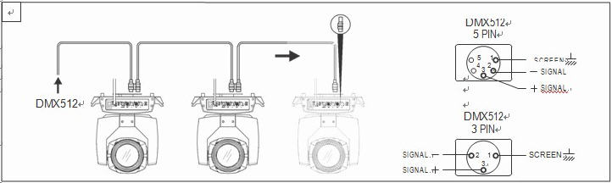
Fig. 1 schematic diagram of DMX signal line connection
- Calculation method of initial address code of lamps and lanterns:
The starting address code of the current lamp is equal to (the starting address code of the previous lamp)+(the number of channels of the lamp).
1: The initial address code value A001 of the first lamp.
2. The number of basic channels of the controller should be greater than or equal to the total number of channels used by lamps.
3. Note: When using any controller, each lamp must have its own starting address code. If the starting address code of the first lamp is set to A001, the number of lamps is 16CH; Then the starting address code of the second lamp is set to A017; The starting address code of the third lamp is set to A033; And so on, (this setting mode also needs to be determined according to different consoles)

  - Lighting installation
Lamps and lanterns can be placed horizontally, hung obliquely and upside down. Pay attention to the installation method when hanging obliquely and upside down.
such asfigure 1As shown in the figure, before positioning the lamps, it is necessary to ensure the stability of the installation site. During the reverse hanging installation, it is necessary to ensure that the lamps do not fall off the support frame, and it is necessary to use a safety rope to pass through the support frame and the lamp handle for auxiliary hanging to ensure safety and prevent the lamps from falling and sliding.
When installing and debugging lamps, pedestrians are forbidden to pass below, and regularly check whether the safety rope is worn and the hook screw is loose.
If the hanging installation is unstable and the lamps fall, our company will not bear any responsibility.
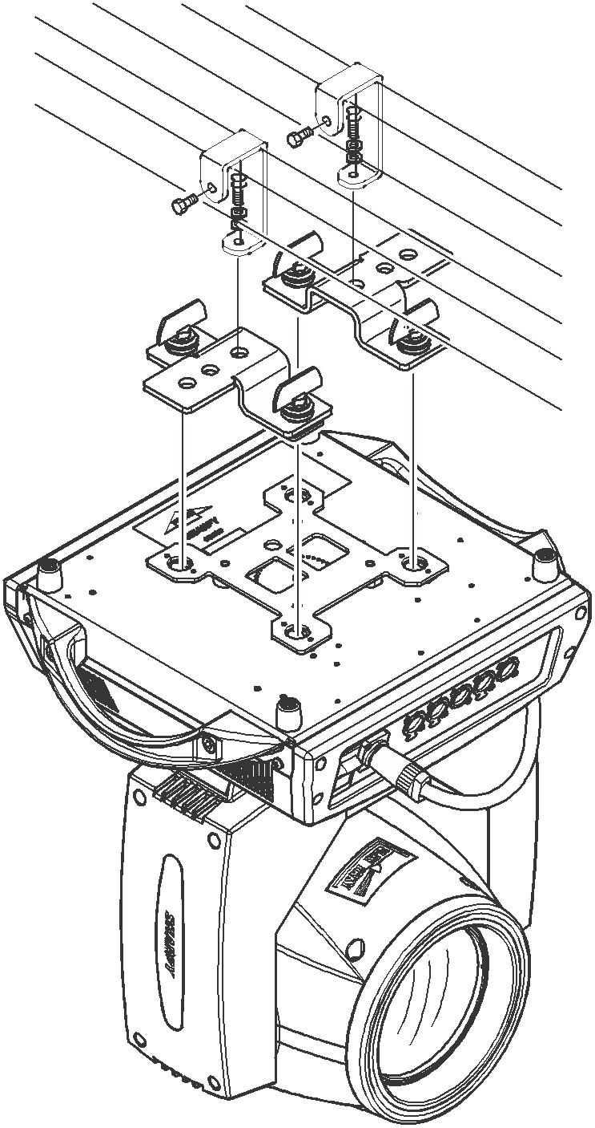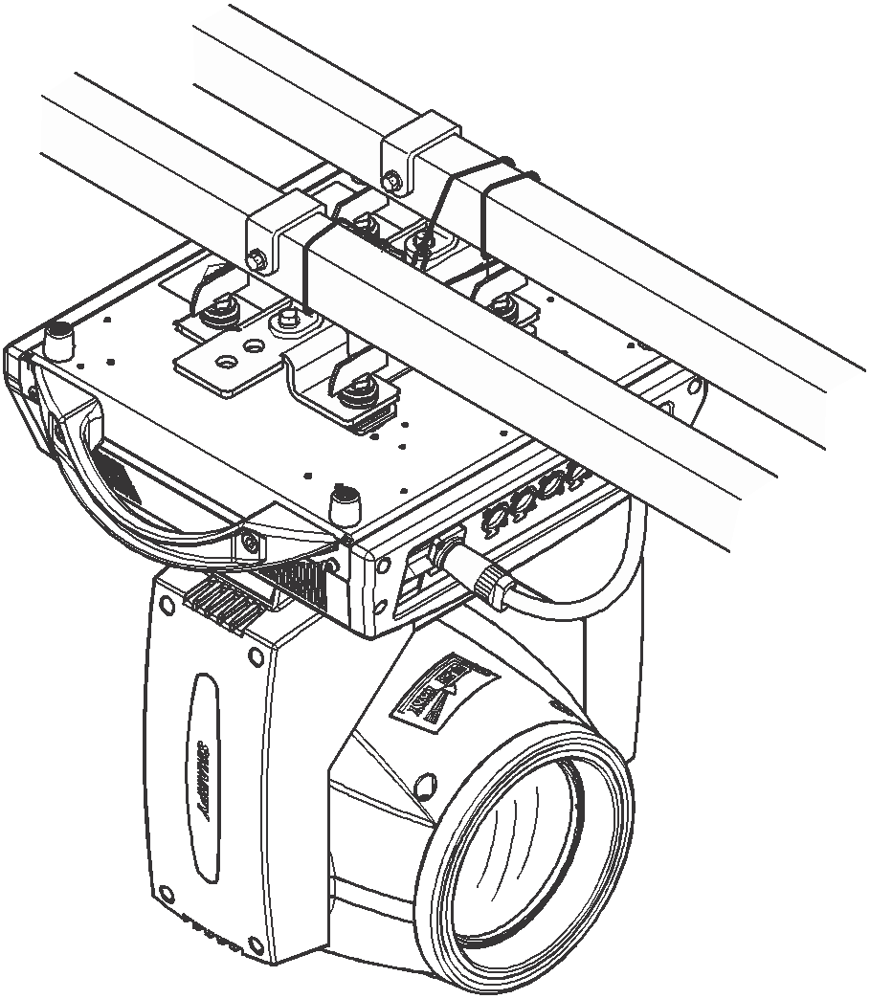
pictureoneSchematic diagram of upside-down lamps

control panel

2.1 key description
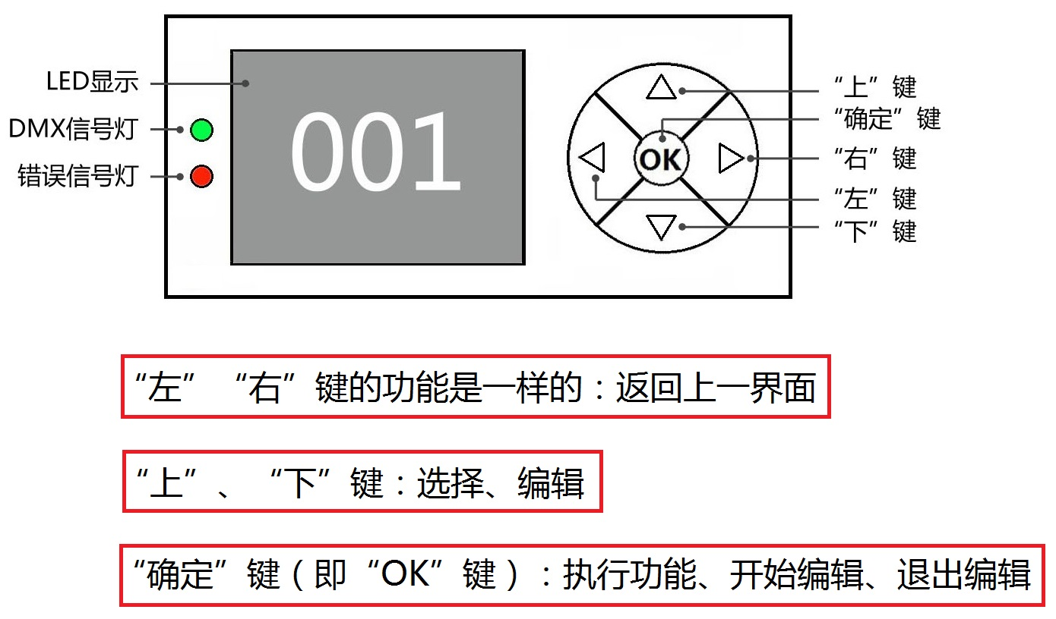

Fig. 3 schematic diagram of panel key explanation
Let's take "Modify DMX Address Code" as an example to describe the use of keys:
1. If it is not the main interface at present, press the "Left" key (one or more times) to return to the main interface.
2. In the main interface, press the "Up" key or the "Down" key to select the "Settings" button.
3. Press the "OK" key to enter the "Settings" interface.
4. In the Settings interface, press the Up key or the Down key to select DMX Address.
5. Press the "OK" key to enter the editing state.
6. Press the "Up" or "Down" key to modify the DMX address code.
7. Press "OK" to exit the editing status.

2.2 menu description

2.2.1 menu display
Menu display
primary menu | Submenu 1 | Function setting | Brief introduction of function
DMX address |  | 1-512
system setup | Display backward | normal | .
system setup | Display backward | turn | .
system setup | Language settings | Chinese | .
system setup | Language settings | English | .
system setup | Channel mode | 20CH | .
system setup | operational mode | DMX | .
system setup | operational mode | sound-controlled | .
system setup | operational mode | automatic | .
system setup | Electronic lighting | close | .
system setup | Electronic lighting | open | .
system setup | Bulb default | On _ off | .
system setup | Bulb control | illumine | .
system setup | shortest route | On _ off | .
system setup | Horizontal reversal | close | .
system setup | Horizontal reversal | open | .
system setup | Vertical inversion | close | .
system setup | Vertical inversion | open | .
system setup | XY speed | low speed | .
system setup | XY speed | intermediate speed | .
system setup | XY speed | fast | .
system setup | Optocoupler detection | close | .
system setup | Optocoupler detection | open | .
system setup | Return to the superior | ▲ | .
information inquiry | Total time | 0-9999
information inquiry | Bulb time | 0-9999
information inquiry | binding hours | 0-9999
information inquiry | display software | Vx001
information inquiry | XY software | Vx001
information inquiry | Small motor software | Vx001
information inquiry | Return to the superior | ▲
Channel control | Color wheel rotation | 0-255
Channel control | stroboscopic | 0-255
Channel control | Dimming " | 0-255
Channel control | Fixed pattern | 0-255
Channel control | prism | 0-255
Channel control | Prism rotation | 0-255
Channel control | Fogging | 0-255
Channel control | Focus adjustment | 0-255
Channel control | Horizontal rotation | 0-255
Channel control | Horizontal fine adjustment | 0-255
Channel control | Vertical rotation | 0-255
Channel control | Vertical fine tuning | 0-255
Channel control | reset | 0-255
Channel control | light a lamp | 0-255
Channel control | XY speed | 0-255
Channel control | Color wheel speed | 0-255
Channel control | Focusing speed | 0-255
Channel control | Pattern speed | 0-255
Channel control | Return to the superior | 0-255
functional mode | XY communication | normal | current state
functional mode | XY communication | mistake | current state
functional mode | Small motor communication | normal | current state
functional mode | Small motor communication | mistake | current state
functional mode | Focusing hall | normal | current state
functional mode | Focusing hall | mistake | current state
functional mode | Color wheel hall | normal | current state
functional mode | Color wheel hall | mistake | current state
functional mode | Pattern hall | normal | current state
functional mode | Pattern hall | mistake | current state
functional mode | X-optical coupler | normal | current state
functional mode | X-optical coupler | mistake | current state
functional mode | Y optocoupler | normal | current state
functional mode | Y optocoupler | mistake | current state
functional mode | Fan speed | 6500 | current state
functional mode | Return to the superior | ▲ | current state
appurtenance | Check code 1 | 0-9999
appurtenance | Total time | clear
appurtenance | Total time | carry out
appurtenance | Lamp time | clear
appurtenance | Lamp time | carry out
appurtenance | Restore default | default
appurtenance | Restore default | recover
appurtenance | Restore default | preserve
appurtenance | Horizontal rotation | 0-255 | Zero initial position
appurtenance | Vertical rotation | 0-255 | Zero initial position
appurtenance | Focus adjustment | 0-255 | Zero initial position
appurtenance | Prism 1 | 0-255 | Zero initial position
appurtenance | Prism 2 | 0-255 | Zero initial position
appurtenance | Prism rotation 1 | 0-255 | Zero initial position
appurtenance | Prism rotation 2 | 0-255 | Zero initial position
appurtenance | Fogging | 0-255 | Zero initial position
appurtenance | Color combination | 0-255 | Zero initial position
appurtenance | Fixed pattern | 0-255 | Zero initial position
appurtenance | colour disc | 0-255 | Zero initial position
appurtenance | Frequency flash | 0-255 | Zero initial position
appurtenance | Stroboscopic midpoint | 0-255 | Zero initial position
appurtenance | Ridge-1 midpoint | 0-255 | Zero initial position
appurtenance | Mid-point of edge two | 0-255 | Zero initial position
appurtenance | Atomization midpoint | 0-255 | Zero initial position
appurtenance | Colorful midpoint | 0-255 | Zero initial position
appurtenance | Return to the superior | ▲ | Zero initial position
Advanced settings | Check code 2 | 0-9999
Advanced settings | Signal encryption | open
Advanced settings | Signal encryption | close
Advanced settings | DMX speed | 0-255
Advanced settings | DMX data packet | 0-255
Advanced settings | DMX type | 0-055
Advanced settings | DMX isolation | 0-65535 | The smaller the value, the more stable the signal is.
Advanced settings | Driving plate temperature | < 110 degrees > | If it exceeds this range, red will be displayed.
Advanced settings | Drive board 3.3V | 3.0V - 3.6V | If it exceeds this range, red will be displayed.
Advanced settings | Drive board 5.0V | 4.5V - 5.5V | If it exceeds this range, red will be displayed.
Advanced settings | Drive board 12V | 10.0V - 14.0V | If it exceeds this range, red will be displayed.
Advanced settings | Drive plate 36V | 20.0V - 42.0V | If it exceeds this range, red will be displayed.
Advanced settings | X state | be motionless
Advanced settings | X state | turn
Advanced settings | X hall | normal
Advanced settings | X hall | mistake | Show red
Advanced settings | X-ray optical coupler phase | 0-3
Advanced settings | X optocoupler a | 40-160 | The standard setting of 100 exceeds the required range and displays red, but the red light on the panel does not give an alarm.
Advanced settings | X optocoupler b | 40-160 | The standard setting of 100 exceeds the required range and displays red, but the red light on the panel does not give an alarm.
Advanced settings | X optocoupler c | 40-160 | The standard setting of 100 exceeds the required range and displays red, but the red light on the panel does not give an alarm.
Advanced settings | X optocoupler d | 40-160 | The standard setting of 100 exceeds the required range and displays red, but the red light on the panel does not give an alarm.
Advanced settings | X current angle | 000-540
Advanced settings | X drive state | normal
Advanced settings | X drive state | mistake | Show red
Advanced settings | Y state | be motionless
Advanced settings | Y state | turn
Advanced settings | Y optocoupler | normal
Advanced settings | Y optocoupler | mistake | Show red
Advanced settings | Y hall | normal
Advanced settings | Y hall | mistake | Show red
Advanced settings | Y-coupler phase | 0-3
Advanced settings | Y optocoupler a | 40-160 | If it exceeds this range, red will be displayed.
Advanced settings | Y optocoupler b | 40-160 | If it exceeds this range, red will be displayed.
Advanced settings | Y optocoupler c | 40-160 | If it exceeds this range, red will be displayed.
Advanced settings | Y optocoupler d | 40-160 | If it exceeds this range, red will be displayed.
Advanced settings | Y current angle | 000-250
Advanced settings | Y drive state | normal
Advanced settings | Y drive state | mistake | Show red
Advanced settings | Return to the superior | ▲
Channel level | Color wheel rotation | 0-255 | Current DMX channel value
Channel level | stroboscopic | 0-255 | Current DMX channel value
Channel level | aiming | 0-255 | Current DMX channel value
Channel level | Fixed pattern | 0-255 | Current DMX channel value
Channel level | prism | 0-255 | Current DMX channel value
Channel level | Prism rotation | 0-255 | Current DMX channel value
Channel level | Fogging | 0-255 | Current DMX channel value
Channel level | Focus adjustment | 0-255 | Current DMX channel value
Channel level | Horizontal rotation | 0-255 | Current DMX channel value
Channel level | Horizontal fine adjustment | 0-255 | Current DMX channel value
Channel level | Vertical rotation | 0-255 | Current DMX channel value
Channel level | Vertical fine tuning | 0-255 | Current DMX channel value
Channel level | reset | 0-255 | Current DMX channel value
Channel level | light a lamp | 0-288 | Current DMX channel value
Channel level | XY speed | 0-255 | Current DMX channel value
Channel level | Color wheel speed | 0-255 | Current DMX channel value
Channel level | Focusing speed | 0-255 | Current DMX channel value
Channel level | Pattern speed | 0-255 | Current DMX channel value
Channel level | Return to the superior |  | Current DMX channel value
reset | Reset all | cancel | manual reset
reset | Reset all | carry out | manual reset
reset | XY reset | cancel | manual reset
reset | XY reset | carry out | manual reset
reset | Effect reset " | cancel | manual reset
reset | Effect reset " | carry out | manual reset
reset | Return to the superior
Exit menu

Channel function

3.1 channel table
passage | 16-channel mode
one | Color wheel
2 | Cut light/strobe
three | aiming
four | Pattern disk
five | Prism 1
six | Prism rotation
seven | Prism 2
eight | atomize
nine | focus
10 | X
11 | X fine tuning
twelve | Y
13 | Y fine tuning
14 | XY speed
15 | various colours
16 | Light bulb & reset

Channel parameter value (full version):
passage | function | Channel value | effect
one | Color wheel | 000 - 004  005 - 009  010 - 014  015 - 019  020 - 024  025 - 029  030 - 034  035 - 039  040 - 044  045 - 049  050 - 054  055 - 059  060 - 064  065 - 069  070 - 074  075 - 079  080 - 084  085 - 089  090 - 094  095 - 099  100 - 104  105 - 109  110 - 114  115 - 119  120 - 124  125 - 129  130 - 134  135 - 139  140 - 144  145 - 149  150 - 203  204 - 255 | white light  White light+color 1  Color 1  Color 1+ Color 2  Color 2  Color 2+ color 3  Color 3  Color 3+ color 4  Color 4  Color 4+ color 5  Color 5  Color 5+ color 6  Color 6  Color 6+ color 7  Color 7  Color 7+ color 8  Color 8  Color 8+ color 9  Color 9  Color 9+ color 10  Color 10  Color 10+ color 11  Color 11  Color 11+ color 12  Color 12  Color 12+ color 13  Color 13  Color 13+ color 14  Color 14  Color 14+ white light  Reverse flow (from fast to slow)  Forward flow (from slow to fast)
2 | stroboscopic | 000-007  008-015  016-131  132-167  168-203  204-247  248-255 | Shutter closed  Shutter open → (controlled by dimming channel)  Strobe from slow to fast  Slow on fast off strobe from slow to fast.  Turn on and off the strobe from slow to fast.  Random strobe from slow to fast  Shutter open → (controlled by dimming channel)
three | aiming | 000-255 | From dark to bright
four | Pattern disk | 000 - 004  005 - 009  010 - 014  015 - 019  020 - 024  025 - 029  030 - 034  035 - 039  040 - 044  045 - 049  050 - 054  055 - 059  060 - 064  065 - 069  070  071 - 075  076 - 080  081 - 085  086 - 090  091 - 095  096 - 100  101 - 105  106 - 110  111 - 115  116 - 120  121 - 125  126 - 130  131 - 135  136 - 139  140 - 189  190 - 194  195 - 255 | Baiguangkong  Solid figure 1  Solid figure 2  Solid figure 3  Solid figure 4  Solid figure 5  Solid figure 6  Solid figure 7  Solid figure 8  Solid figure 9  Solid figure 10  Solid figure 11  Solid figure 12  Solid figure 13  Baiguangkong  Figure 1 jitter (from slow to fast)  Figure 2 jitter (from slow to fast)  Figure 3 jitter (from slow to fast)  Figure 4 jitter (from slow to fast)  Figure 5 jitter (from slow to fast)  Figure 6 jitter (from slow to fast)  Figure 7 jitter (from slow to fast)  Figure 8 jitter (from slow to fast)  Figure 9 jitter (from slow to fast)  Figure 10 jitter (from slow to fast)  Figure 11 jitter (from slow to fast)  Figure 12 jitter (from slow to fast)  Figure 13 jitter (from slow to fast)  Baiguangkong  Forward flow (from fast to slow)  Baiguangkong  Reverse flow (from slow to fast)
five | Prism 1 | 000-015  016-255 | Prism 1 pops up.  Prism 1 cuts in
six | Prism 1 rotates | 000-127  128-187  188-195  196-255 | stop  Reverse rotation (from fast to slow)  stop  Forward rotation (from slow to fast)
seven | Prism 2 | 000-015  016-255 | Prism 1 pops up.  Prism 1 cuts in
eight | atomize | 000-015  016-255 | without  Atomization cut-in
nine | focus | 000-255 | Pattern clarity from far to near
10 | X axis | 000-255 | Horizontal 540-degree scanning
11 | X-axis fine tuning | 000-255 | Horizontal 1.2-degree fine adjustment
twelve | Y axis | 000-255 | Vertical 270-degree scanning
13 | Y axis fine tuning | 000-255 | Vertical 1.2-degree fine adjustment
14 | XY speed | 000-255 | Speed from fast to slow
15 | various colours | 000-127  128-255 | without  Colorful cut-in
16 | Light bulb & reset | 000-099  100-105  200-205  250-255 | No, there is no action in the area where the function is not specified.  Extinguish the light bulb  Light the bulb  All motors reset

Common faults
Aiming at some common faults, the corresponding solutions are put forward. Any problem that cannot be solved should be handled by professionals. Please disconnect the power supply before maintaining the lamps.

The light bulb doesn't work
- Check whether the voltage matched with the lamp is installed;
- Check whether the power supply connection or control switch of lamps and lanterns is in poor contact;
- Check whether the power supply is insufficient;
- Check whether the DMX512 controller has sent instructions.

Lamps and lanterns do not accept the control of the console after normal reset.
- Check whether the digital starting address value and function options of lamps and lanterns are correct;
- Check whether the connection of the communication control line is correct, the communication line is too long or has been interrupted;
- Check whether the control equipment fails, and check whether the signal amplifier connected in series fails;
- Check whether the communication line is too long or other equipment interferes with each other;
- Optimize wiring, shorten the length of control signal line, and separate wiring for high voltage and low voltage lines;
- Add a signal amplifier;
- The signal line adopts high-quality shielded twisted pair;
- Connect the signal termination resistor (120 ohms) at the end of the lamp.

Lamps can't start.
- Check whether the parameters of power supply are consistent with the lamps;
- Check the lamps for poor contact due to extrusion deformation, vibration and humidity of internal parts during long-distance transportation.
Or fall off.
- Please check whether the wiring connector inside the lamp falls off or is loose.
- Check whether the electronic components of lamps (such as electronic transformer, PCB board, motor control board, etc.) are loose, short-circuited and burned out.

When working, the X-axis or Y-axis of the lamp is not normal.
- Check one by one according to the previous step;
- Check whether the drive belt corresponding to the X and Y axis directions in the lamp falls off and breaks;
- Check whether the data feedback receiver (optical coupler) corresponding to the X and Y directions in the lamp is damaged;
- Reboot and reset once.

