Function description of fireworks machine
Passageway | Control function | Numerical value | The nixie tube shows

1 | Off | 000~009 | A001 DMX address code
1 | Spray height 1 | 010~019
1 | Spray height 2 | 020~029
1 | Spray height 3 | 030~039
1 | Spray height 4 | 040~049
1 | Spray height 5 | 050~059
1 | Spray height 6 | 060~069
1 | Spray height 7 | 070~079
1 | Spray height 8 | 080~089
1 | Spray height 9 | 090~099
1 | Spray height 10 | 100~255
2 | Heating off | 000~009 | A001 DMX address code
2 | Heat on | 010~239 | Displays the current temperature value
2 | Emergency stop | 240~255 | STOP

- Panel description
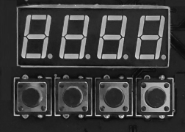

1. Key description
Key sequence from left to right: Menu-> Up-> Down-> Confirm

1) Menu: switch the menu interface to the next menu.
2) Up: it can be used for menu switching, and the previous menu can be used; when the confirmation key is pressed, it will be added up. In the DMX address code interface, the address code will be added up; in the working temperature setting interface, the working temperature will be increased up.
3) Down: when the confirmation key is pressed down, the address code will be decreased down in the DMX address code interface; the working temperature will be decreased down in the working temperature setting interface.
4) Confirm: The interface enters the setting state, and the current interface can add or subtract values. (Valid only under address code and operating temperature)

2. Indicator light description
1) Yellow light: flashing indicates that the working temperature has not been reached; if it is on, it indicates that the heating is completed and the working temperature has been reached.
2) Green light: If it is on, it indicates that there is DMX signal; if it is off, it indicates that the signal is disconnected.
3) Red light: the light is on when there is an error, for example, there is a problem with the temperature control detection or the heating.
4) Blue light: always on when heating.

3. Interface description (press the menu key or up key to switch the interface)

- Address code interface:
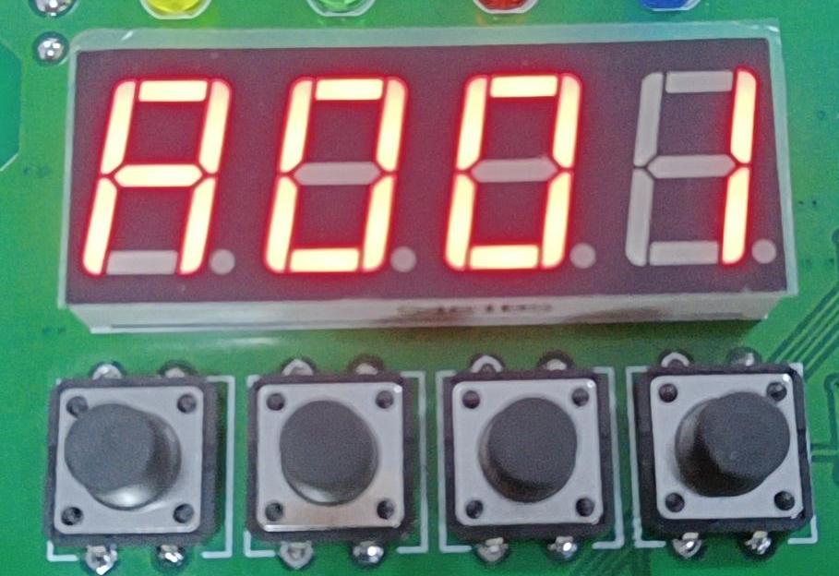

Operating instructions: press the confirmation key to enter the editing, select the address code 001-512, and then press the confirmation key to exit the address code editing.

- Temperature interface:
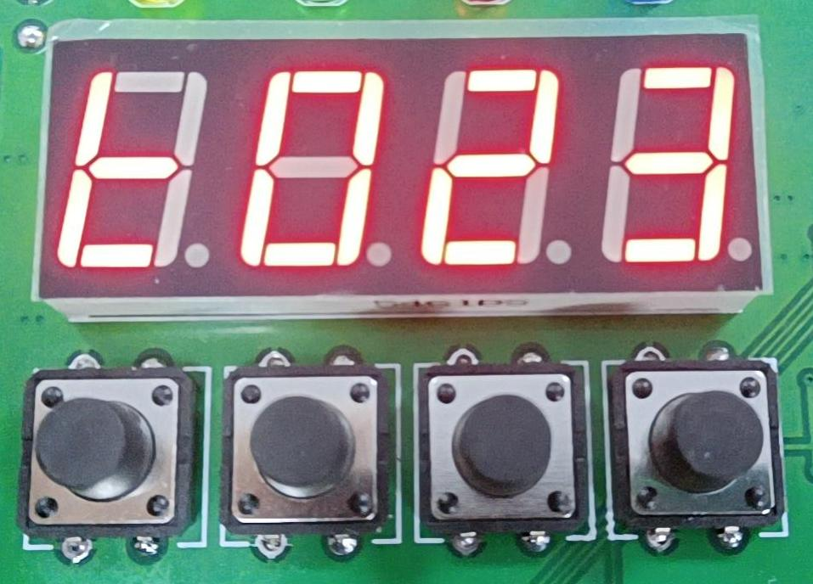

Operating instructions: The current interface cannot be operated, and only the current temperature status can be displayed in real time.

- Working temperature setting interface:
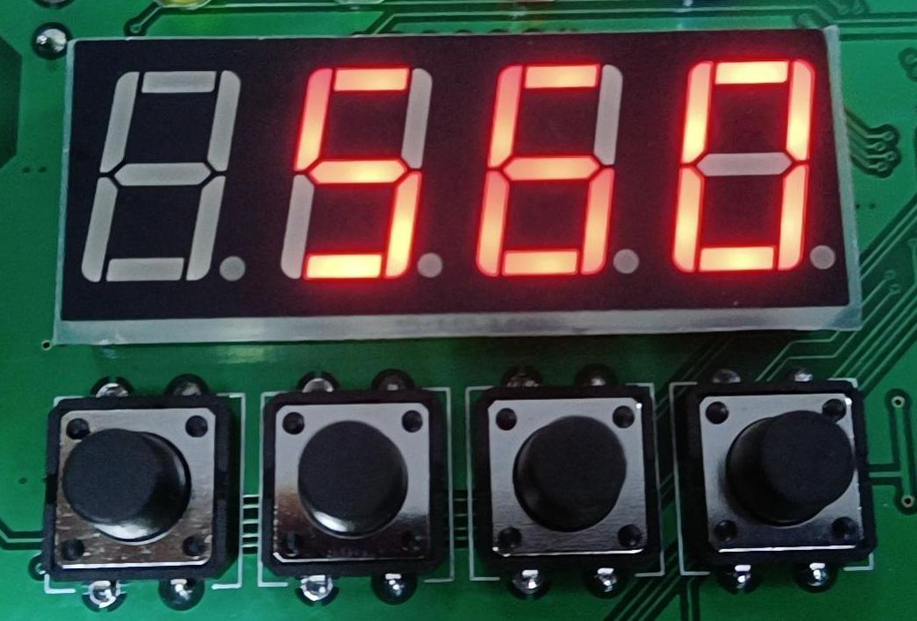

Operating instructions: Set the working temperature, and spray the flowers when the temperature is heated to the current temperature; press the confirmation key to enter the editing, select the temperature range of 560-620 degrees, and then press the confirmation key to exit the editing state.

- Error reporting interface:
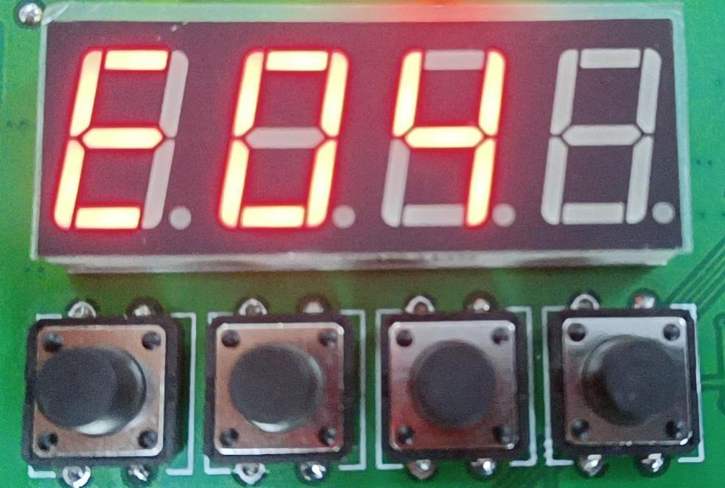

Operating instructions: The current interface cannot be operated, and only appears when an error is reported.
E01: an error is reported when the temperature is lower than 10 ℃ after heating for 2 minutes;
E02: An error is reported when the temperature does not reach the working temperature in the state of heating for half an hour without spraying;
E03: The temperature is too high and an error is reported;
E04: detect that the temperature control is abnormal and report an error;

- Wireless Interface:
1. Slave interface
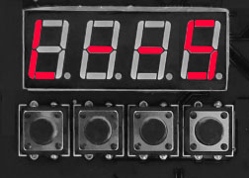
2. Host interface
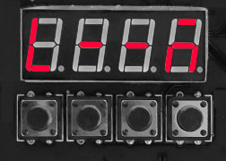

Operating instructions: press the confirmation key to enter the master-slave switch.

- 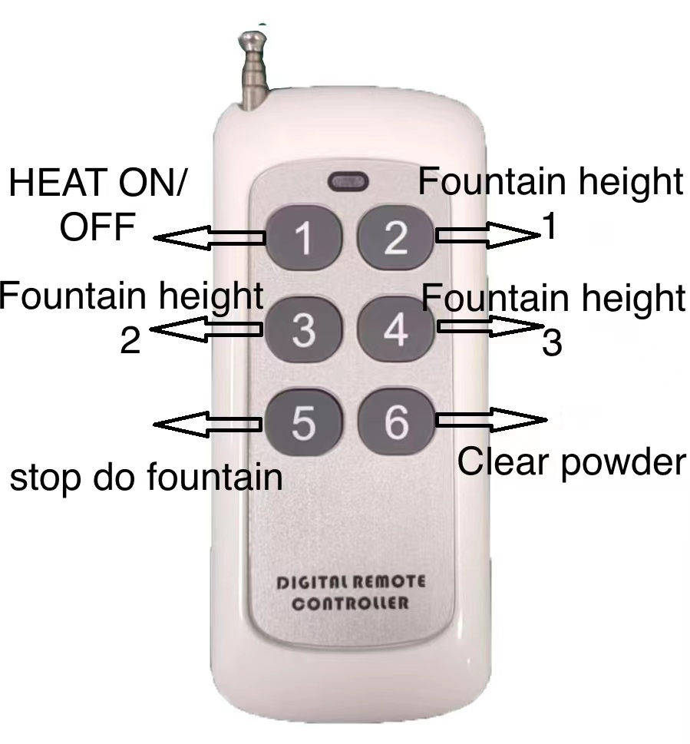Remote control instructions

1) Press key A: press it once to heat, observe that the blue indicator light is on and the temperature display interface is adjusted to heat, the heating state is increased, and press key A again to stop heating.
2) Key B: When the heating temperature is reached, press key B to select spray height 1; during spraying, press key B to stop spraying.
3) Key C: When the heating temperature is reached, press key C to select spray height 2; during spraying, press key C to stop spraying.
4) Key D: When the heating temperature is reached, press key D to select spray height 3; during the spray process, press key D to stop spraying.
5）Long Press 6 key for 5 seconds to start the function, then press 6 key once stop

