1940 Outdoor Waterproof Bee Eye Shake Head Dyeing Light
(LED Strip)
User Manual

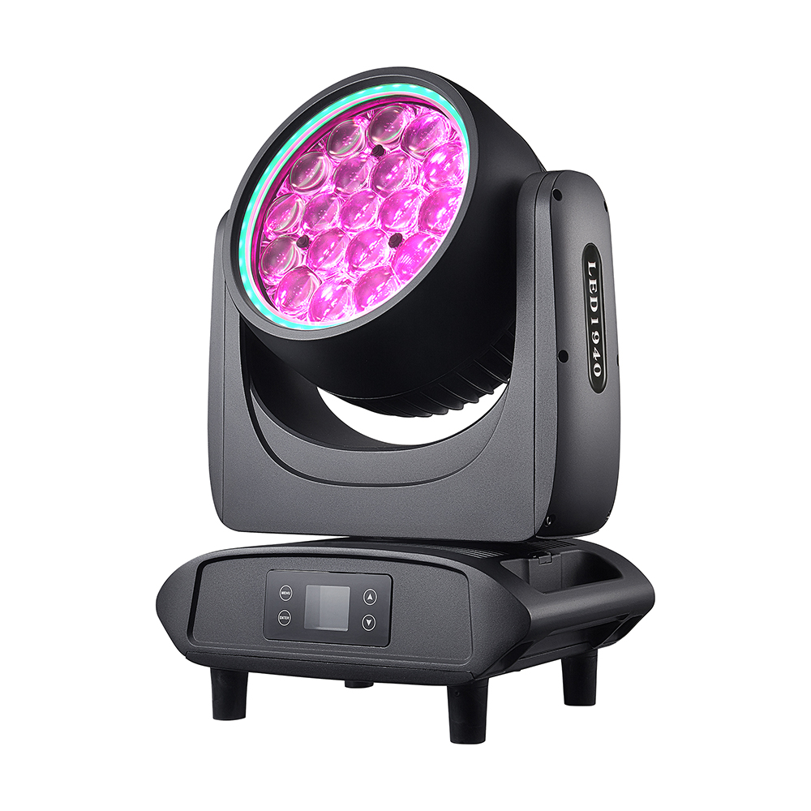

Read the instructions carefully before use

1. Remove the packaging
To ensure proper and safe use of this product, please read the instruction manual carefully before installation. This manual contains essential installation and application information. Please strictly follow the operational steps outlined in the manual during installation and operation. Additionally, please keep this manual properly.

The 19-channel focus system is engineered and manufactured to CE standards, featuring the internationally compliant DMX512 signal protocol. It supports both standalone and networked control, delivering rapid rotation, low noise, and robust functionality. Ideal for small to medium-sized venues including concerts, theaters, studios, nightclubs, and bars.

This product features 19 high-brightness, stable 40W 4-in-1 LEDs. Handle the packaging carefully when removing it. After opening, inspect the product for any damage during transportation and verify that all components are intact.

19 staining lines---------1 unit signal line--------1 unit
Manual------------1 copy Power cord--------------1 piece

2. Remove the packaging

Specifications
Voltage: AC 90–240 V, 50/60 Hz
Total Power: 800 W
Light Source: 19 pcs 4-in-1 40 W high-brightness LEDs
Beam Angle: 4–60°
Strobe: 1–25 Hz, with multiple strobe effects
Dimming: 0–100% linear dimming
Channels: 4 built-in channel modes: 21 CH / 29 CH / 53 CH / 57 CH
Control: DMX512, Auto Run, Sound Active
Pan: 540° with 16-bit fine adjustment
Tilt: 270° with 16-bit fine adjustment
Display: Chinese / English
Product Size: 328 × 252 × 419 mm
N.W.: 14 kg
Carton Size: 428 × 352 × 519 mm

- Security Notice

pay attention to ！
Handle with caution. This high-voltage product may cause electric shock if it comes into contact with live wires.

This product is in perfect condition before leaving the factory. To maintain its integrity and ensure safe operation, users must follow the safety precautions and warnings in this manual. Important: Damages caused by non-compliance with this manual are not covered by warranty. The supplier shall not be liable for any product issues arising from such non-compliance. If the product has been exposed to extreme temperature fluctuations (e.g., during transportation), do not power it on immediately, as condensation from temperature changes may damage the device. Wait until the product reaches normal temperature before use.
This product is designed for indoor use and operates within a voltage range of 90-240V. Ensure the ground voltage does not exceed the product's rated tolerance. The power plug must be inserted into a Class I socket with proper protection. The green or tea-green conductor must be properly grounded.
Regularly inspect this product's power cord. Ensure it is not folded, damaged, or scratched, and avoid connecting it to other wires. Exercise special caution when connecting the power cord or related cables. Always unplug the power supply when not in use or before cleaning.
Before using the product, familiarize yourself with its operation. Do not let children or non-professionals handle the product.
Do not shake this product. Avoid using excessive force during installation or operation. Do not let unqualified personnel operate the product. Most damages are caused by improper operation.
The product is not equipped with relevant repair parts. Maintenance and repair of the product can only be performed by professionals!
Do not modify this product without authorization, as it may cause damage that is not covered by the warranty. Additionally, improper operation may lead to short circuits, burns, or electric shocks.

4. Operation Instructions

This product is a shaking dyeing beam lamp designed to create dynamic dyeing effects.
Do not start the product immediately after significant temperature changes (e.g., post-transportation), as thermal expansion and contraction may cause damage. Wait until the equipment reaches normal room temperature before initiating operation.
--Be cautious of vibrations. Avoid strong impacts during installation.
Do not lift the entire product by the lamp head, as this may cause mechanical damage to the device.
When selecting an installation location, ensure the product is not exposed to overheating, excessive moisture, or dust. Do not place any wires on the ground, as this may pose an electric shock hazard.
--Before installing the product, ensure the installation site is secure
--Please secure the product with a safety rope and check all screws during installation
--Ensure the lens is in good condition. Replace the lens if it is damaged or scratched.
--It is recommended that this product be operated by a technician familiar with it. Non-technical personnel are prohibited from operating this device, as many incidents of loss are caused by improper operation.
Store the packaging materials properly for potential secondary transportation.
Do not modify the product without the manufacturer or distributor's guidance.
Any equipment malfunction caused by improper operation of this device as specified in the instruction manual shall not be covered by warranty. Additionally, any incidents resulting from short circuits, injuries, electric shocks, ultraviolet radiation-induced harm, or bulb explosions shall not be covered by warranty.

5. Product Hanging and Installation

Note: For safety, hang and install this product in a location away from walkways, seating areas, or within easy reach.
Before hanging this product, ensure the mounting point can support up to 10 times its weight.
The product must be equipped with a double protection device, such as a safety rope.
Do not stand under the installation point when hanging, removing, or repairing this product.
Ensure this product is installed at least 0.5 meters away from flammable materials.
Always use safety ropes as a safety measure to prevent accidents caused by loose fasteners.

Safety Tip: Top-mounted installations require highly experienced installers who can calculate load-bearing requirements, select appropriate materials, and conduct periodic safety inspections. If you lack this expertise, never attempt installation yourself. Improper handling may lead to serious consequences, including personal injury.
Before powering on the product, make sure all required hanging and installation steps are completed.
Quick-lock hanging system: This product features a specially designed professional hanging mechanism at the base, including a quick-lock hanging component and a safety rope attachment point (see diagram below).
When installing this product on the truss, use the appropriate quick-release lock to secure it at the designated quick-release lock mounting point, and fasten it with M10 screws. For added safety, attach the safety rope to the product's bottom safety rope mounting point and secure it to the truss.
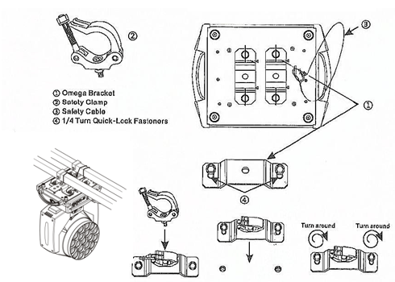
Regardless of the hanging method you choose, always use the safety rope. The product features a dedicated safety rope attachment point at the bottom (see the image above). Never attach the safety rope to the handle.

6.DMX-512 linkage

Connect the male end of the XLR signal cable to the controller's signal output port and the female end to the signal input port on the rear panel of this product. Multiple units can be connected in series. The cable must be three-core, shielded, and equipped with both XLR input and output connectors. Refer to the diagram below.
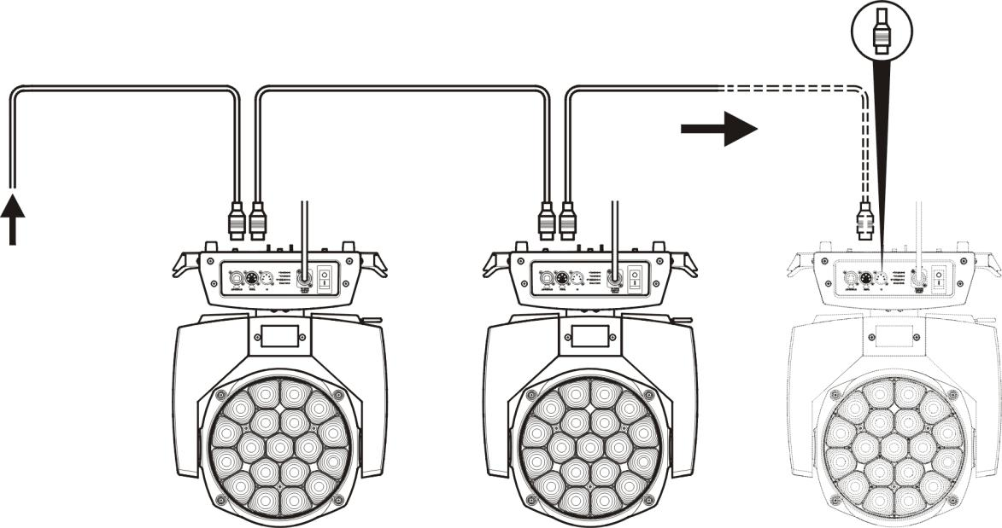
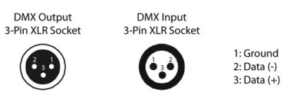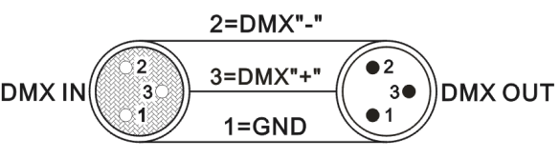

The DMX-512 connection requires a terminal (loop connection)
During installation, if signal cables are laid over long distances or in noisy environments such as dance halls, using a DMX terminal (circuit connection) is recommended to prevent digital control signal interference caused by electrical noise. The DMX terminal consists of a simple XLR connector with 2 or 3 cores and a 120-ohm resistor. Insert the terminal into the XLR output port of the last product, as shown in the figure below.
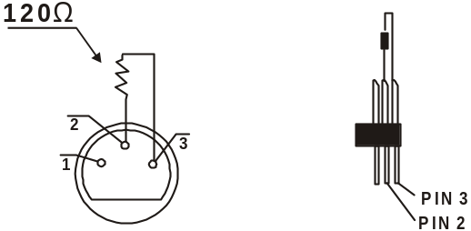

7. Menu
main interface | description | explain
temperature | 32℃ | The temperature of the light plate is 32°C.  Temperature effect on power:  The power is reduced from 70 degrees.  The power increase only begins when the temperature drops below 68 degrees (excluding 68 degrees).  The power remains constant between 68 and 69 degrees.  Turn off the lamp directly at 85 degrees.
temperature | **℃ | Temperature detection abnormal
electric fan | whack | 1) The fan runs for 15 seconds when turned on  2) The fan activates when the light panel temperature reaches 48°C and stops only when it drops below 45°C.
electric fan | Keep turning | 1) Temperature not detected  2) Communication error
address | 001 - 512 | Increment or decrement the address code by 1 or 1
signal lamp | blue | DMX signal
signal lamp | red | report an error

primary menu | Sub-menu | Three-level menu/parameters
System Settings | running mode | DMX/Voice/Trailer 1/Trailer 2
System Settings | channel pattern | 21CH/29CH/53CH/57CH
System Settings | Horizontal Inversion | On/Off
System Settings | Vertical Reversal | On/Off
System Settings | Reserve feature
System Settings | optical coupling error correction | On/Off
System Settings | signal holding | On/Off
System Settings | Screen Protector | On/Off
System Settings | Flip screen | On/Off
System Settings | Sync updates | On/Off  This feature requires the DMX cable to be unplugged.
System Settings | language | centre /EN
System Settings | factory data reset
manual mode | Manual control of channel values | 000-255
system calibration | enter password | lamp calibration
system reset | actuator motor reset | Reset the effect panel except XY
system reset | scan motor reset | Reset only the XY axis
system reset | Reset all motors | Lamp reset
system info | Reduction information | Display specific information
system info | DMX data detection | Display specific DMX detection content
system info | sensor information | Display specific information about optocouplers and Hall effect sensors
system info | Hardware version | Display hardware version
system info | software release | Display software version

◆System Settings

option | explain
running mode | The lamp supports three operating modes: DMX mode, self-driving mode, and voice-controlled mode.
running mode | DMX pattern | Console mode, receiving DMX signals, RDM signals
running mode | Autopilot Mode 1 | The lamp operates automatically according to built-in program 1
running mode | Autopilot Mode 2 | The lamp operates automatically according to built-in program 2
running mode | Voice Mode | When the lamp detects a loud sound, it automatically runs a scene according to the built-in program; otherwise, it maintains the last scene.
channel pattern | Available channel values: 21CH/29CH/53CH/57CH
Horizontal Inversion | Set X-axis rotation direction
Horizontal Inversion | close | Not reverse
Horizontal Inversion | open | opposite direction
Vertical Reversal | Set Y-axis rotation direction
Vertical Reversal | close | Not reverse
Vertical Reversal | open | opposite direction
Reserve feature
optical coupling error correction | Check if XY is out of sync and correct
optical coupling error correction | close | Failure to correct position after losing track
optical coupling error correction | open | Automatic position correction after loss of step
signal holding | The output status of the lamp when there is no DMX signal
signal holding | close | No signal detected, so the motor and light source reset to their initial positions and states.
signal holding | open | No signal detected. Maintain the last frame of DMX data output.
Screen Protector | Screen on time
Screen Protector | close | Always on
Screen Protector | open | Turn off the screen automatically in static mode
Flip screen | Set the screen orientation
Flip screen | close | Display in reverse
Flip screen | open | Reverse display
Sync updates | Sync the setup or calibration parameters of multiple lights
Sync updates | close | Sync update is disabled.
Sync updates | open | Connect multiple lamps with DMX cables to synchronize information on the calibration interface. (Note: Unplug the DMX signal cable)
language | Switch between Chinese and English menus
language | centre | the Chinese language
language | EN | English menu
factory data reset | Lamp parameters return to factory settings
factory data reset | cancel | res sic stantibus
factory data reset | affirm | Restore the lamp to factory settings

◆ manual control
This interface controls the current light. See the channel table for details.
Press OK to enter edit mode. Use the up and down keys to change channel values. Press OK again to save changes and exit edit. Press Exit to exit edit without saving changes.

◆ system calibration
A password "8888" is set here to prevent unauthorized access. Press the "OK" key to verify the password.
option | explain
initial position calibration | After entering the sub-interface, you can adjust the reset positions of motors for X-axis, Y-axis, focus adjustment, and rotation to compensate for hardware installation errors. The adjustment range is 0 to 255, with 127 indicating no adjustment.
white balance CAL | Adjust the power of individual LEDs (1-19) and the total LED output, with a range of 0 to 255, where 255 indicates no adjustment.
calibration of power | Adjust the maximum power of the entire lamp. The range is 0 to 255, with 200 indicating no adjustment.
MIC sensitivity calibration | Adjust the voice sensitivity.
change password | Set the system calibration password.

◆ reset
Press the up or down key to switch between reset modes. Press OK to reset directly.
option | explain
actuator motor reset | focus adjustment, motor reset
scan motor reset | Reset only the XY axis
Reset all motors | Lamp reset

◆ system info
option | explain
Reduction error message | If the red ERR indicator light turns on, the lamp is malfunctioning.  1) MCU1 communication failure (motor and display board communication failure)  2) MCU2 communication failure (communication between motor board and light board failed)  3) X/Y optical coupler error  4) Failed rotation and focus reset
DMX data monitoring | Enter the sub-interface to view channel values numerically. You can navigate through pages.
sensor information | 1) Hall:  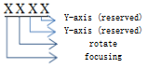  - sensor ：  X/Y optical coupler: XXXX--XXXX  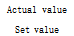
Hardware version | Hardware information of the lamp  XX . XX . XX .XX  Display board version. Motor version. Light board version.
Software version | Lamp software version  XX . XX . XX .XX  Display board version. Motor version. Light board version.

8. Channel Table
Channel table reference to original BQ channel
21CH | function | DMX numeric value | function
1 | stroboflash | 0-3 | photopigment
1 | stroboflash | 4-103 | Synchronous Stroboscopic Lighting from Slow to Fast
1 | stroboflash | 104-107 | opening the light
1 | stroboflash | 108-207 | Split Frequency Strobismus from Slow to Fast
1 | stroboflash | 208-212 | opening the light
1 | stroboflash | 213-225 | slow random stroboscopic
1 | stroboflash | 226-238 | medium speed random strobe
1 | stroboflash | 239-255 | fast random strobe
2 | aiming | 0-255 | Linear dimming from dark to bright 0-100%
3 | amplify | 0-255 | Focus range from large to small
4 | X axle | 0-255 | horizontal control
5 | X-axis fine-tuning | 0-255 | level control fine adjustment
6 | Y axle | 0-255 | vertical control
7 | Y-axis fine-tuning | 0-255 | vertical fine-tuning control
8 | macro | 0-9 | NF
8 | macro | 10-14 | All reset valid for 5 seconds
9 | Color Macro | 0-9 | NF
9 | Color Macro | 9-255 | Color Macro
10 | red | 0-255 | Red linear dimming from dark to bright 0-100%
11 | green | 0-255 | Linear dimming from dark to bright (0-100%)
12 | blue | 0-255 | Blue linear dimming from dark to light 0-100%
13 | white | 0-255 | White linear dimming from dark to bright 0-100%
14 | colour temperature | 0-9 | NF
14 | colour temperature | 10-255 | 8000K-2500K
15 | halo strobismus | 0-4 | NF
15 | halo strobismus | 5-250 | The frequency of the supplementary light flicker increases from slow to fast.
15 | halo strobismus | 251-255 | NF
16 | halo light dimming | 0-255 | Linear dimming from dark to bright 0-100%
17 | Aurora Red | 0-255 | The halo red gradually dims from dark to bright with linear dimming 0-100%
18 | Aurora Green | 0-255 | The halo green gradually dims from dark to bright with linear dimming 0-100%
19 | Aurora Blue | 0-255 | The halo blue transitions linearly from dark to bright at 0-100%
20 | Halo effect | 0-51 | NF
20 | Halo effect | 52-255 | Effect 1-47 (one effect per 4 numbers)
21 | halo effect speed | 0-255 | Halo effect speed from slow to fast

29CH | function | DMX numeric value | function
1 | stroboflash | 0-3 | photopigment
1 | stroboflash | 4-103 | Synchronous Stroboscopic Lighting from Slow to Fast
1 | stroboflash | 104-107 | opening the light
1 | stroboflash | 108-207 | Split Frequency Strobismus from Slow to Fast
1 | stroboflash | 208-212 | opening the light
1 | stroboflash | 213-225 | slow random stroboscopic
1 | stroboflash | 226-238 | medium speed random strobe
1 | stroboflash | 239-255 | fast random strobe
2 | aiming | 0-255 | Linear dimming from dark to bright 0-100%
3 | dimming fine adjustment | 0-255 | Linear dimming from dark to bright 0-1%
4 | amplify | 0-255 | Focus range from large to small
5 | X axle | 0-255 | horizontal control
6 | X-axis fine-tuning | 0-255 | level control fine adjustment
7 | Y axle | 0-255 | vertical control
8 | Y-axis fine-tuning | 0-255 | vertical fine-tuning control
9 | macro | 0-9 | NF
9 | macro | 10-14 | All reset valid for 5 seconds
10 | Color Macro | 0-9 | NF
10 | Color Macro | 9-255 | Color Macro
11 | red | 0-255 | Red linear dimming from dark to bright 0-100%
12 | Red fine-tuning | 0-255 | Red fine-tuning: linear dimming from dark to bright (0-1%)
13 | green | 0-255 | Linear dimming from dark to bright (0-100%)
14 | Green fine-tuning | 0-255 | Green fine-tuning for linear dimming from dark to bright (0-1%)
15 | blue | 0-255 | Blue linear dimming from dark to light 0-100%
16 | Blue fine-tuning | 0-255 | Blue fine-tuning: linear dimming from dark to bright (0-1%)
17 | white | 0-255 | White linear dimming from dark to bright 0-100%
18 | White fine-tuning | 0-255 | White fine-tuning: linear dimming from dark to bright (0-1%)
19 | colour temperature | 0-9 | NF
19 | colour temperature | 10-255 | 8000K-2500K
20 | effect | 0-9 | NF
20 | effect | 10-255 | Effect 1-5 (one effect per 50 numbers)
21 | Effect speed | 0-63 | Static effect
21 | Effect speed | 64-158 | From fast to slow in the forward direction
21 | Effect speed | 159-160 | static
21 | Effect speed | 161-255 | Reverse from slow to fast
22 | Effect fade | 0-255 | Effect duration from longest to shortest
23 | halo strobismus | 0-4 | NF
23 | halo strobismus | 5-250 | The frequency of the supplementary light flicker increases from slow to fast.
23 | halo strobismus | 251-255 | NF
24 | halo light dimming | 0-255 | Linear dimming from dark to bright 0-100%
25 | Aurora Red | 0-255 | The halo red gradually dims from dark to bright with linear dimming 0-100%
26 | Aurora Green | 0-255 | The halo green gradually dims from dark to bright with linear dimming 0-100%
27 | Aurora Blue | 0-255 | The halo blue transitions linearly from dark to bright at 0-100%
28 | Halo effect | 0-51 | NF
28 | Halo effect | 52-255 | Effect 1-47 (one effect per 4 numbers)
29 | halo effect speed | 0-255 | Halo effect speed from slow to fast

53CH | function | DMX numeric value | function
1 | stroboflash | 0-3 | photopigment
1 | stroboflash | 4-103 | Synchronous Stroboscopic Lighting from Slow to Fast
1 | stroboflash | 104-107 | opening the light
1 | stroboflash | 108-207 | Split Frequency Strobismus from Slow to Fast
1 | stroboflash | 208-212 | opening the light
1 | stroboflash | 213-225 | slow random stroboscopic
1 | stroboflash | 226-238 | medium speed random strobe
1 | stroboflash | 239-255 | fast random strobe
2 | aiming | 0-255 | Linear dimming from dark to bright 0-100%
3 | dimming fine adjustment | 0-255 | Linear dimming from dark to bright 0-1%
4 | amplify | 0-255 | Focus range from large to small
5 | X axle | 0-255 | horizontal control
6 | X-axis fine-tuning | 0-255 | level control fine adjustment
7 | Y axle | 0-255 | vertical control
8 | Y-axis fine-tuning | 0-255 | vertical fine-tuning control
9 | macro | 0-9 | NF
9 | macro | 10-14 | All reset valid for 5 seconds
10 | Color Macro | 0-9 | NF
10 | Color Macro | 9-255 | Color Macro
11 | red | 0-255 | Red linear dimming from dark to bright 0-100%
12 | Red fine-tuning | 0-255 | Red fine-tuning: linear dimming from dark to bright (0-1%)
13 | green | 0-255 | Linear dimming from dark to bright (0-100%)
14 | Green fine-tuning | 0-255 | Green fine-tuning for linear dimming from dark to bright (0-1%)
15 | blue | 0-255 | Blue linear dimming from dark to light 0-100%
16 | Blue fine-tuning | 0-255 | Blue fine-tuning: linear dimming from dark to bright (0-1%)
17 | white | 0-255 | White linear dimming from dark to bright 0-100%
18 | White fine-tuning | 0-255 | White fine-tuning: linear dimming from dark to bright (0-1%)
19 | Red 1 | 0-255 | Red 1: Linear dimming from dark to bright (0-100%)
20 | Red 1 fine-tuning | 0-255 | Red 1: Linear dimming from dark to bright (0-1%)
21 | Green 1 | 0-255 | Green 1: Linear dimming from dark to bright (0-100%)
22 | Green 1 fine-tune | 0-255 | Green 1: Linear dimming from dark to bright (0-1%)
23 | Blue 1 | 0-255 | Blue 1: Linear dimming from dark to light (0-100%)
24 | Blue 1 Fine Adjustment | 0-255 | Blue 1: Linear dimming from dark to bright (0-1%)
25 | White 1 | 0-255 | White 1: Linear dimming from dark to bright (0-100%)
26 | White 1 fine-tuning | 0-255 | White 1: Linear dimming from dark to bright (0-1%)
27 | Red 2 | 0-255 | Red 2: Linear dimming from dark to bright (0-100%)
28 | Red 2 fine-tuning | 0-255 | Red 2: Linear dimming from dark to bright (0-1%)
29 | Green 2 | 0-255 | Green 2: Linear dimming from dark to bright (0-100%)
30 | Green 2 Fine-tuning | 0-255 | Green 2: Linear dimming from dark to bright (0-1%)
31 | Blue 2 | 0-255 | Blue 2: Linear dimming from dark to bright (0-100%)
32 | Blue 2 Fine-Tune | 0-255 | Blue 2: Linear dimming from dark to bright (0-1%)
33 | White 2 | 0-255 | White 2: Linear dimming from dark to bright (0-100%)
34 | White 2 fine-tuning | 0-255 | Adjust the white 2 from dark to bright with linear dimming 0-1%
35 | Red 3 | 0-255 | Red 3: Linear dimming from dark to bright (0-100%)
36 | Red 3 fine-tuning | 0-255 | Red 3: Linear dimming from dark to bright (0-1%)
37 | Green 3 | 0-255 | Green 3: Linear dimming from dark to bright (0-100%)
38 | Green 3 Fine-tuning | 0-255 | Green 3: Linear dimming from dark to bright (0-1%)
39 | Blue 3 | 0-255 | Blue 3: Linear dimming from dark to bright (0-100%)
40 | Blue 3 Fine Adjustment | 0-255 | Blue 3: Linear dimming from dark to bright (0-1%)
41 | White 3 | 0-255 | White 3: Linear dimming from dark to bright (0-100%)
42 | White 3 fine-tuning | 0-255 | White 3: Linear dimming from dark to bright (0-1%)
43 | colour temperature | 0-9 | NF
43 | colour temperature | 10-255 | 8000K-2500K
44 | effect | 0-9 | NF
44 | effect | 10-255 | Effect 1-5 (one effect per 50 numbers)
45 | Effect speed | 0-63 | Static effect
45 | Effect speed | 64-158 | From fast to slow in the forward direction
45 | Effect speed | 159-160 | static
45 | Effect speed | 161-255 | Reverse from slow to fast
46 | Effect fade | 0-255 | Effect duration from longest to shortest
47 | halo strobismus | 0-4 | NF
47 | halo strobismus | 5-250 | The frequency of the supplementary light flicker increases from slow to fast.
47 | halo strobismus | 251-255 | NF
48 | halo light dimming | 0-255 | Linear dimming from dark to bright 0-100%
49 | Aurora Red | 0-255 | The halo red gradually dims from dark to bright with linear dimming 0-100%
50 | Aurora Green | 0-255 | The halo green gradually dims from dark to bright with linear dimming 0-100%
51 | Aurora Blue | 0-255 | The halo blue transitions linearly from dark to bright at 0-100%
52 | Halo effect | 0-51 | NF
52 | Halo effect | 52-255 | Effect 1-47 (one effect per 4 numbers)
53 | halo effect speed | 0-255 | Halo effect speed from slow to fast

57CH | function | DMX numeric value | function
1 | stroboflash | 0-3 | photopigment
1 | stroboflash | 4-103 | Synchronous Stroboscopic Lighting from Slow to Fast
1 | stroboflash | 104-107 | opening the light
1 | stroboflash | 108-207 | Split Frequency Strobismus from Slow to Fast
1 | stroboflash | 208-212 | opening the light
1 | stroboflash | 213-225 | slow random stroboscopic
1 | stroboflash | 226-238 | medium speed random strobe
1 | stroboflash | 239-255 | fast random strobe
2 | aiming | 0-255 | Linear dimming from dark to bright 0-100%
3 | dimming fine adjustment | 0-255 | Linear dimming from dark to bright 0-1%
4 | amplify | 0-255 | Focus range from large to small
5 | X axle | 0-255 | horizontal control
6 | X-axis fine-tuning | 0-255 | level control fine adjustment
7 | Y axle | 0-255 | vertical control
8 | Y-axis fine-tuning | 0-255 | vertical fine-tuning control
9 | macro | 0-9 | NF
9 | macro | 10-14 | All reset valid for 5 seconds
10 | Color Macro | 0-9 | NF
10 | Color Macro | 9-255 | Color Macro
11 | red | 0-255 | Red linear dimming from dark to bright 0-100%
12 | Red fine-tuning | 0-255 | Red fine-tuning: linear dimming from dark to bright (0-1%)
13 | green | 0-255 | Linear dimming from dark to bright (0-100%)
14 | Green fine-tuning | 0-255 | Green fine-tuning for linear dimming from dark to bright (0-1%)
15 | blue | 0-255 | Blue linear dimming from dark to light 0-100%
16 | Blue fine-tuning | 0-255 | Blue fine-tuning: linear dimming from dark to bright (0-1%)
17 | white | 0-255 | White linear dimming from dark to bright 0-100%
18 | White fine-tuning | 0-255 | White fine-tuning: linear dimming from dark to bright (0-1%)
19 | Red 1 | 0-255 | Red 1: Linear dimming from dark to bright (0-100%)
20 | Red 1 fine-tuning | 0-255 | Red 1: Linear dimming from dark to bright (0-1%)
21 | Green 1 | 0-255 | Green 1: Linear dimming from dark to bright (0-100%)
22 | Green 1 fine-tune | 0-255 | Green 1: Linear dimming from dark to bright (0-1%)
23 | Blue 1 | 0-255 | Blue 1: Linear dimming from dark to light (0-100%)
24 | Blue 1 Fine Adjustment | 0-255 | Blue 1: Linear dimming from dark to bright (0-1%)
25 | White 1 | 0-255 | White 1: Linear dimming from dark to bright (0-100%)
26 | White 1 fine-tuning | 0-255 | White 1: Linear dimming from dark to bright (0-1%)
27 | Red 2 | 0-255 | Red 2: Linear dimming from dark to bright (0-100%)
28 | Red 2 fine-tuning | 0-255 | Red 2: Linear dimming from dark to bright (0-1%)
29 | Green 2 | 0-255 | Green 2: Linear dimming from dark to bright (0-100%)
30 | Green 2 Fine-tuning | 0-255 | Green 2: Linear dimming from dark to bright (0-1%)
31 | Blue 2 | 0-255 | Blue 2: Linear dimming from dark to bright (0-100%)
32 | Blue 2 Fine-Tune | 0-255 | Blue 2: Linear dimming from dark to bright (0-1%)
33 | White 2 | 0-255 | White 2: Linear dimming from dark to bright (0-100%)
34 | White 2 fine-tuning | 0-255 | Adjust the white 2 from dark to bright with linear dimming 0-1%
35 | Red 3 | 0-255 | Red 3: Linear dimming from dark to bright (0-100%)
36 | Red 3 fine-tuning | 0-255 | Red 3: Linear dimming from dark to bright (0-1%)
37 | Green 3 | 0-255 | Green 3: Linear dimming from dark to bright (0-100%)
38 | Green 3 Fine-tuning | 0-255 | Green 3: Linear dimming from dark to bright (0-1%)
39 | Blue 3 | 0-255 | Blue 3: Linear dimming from dark to bright (0-100%)
40 | Blue 3 Fine Adjustment | 0-255 | Blue 3: Linear dimming from dark to bright (0-1%)
41 | White 3 | 0-255 | White 3: Linear dimming from dark to bright (0-100%)
42 | White 3 fine-tuning | 0-255 | White 3: Linear dimming from dark to bright (0-1%)
43 | colour temperature | 0-9 | NF
43 | colour temperature | 10-255 | 8000K-2500K
44 | effect | 0-9 | NF
44 | effect | 10-255 | Effect 1-5 (one effect per 50 numbers)
45 | Effect speed | 0-63 | Static effect
45 | Effect speed | 64-158 | From fast to slow in the forward direction
45 | Effect speed | 159-160 | static
45 | Effect speed | 161-255 | Reverse from slow to fast
46 | Effect fade | 0-255 | Effect duration from longest to shortest
47 | Effect Background Color | 0-255 | Effect background color: Linear dimming from dark to light 0-100%
48 | Background color | 0-255 | Effect background color: Linear dimming from dark to light 0-100%
49 | Effect Background Color | 0-255 | Effect background color: Linear dimming from dark to light 0-100%
50 | Effect Background White | 0-255 | Effect: Background white linearly dims from dark to light 0-100%
51 | halo strobismus | 0-4 | NF
51 | halo strobismus | 5-250 | The frequency of the supplementary light flicker increases from slow to fast.
51 | halo strobismus | 251-255 | NF
52 | halo light dimming | 0-255 | Linear dimming from dark to bright 0-100%
53 | Aurora Red | 0-255 | The halo red gradually dims from dark to bright with linear dimming 0-100%
54 | Aurora Green | 0-255 | The halo green gradually dims from dark to bright with linear dimming 0-100%
55 | Aurora Blue | 0-255 | The halo blue transitions linearly from dark to bright at 0-100%
56 | Halo effect | 0-51 | NF
56 | Halo effect | 52-255 | Effect 1-47 (one effect per 4 numbers)
57 | halo effect speed | 0-255 | Halo effect speed from slow to fast

9. Product Maintenance and Cleaning
When testing this product, please note the following points:
- All screws and components of installed products must be securely fastened and rust-free.
- The housing, lenses, fasteners, and mounting locations (e.g., ceilings, brackets, trusses, etc.) must remain undistorted.
- The moving parts of the machine should not be worn out or rotate unbalance.
- The power cord must be free from any damage, including material peeling or scratches.
The installation and use of the product must be performed by trained professional technicians to ensure the elimination of safety hazards.
Note: Please unplug the power cord before product maintenance!!

To maintain optimal product condition and prolong its service life, we recommend routine cleaning.
1. Clean both the external and internal lenses weekly to prevent dust buildup that could reduce the product's light output.
2. Clean the fan every week.
3. Every three months, a certified electrical engineer conducts a thorough circuit inspection to ensure proper connections, preventing aging caused by overheating.
We recommend regular cleaning of the product. Please note that do not use damp or linen cloths, and absolutely avoid using alcohol or solvents for cleaning.
This product does not include replacement parts. Refer to the "Installation Instructions" section.
If you need any spare parts, purchase them from your local dealer.

