Product Technical Specification (Moving Head Light Series)
Product Image |  |  | Product Dimension Drawing
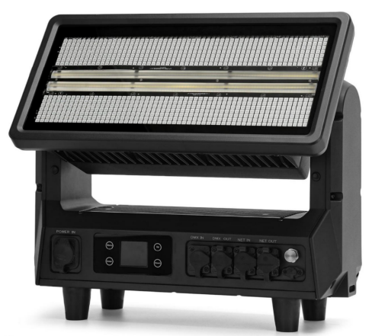 |  |  | 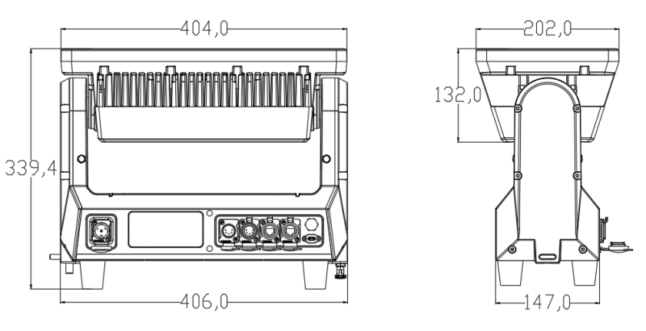
Lighting Specifications |  |  |  | Parameters
Product Name | Waterproof Moving Head Strobe Light | Light Color | Black | Input Voltage: AC100V-240V 50/60HZ  Power Consumption: 1400W  RGB color washing light source：  784 pcs×1.5W×3-color 5050 LED  White light strobe light source：  392 pcs×2W Cool White LED  RGB Zones：14 independently controllable zones  White Light Zones：28 independently controllable zones  CCT：Approx. 6000K (Daylight)  Beam Angle：Combined light 98°×57°, strobe light 95°× 50°  Luminous Flux：Up to 71620 lumens  Tilt Range：180°electronic tilt  Operating Temperature: -10℃～+40℃  Dimming：16-bit high-precision dimming for ultra-smooth transitions  Strobe：Electronic strobe, rate 0–30 Hz  Other Features：Adjustable PWM frequency (up to 25kHz) for flicker-free filming  Control Mode: DMX、Art-Net、sACN、RDM  Channel：8CH /11CH /13CH /14CH /24CH /30CH /47CH /74CH /97CH  IP Rating:IP65  Product Dimensions: 406*339.4*202mm  Net Weight: 11.5kg  in-1 strobe & wash effect, 180° electric pan, rich varied effects.  High brightness output, pixel-level precise control, ideal for large stages and outdoor performances.
Net Weight | 11.5kg | Gross Weight | 14.5kg
Product Dimensions | 406*339.4*202mm | Lighting Material | All-magnesium alloy body
Optical System/Effect System
RGB color washing light source | 784 pcs×1.5W×3-color 5050 LED | White light strobe light source | 392 pcs×2W Cool White LED
RGB Zones | 14 independently controllable zones | White Light Zones | 28 independently controllable zones
Beam Angle | Combined light 98°×57°, strobe light 95°× 50° | CCT | Approx. 6000K (Daylight)
Tilt Range | 180°electronic tilt | Dimming | 16-bit high-precision dimming for ultra-smooth gradient effect
Luminous Flux | Up to 71620 lumens | Strobe | Electronic strobe, rate 0–30 Hz
Effect Light | - in-1 strobe & wash effect, 180° electric pan, rich varied effects. | Other Features | Adjustable PWM frequency (up to 25kHz) for flicker-free filming
Electrical Connection |  | Control System
Input Voltage | AC100V-240V 50/60HZ | Mechanical Movement | Vertical Scanning Angle 221°, Automatic Return Correction and 16bit Precision Fine-Tuning Function
Total Lamp Power | 1400W | Communication Design | DMX Wired/Wireless Transmission, Convenient and Fast Software Upgrade via DMX Data Cable
Signal Connection | 3-pin / 5-pin waterproof signal cable & XLR socket & RJ45 interface | Heat Dissipation System | Fan Heat Dissipation Structure and Temperature Intelligent Monitoring Technology, Automatically Adjusts Heat Dissipation System to Effectively Control Lamp Temperature
Power Connection | Waterproof Power I/O & Xishan Connector I/O | Control Protocol | DMX、Art-Net、sACN、RDM
Display Screen | Fixture and lamp usage time can be queried for easy maintenance | Channel Mode | 8CH/11CH/13CH/14CH/24CH/30CH/47CH/74CH/97CH
Photometric Diagram
