Four in one cutting lamp

operation instruction

Please read the instructions carefully before use.

catalogue
1. Matters needing attention and installation one
1.1 statement one
1.2 maintenance one
1.3 Product Precautions one
1.4 Product introduction one
1.5 signal line connection 2
1.6 Installation of lamps 2
2 control panel four
2.1 key description four
2.2 main menu five
2.2.1 Settings five
3-channel function six
3.1 channel table six
4 Common faults one0

Precautions and installation
  - statement
Thank you for choosing our products! This product is in good condition and the packaging is complete when it leaves the factory. For your safe and effective use of this product, please read this instruction carefully and completely before using this product. This instruction manual contains important information for installation and use. Please follow the instructions for installation and operation. At the same time, please take good care of this instruction manual for use from time to time. Our company is not responsible for the damage to lamps or other performance caused by personal failure to follow the instructions during installation, use or maintenance.
This manual is subject to technical changes without prior notice.
  - maintain
- Disconnect the power supply before maintenance.
- The lamp tube should be kept dry to avoid working in wet environment.
- Intermittent use will effectively prolong the service life of lamps.
- In order to prolong the service life of lamps, please clean the fan, fan net and lens frequently.
- Do not rub the lamp housing with organic solvents such as alcohol to avoid damage.
  - Precautions for products
- This lamp is for professional use only.
- Ensure that the power supply voltage is consistent with the equipment requirements before operation.
- Do not place this product where it is easy to loosen or shake.
- In the process of use, if the lamp is abnormal, stop using the lamp in time.
- In order to ensure the service life of the product, the product should not be placed in a damp or leaking place, nor should it work in an environment where the temperature exceeds 60 degrees.
- After the power failure, it takes 20 minutes to completely cool the lamp before using the power supply again.
- The rotating parts of lamps and lanterns and the attached accessories must be inspected regularly. If it is loose and shaking, it should be reinforced in time to prevent accidents.
- To ensure the normal use of this product, please read the instructions carefully.
  - Product introduction
- Power of light source:
- Power supply: AC 200V~240V/50~60Hz;
- Color wheel 1: each color wheel consists of 5 color wheels+white light;
- Color wheel 2: includes cmyfunction;
- Color wheel 3: contains CTO function
- Pattern plate: 6 patterns+white circle;
- Glass pattern: 7 patterns+white circle;
- 540 translation and 270 inclination;
- Overheating protection;
- Control mode: DMX512/ master-slave/automatic;
- IP20 protection level

  - Signal wire connection
Lamps and lanterns have standard DMX input and output 3-core or 5-core XLR sockets. Use the shielded twisted pair signal line specially designed for DMX 512; Signal lines are generally connected at 150 meters, and DMX512 signal amplifier must be added for long-distance signal transmission.
Connect the shielded twisted pair signal line from the DMX socket of the controller to the DMX input of the first device, from the DMX socket of the first device to the DMX input of the second device, and so on until all the lights are connected. Then install a terminal plug on the 3-core jack of the last connected lamp outlet on each circuit. (Weld a 4/1W, 120Ω resistor between pins 2 and 3 of the 3-pin cannon plug).

Important: The wires should not touch each other or the metal casing.

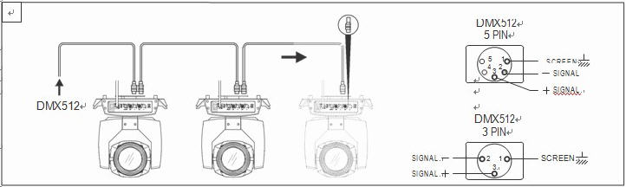
Fig. 1 schematic diagram of DMX signal line connection

Calculation method of starting address code of lamps;

The initial address code of the current lamp is equal to (the initial address code of the previous lamp) (the number of channels of the lamp)
1: The starting address code value A001 of the first lamp.

2. The number of basic channels of the controller should be greater than or equal to the total number of channels used by the lamp.

3. Note: When using any controller, each lamp should have its own initial address code. If the initial address code of the first lamp is set to 001, the number of lamp channels is 24CH; Then the beginning of the second lamp address code is set to 025; The initial address code of the third lamp is set to 050; And so on (this setting also needs to be determined according to different control platforms).

  - fix

Lamps can be placed horizontally, obliquely and upside down. Pay attention to the installation method when hanging obliquely and upside down.
As shown in Figure 2, before positioning the lamps, the stability of the installation site must be ensured. When installing the reverse suspension, it must be ensured that the lamp will not fall on the support frame. Safety ropes passing through the support frame and auxiliary suspended light handles must be used to ensure safety. Prevent lamps from falling and sliding.
.
When installing and debugging lamps, pedestrians are forbidden to pass under them. Regularly check whether the safety rope is worn and whether the hook screw is loose.

Our company will not take any responsibility for all the consequences caused by the unstable installation of chandeliers.

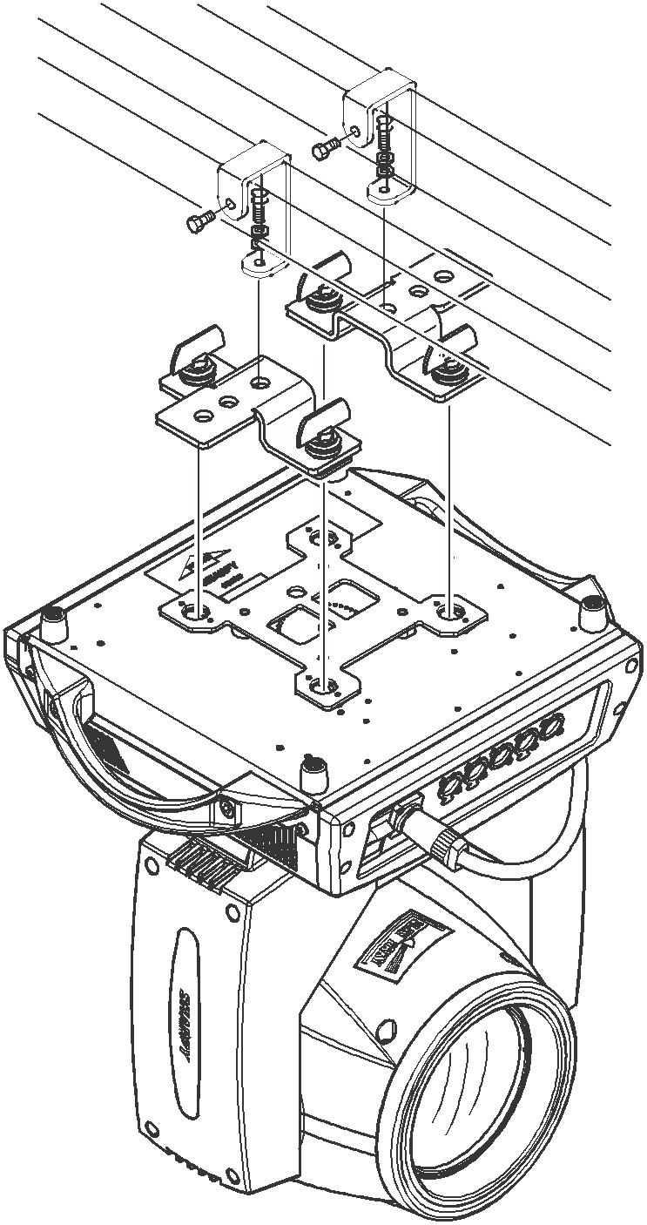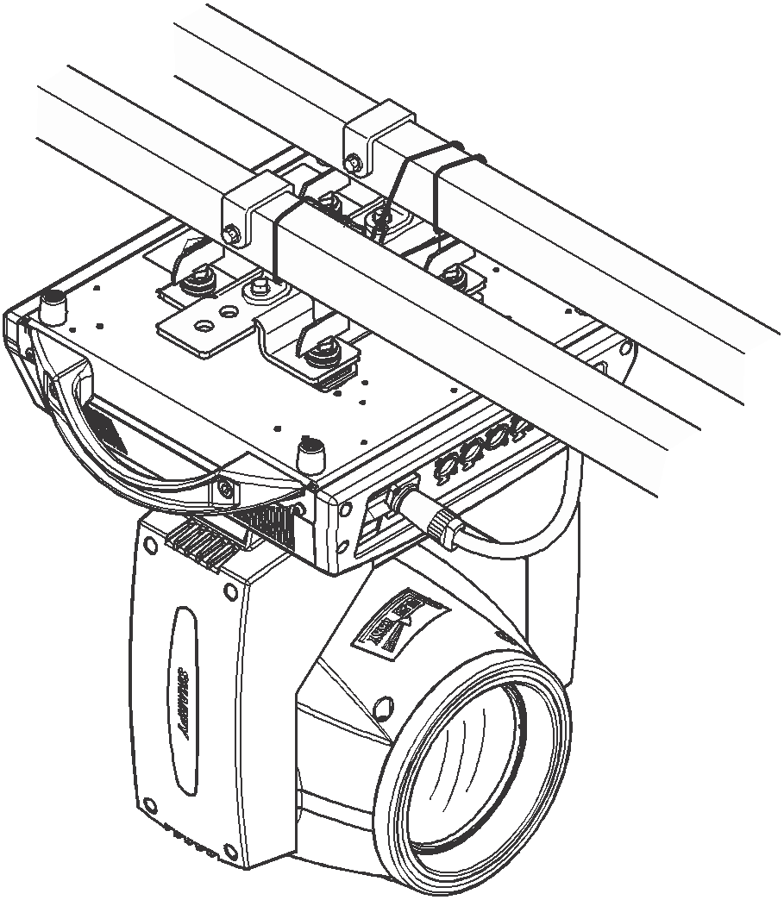
Schematic diagram of upside-down lamp

control panel

2.1 key description
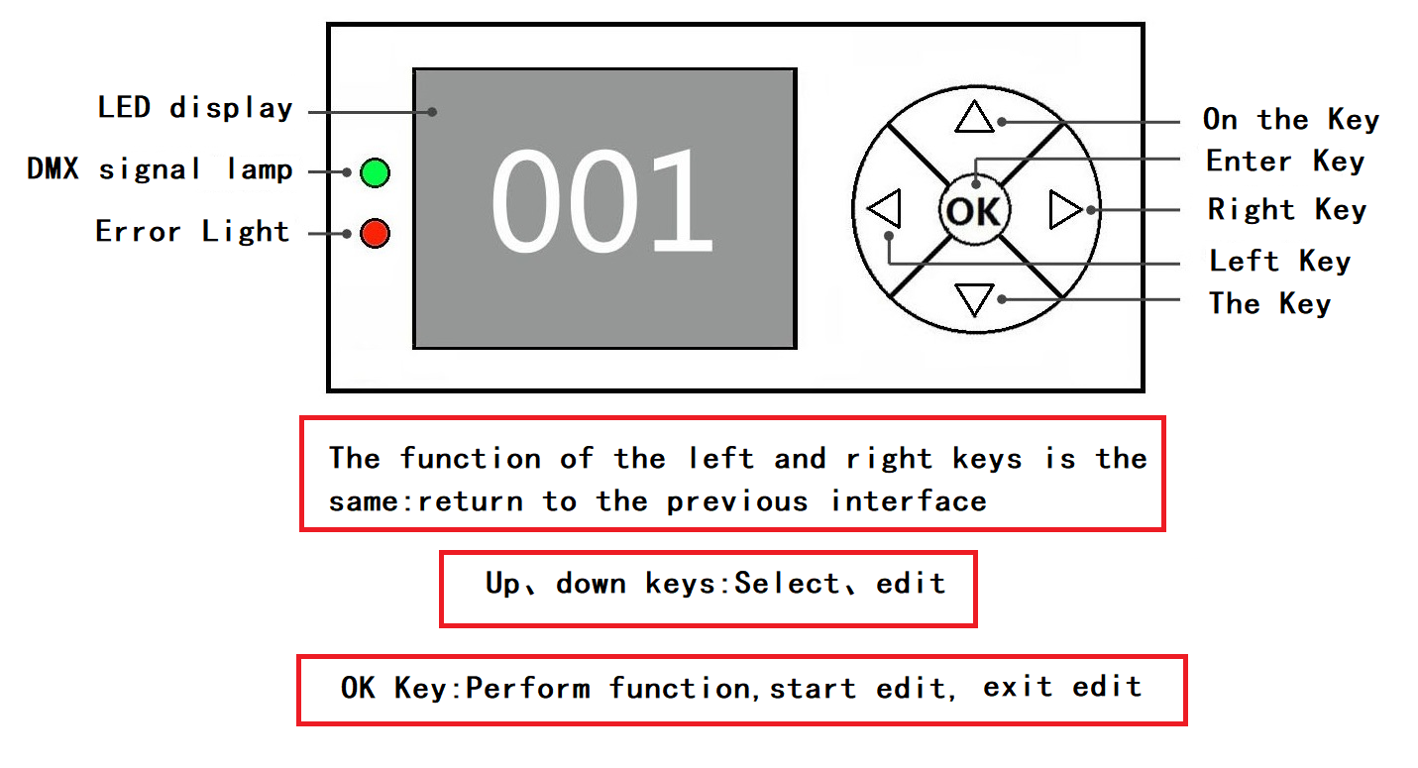
Figure 3 Schematic diagram of key descriptions on the panel

Take "Modify DMX Address Code" as an example to introduce the usage of keys:

1. If it is not the main interface at present, press the "Left" key (one or more times) to return to the main interface.

2. In the main interface, press the "Up" key or the "Down" key to select the "DMX Settings" button.

3. Press "OK" key to enter "DMX Settings" interface.

4. Press the "Up" or "Down" key to modify the DMX address code.

5. Press "OK" to exit the editing status.

6. Right click on the main interface to enter the shortcut key of calibration interface.

7. Note: The shortcut keys at the bottom of the main interface, Chinese/English, screen hovering and reset, can only be touched manually, but not pressed.

2.2.1DMX settings

Key description: press up or down to 1 or -1 mode; Right click is next; Press the left and confirm button to save and exit.
2.2.2 Menu
First-level menu | Secondary menu | Three-level menu | Four-level menu | Five-level menu
DMX settings | DMX address | 1 - 512
DMX settings | Channel mode | 24CH
DMX settings | operational mode | DMX
DMX settings | operational mode | automatic
DMX settings | operational mode | sound-controlled
Effect setting | Horizontal reversal | no
Effect setting | Horizontal reversal | be
Effect setting | T vertical inversion | no
Effect setting | T vertical inversion | be
Effect setting | Vertical feedback | close
Effect setting | Vertical feedback | open
Effect setting | Dimming curve | straight line
Effect setting | Dimming curve | Square law
Effect setting | Dimming curve | Inverse square law
Effect setting | Dimming curve | S- curve
Effect setting | Dimming frequency | 600 Hz
Effect setting | Dimming frequency | 1200
Effect setting | Dimming frequency | 2400 Hz
Effect setting | Dimming frequency | 4800 Hz
Effect setting | Dimming frequency | 9600 Hz
Effect setting | Dimming frequency | 12,000 Hz
Effect setting | Dimming frequency | 24,000 Hz
Effect setting | No signal mode | Fade to Black
Effect setting | No signal mode | keep
Effect setting | Master-slave mode | From the machine
Effect setting | Master-slave mode | M host
Effect setting | Acoustic sensitivity | 10 - 100
display setting | Display direction | Normal/normal
display setting | Display direction | Rotate 180/rotate 180
display setting | Display brightness | 1-100
display setting | Temperature unit | °C
display setting | Temperature unit | °F
display setting | language | English
display setting | language | Chinese
Motor reset | department | no
Motor reset | department | be
Motor reset | perpendicular/vertical | no
Motor reset | perpendicular/vertical | be
Motor reset | head | no
Motor reset | head | be
Manual control | level | 0 - 255
Manual control | . . . | 0 - 255
Manual control | Function setting | 0 - 255
MX reality | level | 0 - 255
MX reality | . . . | 0 - 255
MX reality | Function setting | 0 - 255
service | password | rectify | Motor calibration | level | -128 -> 127
 |  |  |  | . . . | -128 -> 127
service | password | Restore factory settings | no

Channel table:
passage | function | Channel value |  |  | effect
35 channel | function |  |  |  | effect
one | Pan/level | 000 | - | 255 | 0-100%
2 | PanFine/horizontal fine adjustment | 000 | - | 255 | 0-100%
three | Tilt/vertical | 000 | - | 255 | 0-100%
four | TiltFine/vertical fine adjustment | 000 | - | 255 | 0-100%
five | PanTiltSpeed/horizontal vertical speed | 000 | - | 255 | Horizontal vertical speed, fast to slow
six | Strobe/strobe | 000 | - | 009 | consecrate
six | Strobe/strobe | 010 | - | 199 | Synchronous strobe is slow to fast.
six | Strobe/strobe | 200 | - | 249 | Asynchronous strobe is slow to fast.
six | Strobe/strobe | 250 | - | 255 | consecrate
seven | Dimmer/dimming | 000 | - | 255 | Dimming from 0% to 100%
eight | Cyan/cyan | 000 | - | 255 | From shallow to deep
nine | Magenta/magenta | 000 | - | 255 | From shallow to deep
10 | Yellow/yellow | 000 | - | 255 | From shallow to deep
11 | CTO/color temperature | 000 | - | 255 | From shallow to deep
twelve | Colour1/color wheel 1 | 000 | - | 009 | white light
twelve | Colour1/color wheel 1 | 010 | - | 019 | Color 1
twelve | Colour1/color wheel 1 | 020 | - | 029 | Color 2
twelve | Colour1/color wheel 1 | 030 | - | 039 | Color 3
twelve | Colour1/color wheel 1 | 040 | - | 049 | Color 4
twelve | Colour1/color wheel 1 | 050 | - | 059 | Color 5
twelve | Colour1/color wheel 1 | 060 | - | 069 | Color 5+ color 4
twelve | Colour1/color wheel 1 | 070 | - | 079 | Color 4+ Color 3
twelve | Colour1/color wheel 1 | 080 | - | 089 | Color 3+ Color 2
twelve | Colour1/color wheel 1 | 090 | - | 099 | Color 2+ Color 1
twelve | Colour1/color wheel 1 | 100 | - | 109 | Color 1+ white light
twelve | Colour1/color wheel 1 | 110 | - | 255 | Turn slowly to fast.
13 | CRI/demonstrative finger | 000 | - | 127 | white light
13 | CRI/demonstrative finger | 128 | - | 255 | Finger cutting
14 | FixGobo/fixed pattern | 000 | - | 009 | white light
14 | FixGobo/fixed pattern | 010 | - | 019 | Pattern 1
14 | FixGobo/fixed pattern | 020 | - | 029 | Pattern 2
14 | FixGobo/fixed pattern | 030 | - | 039 | Pattern 3
14 | FixGobo/fixed pattern | 040 | - | 049 | Pattern 4
14 | FixGobo/fixed pattern | 050 | - | 059 | Pattern 5
14 | FixGobo/fixed pattern | 060 | - | 069 | Pattern 6
14 | FixGobo/fixed pattern | 070 | - | 079 | Pattern 1 jitter from slow to fast.
14 | FixGobo/fixed pattern | 080 | - | 089 | Pattern 2 jitter from slow to fast.
14 | FixGobo/fixed pattern | 090 | - | 099 | Pattern 3 jitter from slow to fast.
14 | FixGobo/fixed pattern | 100 | - | 109 | Pattern 4 jitter from slow to fast.
14 | FixGobo/fixed pattern | 110 | - | 119 | Pattern 5 jitter from slow to fast.
14 | FixGobo/fixed pattern | 120 | - | 129 | Pattern 6 jitter from slow to fast.
14 | FixGobo/fixed pattern | 130 | - | 191 | Turn fast to slow.
14 | FixGobo/fixed pattern | 192 | - | 255 | Reverse slowly to quickly.
15 | RotGobo/rotating pattern | 000 | - | 009 | white light
15 | RotGobo/rotating pattern | 010 | - | 019 | Pattern 1
15 | RotGobo/rotating pattern | 020 | - | 029 | Pattern 2
15 | RotGobo/rotating pattern | 030 | - | 039 | Pattern 3
15 | RotGobo/rotating pattern | 040 | - | 049 | Pattern 4
15 | RotGobo/rotating pattern | 050 | - | 059 | Pattern 5
15 | RotGobo/rotating pattern | 060 | - | 069 | Pattern 6
15 | RotGobo/rotating pattern | 070 | - | 079 | Pattern 7
15 | RotGobo/rotating pattern | 080 | - | 089 | Pattern 1 jitter from slow to fast.
15 | RotGobo/rotating pattern | 090 | - | 099 | Pattern 2 jitter from slow to fast.
15 | RotGobo/rotating pattern | 100 | - | 109 | Pattern 3 jitter from slow to fast.
15 | RotGobo/rotating pattern | 110 | - | 119 | Pattern 4 jitter from slow to fast.
15 | RotGobo/rotating pattern | 120 | - | 129 | Pattern 5 jitter from slow to fast.
15 | RotGobo/rotating pattern | 130 | - | 139 | Pattern 6 jitter from slow to fast.
15 | RotGobo/rotating pattern | 140 | - | 149 | Pattern 7 jitter from slow to fast.
15 | RotGobo/rotating pattern | 150 | - | 190 | Turn fast to slow.
15 | RotGobo/rotating pattern | 191 | - | 192 | stop
15 | RotGobo/rotating pattern | 193 | - | 255 | Reverse slowly to quickly.
16 | GoboRot/pattern rotation | 000 | - | 127 | Pattern angle adjustment
16 | GoboRot/pattern rotation | 128 | - | 190 | The pattern is turning fast to slow.
16 | GoboRot/pattern rotation | 191 | - | 192 | stop
16 | GoboRot/pattern rotation | 193 | - | 255 | Pattern inversion is slow to fast.
17 | Animation Disk/effect pattern | 000 | - | 009 | white light
17 | Animation Disk/effect pattern | 010 | - | 127 | Linear pattern
17 | Animation Disk/effect pattern | 128 | - | 255 | Pattern jitter is slow to fast.
18 | Zoom/zoom | 000 | - | 255 | 0-100%
19 | Focus/focusing | 000 | - | 255 | 0-100%
twenty | Focus Fine/focus fine adjustment | 000 | - | 255 | 0-100%
21 | Prism/prism | 000 | - | 127 | Prismatic
21 | Prism/prism | 128 | - | 255 | Prism cut in
22 | PrismRot/prism rotation | 000 | - | 127 | Prism angle adjustment
22 | PrismRot/prism rotation | 128 | - | 187 | The prism is turning slowly to fast.
22 | PrismRot/prism rotation | 188 | - | 195 | Prism rotation stops
22 | PrismRot/prism rotation | 196 | - | 255 | Prism reversal is slow to fast.
23 | Frost/atomization | 000 | - | 003 | No atomization
23 | Frost/atomization | 004 | - | 255 | Linear atomization
24 | Framing Macro/cutting macro | 000 | - | 009 | No function
24 | Framing Macro/cutting macro | 010 | - | 026 | Figure 1
24 | Framing Macro/cutting macro | 027 | - | 043 | Figure 2
24 | Framing Macro/cutting macro | 044 | - | 060 | Figure 3
24 | Framing Macro/cutting macro | 061 | - | 077 | Figure 4
24 | Framing Macro/cutting macro | 078 | - | 094 | Figure 5
24 | Framing Macro/cutting macro | 095 | - | 111 | Figure 6
24 | Framing Macro/cutting macro | 112 | - | 128 | Figure 7
24 | Framing Macro/cutting macro | 129 | - | 145 | Figure 8
24 | Framing Macro/cutting macro | 146 | - | 162 | Figure 9
24 | Framing Macro/cutting macro | 163 | - | 179 | Figure 10
24 | Framing Macro/cutting macro | one hundred and eighty | - | 196 | Figure 11
24 | Framing Macro/cutting macro | 197 | - | 213 | Figure 12
24 | Framing Macro/cutting macro | 214 | - | 230 | Figure 13
24 | Framing Macro/cutting macro | 231 | - | 247 | Figure 14
24 | Framing Macro/cutting macro | 248 | - | 255 | Graphics 1-14 automatic switching
25 | Framing Up1/Cutting Up 1 | 000 | - | 255 | 0-100%
26 | Framing Up2/Cutting Up 2 | 000 | - | 255 | 0-100%
27 | Framing Down1/cutting down 1 | 000 | - | 255 | 0-100%
28 | Framing Down2/cutting down 2 | 000 | - | 255 | 0-100%
29 | Framing Left1/cutting left1 | 000 | - | 255 | 0-100%
thirty | Framing Left2/cutting left2 | 000 | - | 255 | 0-100%
31 | Framing Right1/cutting right 1 | 000 | - | 255 | 0-100%
32 | Framing Right2/cutting right 2 | 000 | - | 255 | 0-100%
33 | Framing Rota/cutting rotation | 000 | - | 255 | 0-100%
34 | Iris/aperture | 000 | - | 127 | Linear aperture
34 | Iris/aperture | 128 | - | 159 | Aperture fast forward and slow out.
34 | Iris/aperture | 160 | - | 191 | Aperture enters slowly and exits quickly.
34 | Iris/aperture | 192 | - | 255 | Aperture fast-forward and fast-out
35 | Function/function | 210 | - | 215 | XY reset, hold for 3S.
35 | Function/function | 220 | - | 235 | Head motor is reset for 3S.
35 | Function/function | 240 | - | 255 | All motors are reset for 3S.

Common faults
According to some common faults, the corresponding solutions are put forward. Any problem that cannot be solved should be handled by professionals. Disconnect the lamp before servicing it.

After a normal reset, the lamp will not accept control from the console.
- Check whether the digital starting address value and function options of lamps and lanterns are correct;
- Check whether the communication control line is connected correctly, whether the communication line is too long or interrupted;
- Check whether the control equipment is invalid and whether the serial access signal amplifier is invalid;
- Check whether the communication line is too long or other equipment interferes with each other;
- Optimize wiring, shorten the length of control signal line, and wire the high and low voltage lines separately;
- Add a signal amplifier;
- The signal line adopts high-quality shielded twisted pair;
- Connect the signal terminal resistor (120 ohm) at the end of the lamp.

Lamps can't start.
- Check whether the power parameters are consistent with the lamps;
- Check the poor contact caused by extrusion deformation, vibration, damp internal parts and other reasons during long-distance transportation.
- Or fall.
- Please check whether the internal integrated wire connector of the lamp falls off or is loose.
- Check whether the electronic components of the lamp tube (such as electronic transformer, PCB board, motor control board, etc.) are loose, short-circuited and burned.

When working, the X-axis or Y-axis action of the lamp is abnormal.
- Check one by one according to the previous step;
- Check whether the transmission belt corresponding to the X and Y axis directions in the lamp tube falls off or breaks;
- Check whether the data feedback receiver (optical coupler) corresponding to the X and Y directions in the lamp is damaged;
- Restart the machine and reset it once.

