Single 150W Kaleidoscope Torn-
ado User Manual

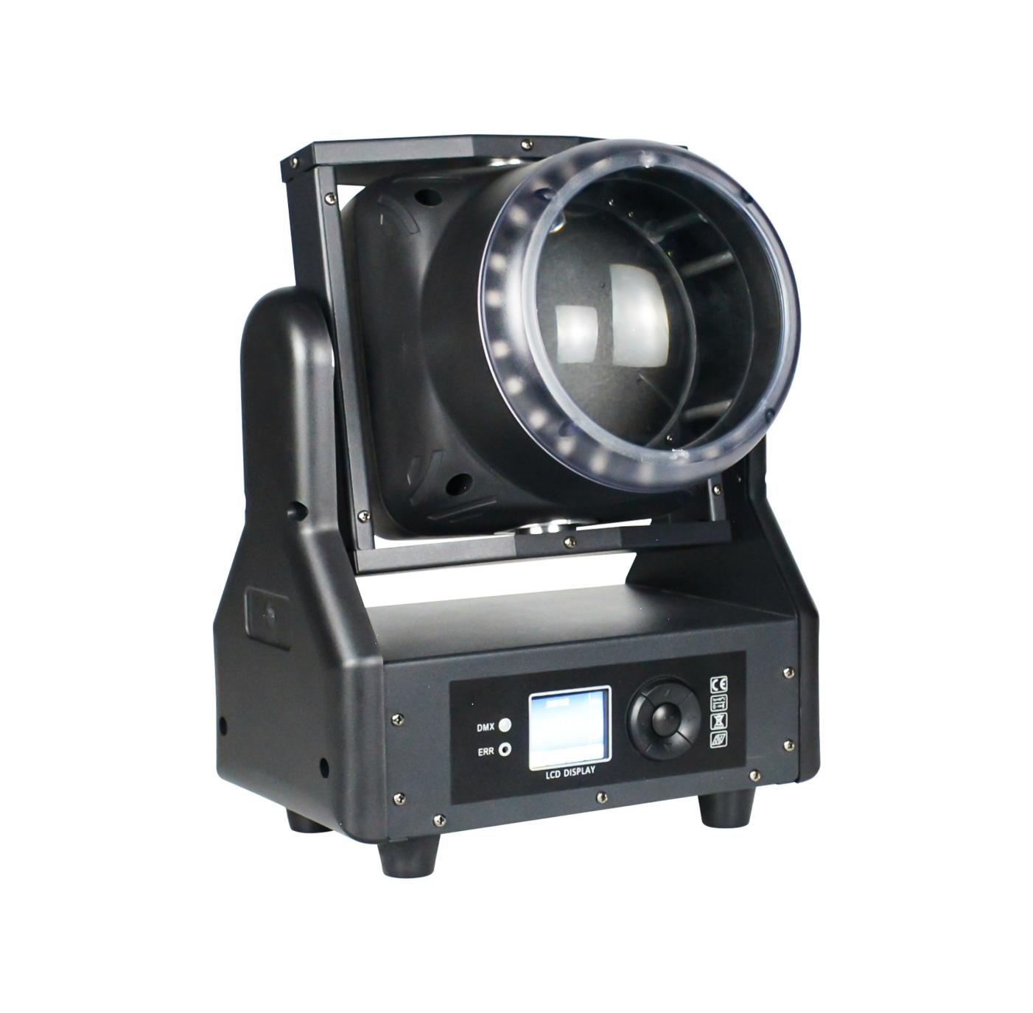

Please Read the Instructions Carefully Before Use.

Catalogue

1. Precautions and Installation Guidelines 3
1.1. statement 3
1.2. Maintenance 3
1.3. Product Precautions 3
1.4. product presentation 4
2. Display panel and button definition 5
2.1 control panel 5
2.2 Menu features 5
3. master-slave control 5
4. DMX512 control 5
5. Common faults 7

1. Precautions and Installation Guidelines

1.1 Statement

Thank you for choosing our products! All products are delivered in perfect condition with intact packaging. To ensure safe and effective use, please read this manual thoroughly before operation. The instructions provide essential details for installation and usage. Follow the guidelines carefully and keep the manual safe for future reference.
No separate notice will be given for any technical modifications to this manual.

1.2 Maintenance

l This lamp is for professional use only.
l If the external flexible cable or wiring of this luminaire is damaged, replace it with the dedicated cable or wiring provided by the manufacturer or its service agent.
l The light source contained in this lamp shall only be replaced by the manufacturer, its authorized service agent, or similar qualified personnel.
l Always connect the product to a protected circuit (circuit breaker or fuse). Ensure the product has proper electrical grounding to avoid the risk of electric shock or fire.
l To avoid unnecessary wear and extend its service life, the power supply should be completely disconnected by using a circuit breaker or unplugging the plug when not in use.
l The product housing may become hot during operation. This product should be installed in a well-ventilated location.
l When transferring products from extreme temperature environments (e.g., from cold trucks to warm and humid conditions), condensation may form on internal electronic components. To prevent malfunctions, allow the product to fully acclimate to the surrounding environment before powering it on.
l It is well established that flashlights can trigger epileptic seizures. Users must comply with local regulations regarding the use of flashlights.

1.3 Product Precautions

l Before using cleaning products or replacing fuses, disconnect the power supply first.
l When not in use, replace and secure all power, data,USB or other port covers to achieve IP protection levels.
l When installing this product above the head, use safety ropes.
l Connect this product to a grounded and protected circuit.
l When the product is activated, check the light source.
l Do not place any flammable materials within 20 cm of this product when operating or powering on.
l Do not operate this product if the casing, lenses, or cables are damaged.
l This product must be handled using handles or lifting/installation brackets only.
l To avoid unnecessary wear and extend its service life, the power supply should be completely disconnected by using a circuit breaker or unplugging the plug when not in use.
l If severe operational issues occur, stop using it immediately.

1.4 Product Presentation

l Voltage: AC100~240V 50/60HZ
l Power: 150W
l LEDs: Main light: 1 RGB lemon-yellow LED (1212–120 W) + Secondary lights: 24 RGB LEDs (5050–0.5 W each)
l Control modes: DMX512, self-propelled, master-slave, voice-controlled, with RDM functionality.
l channel ：CH18 ，CH27
l Dimming: 32-bit linear dimming from 0% to 100%
l Features: Single bead oscillation + staining + light beam
l Operating temperature: -30°C to 50°C
l Stroboscopic frequency: 1~30 Hz
l Appearance: Metal, black
l Connection method: DMX512 input/output / power input/output.
l IP rating: IP20
l weight ：
l size ：

2. Display Panel and Button Definition

2.1 Control Panel

Menu key: Go to or return to the main menu
Up arrow key: Menu function for upward selection/parameter increment
Down arrow: Select menu options or decrease parameters
Confirm key: Select menu functions and confirm and save changes when modifying menu function parameters.

2.2 Menu Features

After powering on and resetting the device, press the menu key to enter the main menu (the interface remains inactive for 30 seconds before exiting). Refer to the main menu function table (which includes five options). Use the up/down keys to navigate through the menu, and the confirm key to modify functional parameters of individual menus. Save the changes by confirming— the modified parameters retain their state after power loss.

3. Master-Slave Control

Two or more identical lighting fixtures are connected via DMX three-core signal cables. All fixtures are assigned random address codes ranging from 001 to 512, with one designated as the master unit and the others as slave units. All slave units display static screens without flickering. When the master unit adjusts effects such as gradient, pulse, jump transitions, sound control, or auto-rolling, all slave units synchronize these effects in real-time.
Special note: 1. Only one host can be configured per lighting fixture group. If multiple hosts are used, all fixtures will flash randomly and become unsynchronized.
2 、 All lighting fixtures must be activated only when the DMX512 console is turned off, enabling both master and slave units to function.

4. DMX512 Control

4.1 Address Code

After configuring the address codes for all luminaires, connect each luminaire in parallel to the DMX512 console using DMX three-core signal cables. When the address codes cease flashing, it indicates that the DMX512 console has successfully transmitted signals to the luminaires. Follow the channel specifications to control the corresponding functions via the DMX512 console.

4.2 CH18 Channel Table

Channel | Channel va. lue | Basic function
1 | 000-255 | X
2 | 000-255 | X fine.tuning

3 | 000-255 | X velocity
4 | 000-255 | Y
5 | 000-255 | Y fine-tuning
6 | 000-255 | Y velocity
7 | 000-255 | Focus
8 | 000- 128 | Rotating motor stroke
8 | 129- 192 | The forward speed of the rotating motor increases from slow to fast.
8 | 193-255 | Reverse rotation of the motor: speed increases from slow to fast
9 | 000-255 | Central Control
10 | 000-255 | Stroboflash
11 | 000-255 | Primary optic disc hemorrhage
12 | 000-255 | Primary light green
13 | 000-255 | Primary Light Blue
14 | 000-255 | Main Light Lemon Yellow
15 | 000-255 | Auxiliary red
16 | 000-255 | Background Light Green
17 | 000-255 | Auxiliary light blue
18 | 000-255 | Reset

4.3 CH27 Channel Table(Main Light Mode: 4 Values and 1 Effect) (Fill Light Mode: 4 Values and 1 Effect)

Channel | Channel va- lue | Basic function
1 | 000-255 | X
2 | 000-255 | X fine-tuning
3 | 000-255 | X velocity
4 | 000-255 | Y
5 | 000-255 | Y fine-tuning
6 | 000-255 | Y velocity
7 | 000-255 | Focus
8 | 000- 128 | Rotating motor stroke
8 | 129- 192 | The forward speed of the rotating motor increases from slow to fast.
8 | 193-255 | Reverse rotation of the motor: speed increases from slow to fast
9 | 000-255 | Main Light Master Control
10 | 000-255 | Main light strobe
11 | 000-255 | Main light color temperature
12 | 000-255 | Main light color
13 | 000-255 | Main Light Mode
14 | 000-255 | Main light mode speed
15 | 000-255 | Red light from the main lamp
16 | 000-255 | Main light green light
17 | 000-255 | Main lamp blue light
18 | 000-255 | Main light: lemon yellow light
19 | 000-255 | Light Ring General Adjustment

20 | 000-255 | Halo Stroboscopic Effect
21 | 000-255 | Halo Color
22 | 000-255 | Halo Model
23 | 000-255 | Halo Mode Speed
24 | 000-255 | Halo red light
25 | 000-255 | Aurora green light
26 | 000-255 | Halo blue light
27 | 000-255 | Reset

5. Common Faults

Corresponding solutions have been proposed for common faults. Any unresolved issues should be handled by professionals. Before maintaining the lighting fixtures, disconnect the power supply first.

1. The LED Is Not Lit

l Check if the voltage compatible with the lighting fixture is installed.
l Check whether the contact at the power supply connection point of the lamp or the control switch is poor;
l Check if there is insufficient electricity supply;
l Check whether the DMX512 controller has sent the command.

2. After Normal Reset of the Lamp, It Does Not Accept Control from the Console.

l Check whether the digital start address value and function options of the lamp are correct.
l Check whether the connection status of the communication control line is correct, and whether the communication line is excessively long or has been interrupted;
l Check whether the control equipment is malfunctioning and verify that the series-connected signal amplifier is functioning properly.
l Check whether the communication line is excessively long or if there is mutual interference from other equipment;
l Optimize wiring layout by shortening control signal lines and separating high-voltage and low-voltage circuits.
l Add a signal amplifier;
l The signal lines utilize high-quality shielded twisted-pair cables.
l Connect a signal terminal resistor (120 ohms) to the end of the lamp.

3. The Lamp Cannot Be Turned On

l Check whether the power supply parameters match the lighting fixture specifications.
l Check for poor contact or detachment of lighting fixtures during long-distance transportation due to compression deformation, vibration of internal components, moisture, or other factors.
l Check whether the internal wiring and connectors of the lamp are detached or loose.
l Inspect the electronic components of the lamp (such as electronic transformers, PCB boards, motor control boards, etc.) for looseness, short circuits, or burnout.

4. The Lamp's X-Axis or Y-Axis Movement Is Abnormal During Operation.

l Check step by step according to the previous steps;
l Inspect whether the drive belts corresponding to the X and Y axes inside the lamp are detached or broken;
l Check whether the X-and Y-direction data feedback receiver (Hall sensor) inside the lamp is damaged;
l Restart and reset once.

